Unit 6 Lesson 1: Rigid Transformations in the Plane

1 Traversing the Plane (Warm up)

Student Task Statement
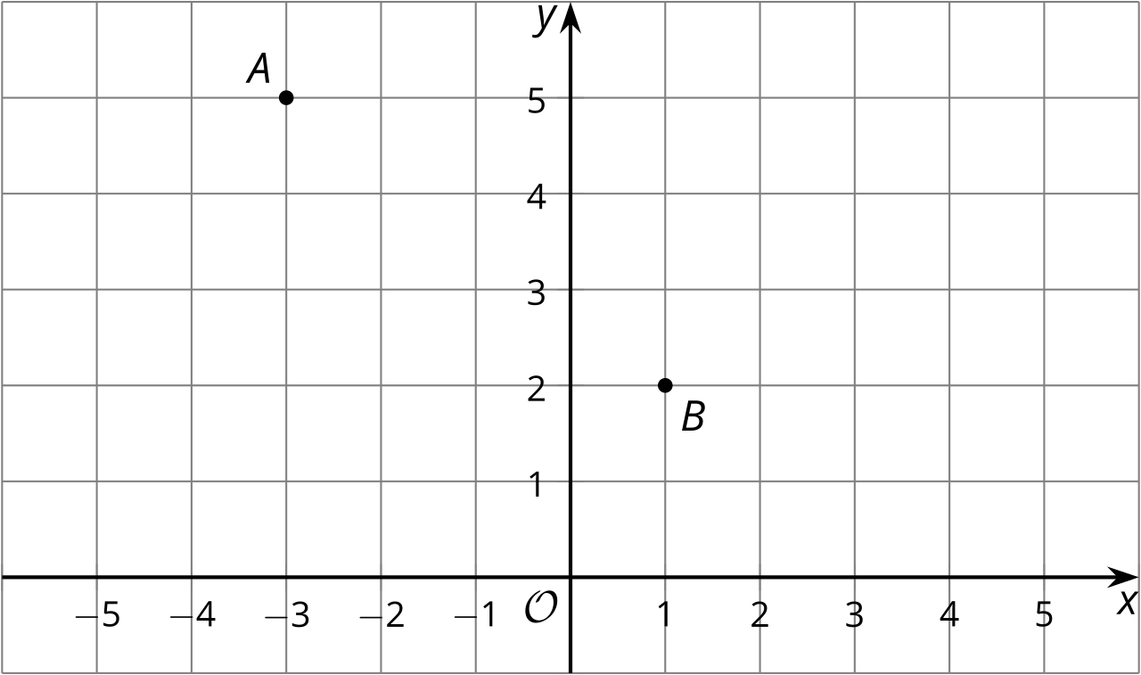
- How far is point $A$ from point $B$?
- What transformations will take point $A$ to point $B$?

2 Transforming with Coordinates

Student Task Statement
First, predict where each transformation will land. Next, carry out the transformation.
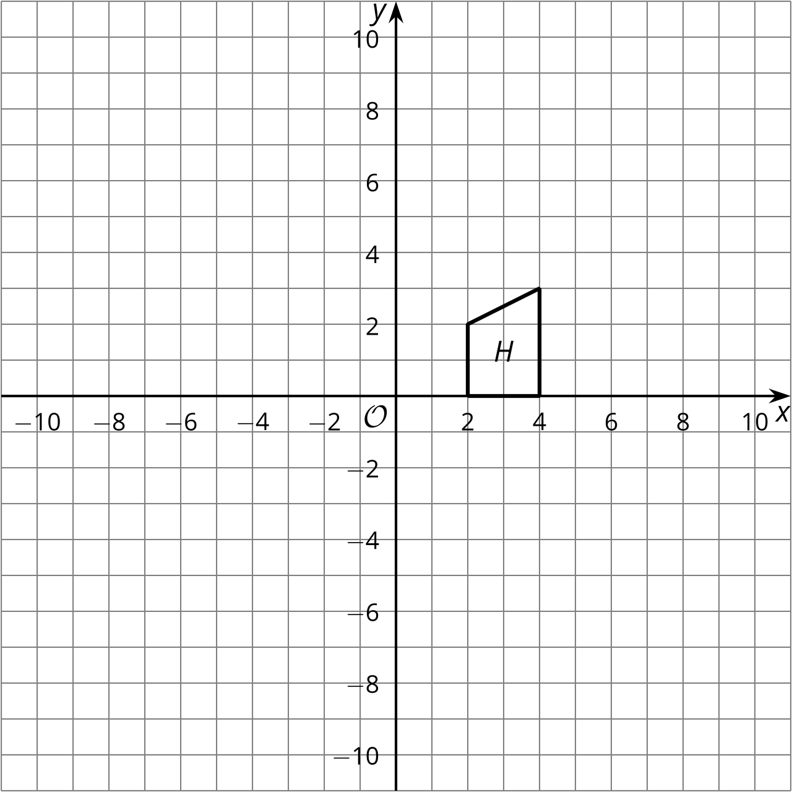
- Rotate Figure $H$ clockwise using center $\left(2,0\right)$ by 90 degrees.
Translate the image by the directed line segment from $\left(2,0\right)$ to $\left(3,\text{-}4\right)$.
Label the result $R$.
- Reflect Figure $H$ across the $y$-axis.
Rotate the image counterclockwise using center $\left(0,0\right)$ by 90 degrees.
Label the result $L$.

3 Congruent by Coordinates

Student Task Statement
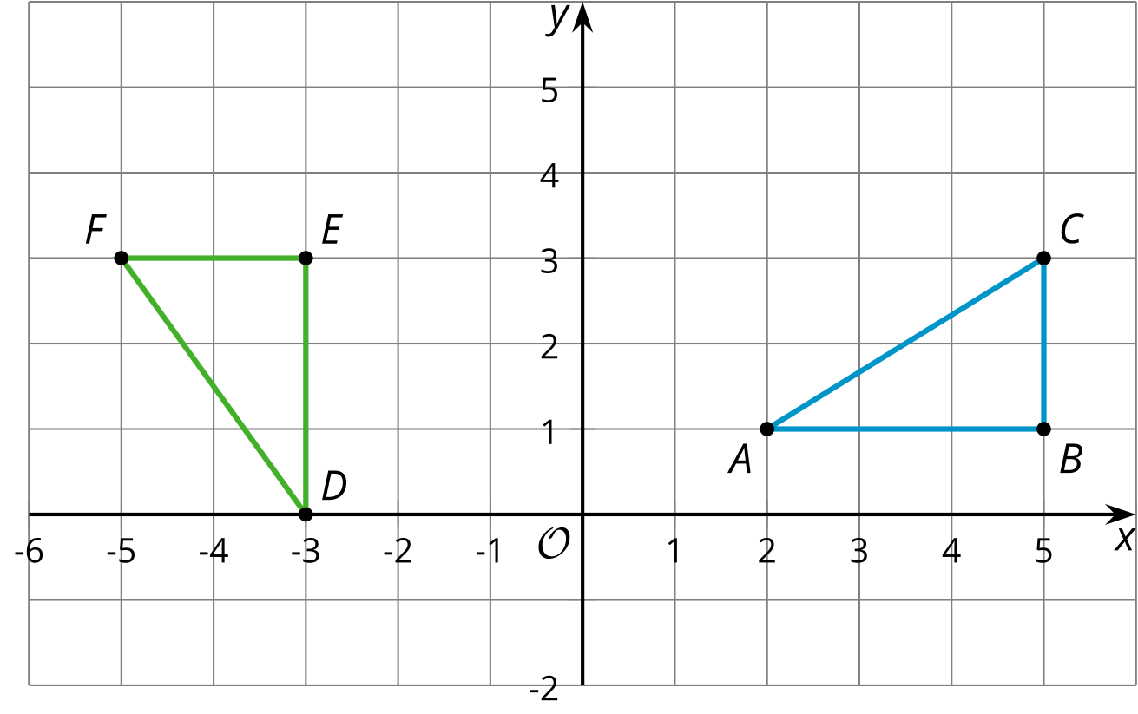
- Calculate the length of each side in triangles $ABC$ and $DEF$.
- Calculate the measure of each angle in triangles $ABC$ and $DEF$.
- The triangles are congruent. How do you know this is true?
- Because the triangles are congruent, there must be a sequence of rigid motions that takes one to the other. Find a sequence of rigid motions that takes triangle $ABC$ to triangle $DEF$.

Images for Activity Synthesis
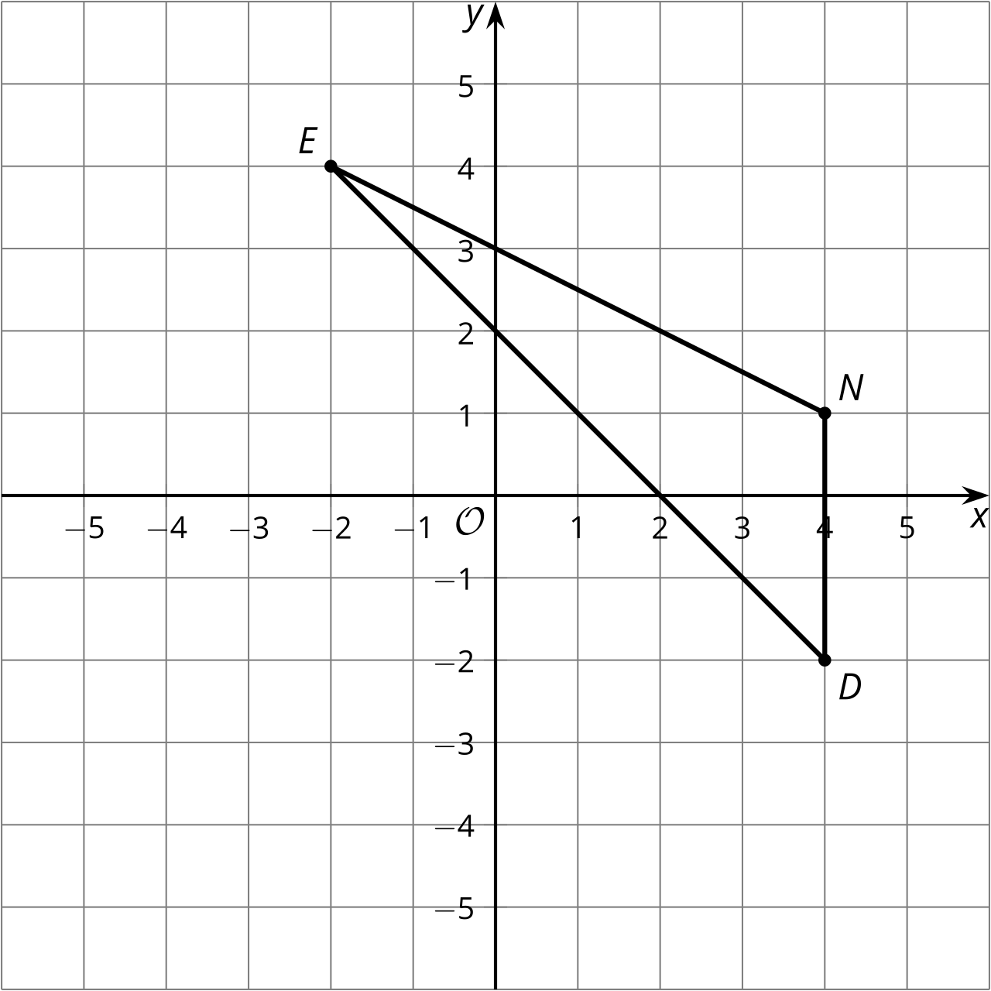
© CC BY 2019 by Illustrative Mathematics®

