Lesson 9: End Behavior (Part 2)
- Let’s describe the end behavior of polynomials.

9.1: It’s a Cover Up
Match each of the graphs to the polynomial equation it represents. For the graph without a matching equation, write down what must be true about the polynomial equation.

A

B
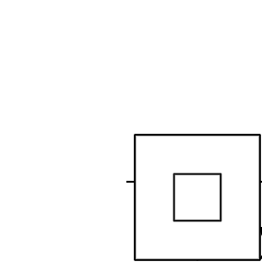

C
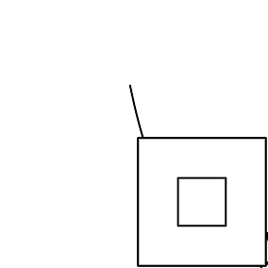

D
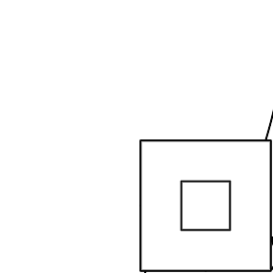
- $y=x(x+3)(2−x)$
- $y=1−3x+5x^{4}$
- $y=5(x+3)−5x$

9.2: The Case of Unexpected End Behavior
- Write an equation for a polynomial with the following properties: it has even degree, it has at least 2 terms, and, as the inputs get larger and larger in either the negative or positive directions, the outputs get larger and larger in the negative direction.
- Pause here so your teacher can review your work.
- Write an equation for a polynomial with the following properties: it has odd degree, it has at least 2 terms, as the inputs get larger and larger in the negative direction the outputs get larger and larger in the positive direction, and as the inputs get larger and larger in the positive direction, the outputs get larger and larger in the negative direction.

Are you ready for more?
In the given graph all of the horizontal intercepts are shown. Find a function with this general shape and the same horizontal intercepts.
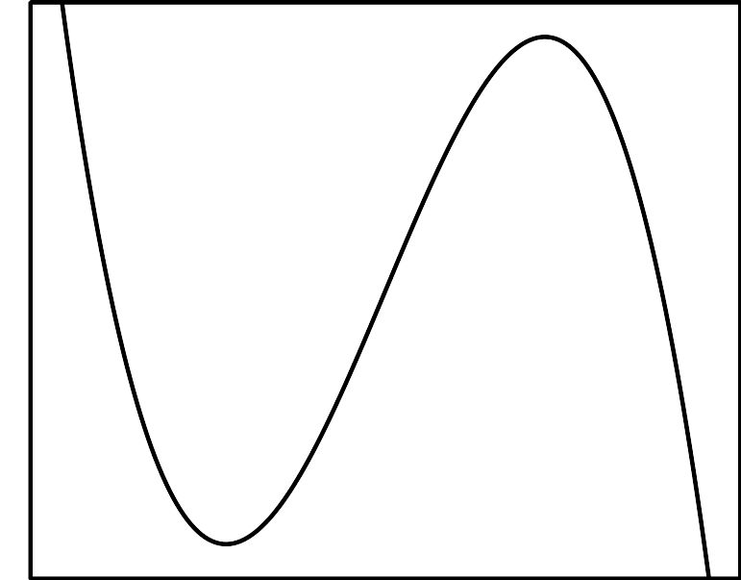

9.3: Which is Greater?
$M$ and $N$ are each functions of $x$ defined by $M(x)=\text{-}x^{3}−2x+8$ and $N(x)=\text{-}20x^{2}+3x+8$.
- Describe the end behavior of $M$ and $N$.
- For $x>0$, which function do you think has greater values? Be prepared to share your reasoning with the class.

Lesson 9 Summary
What happens when we multiply a number by a negative number? If the original number was positive, the product is negative. But if the original number was negative, the product is positive. The sign of the new number is the opposite of the original number.
Now let’s consider the polynomial functions $f(x)=x^{2}$ and $g(x)=\text{-}x^{2}$. For any non-zero real number $x$, the output of $f$ is positive while the output of $g$ is negative. The signs of all the output values for $g$ are the opposite of those of $f$. The difference between these two functions is also easy to see when we look at their graphs.

$g(x)=\text{-}x^{2}$
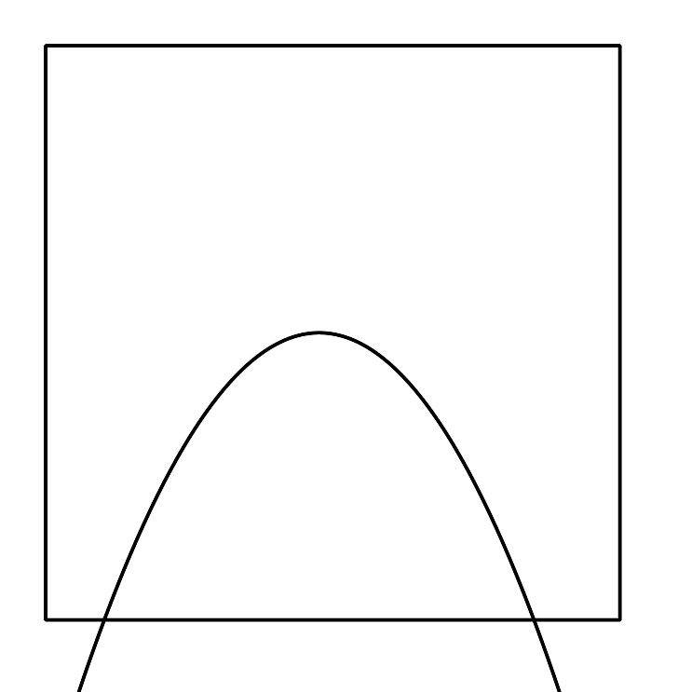

$f(x)=x^{2}$
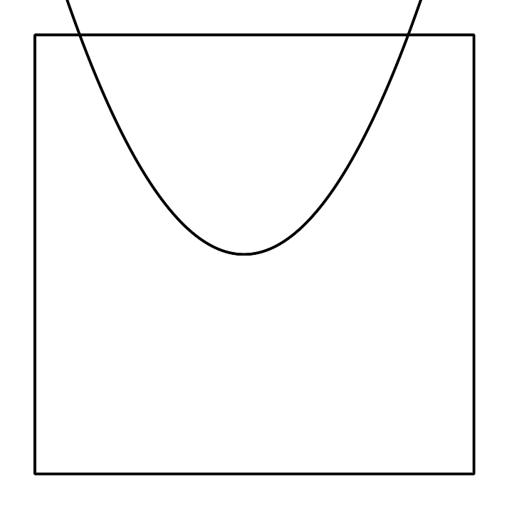
This is the effect of a negative leading coefficient: the end behavior of the polynomial is the opposite of what it would be if the leading coefficient were positive. For polynomials of odd degree, we can see that a negative leading coefficient has the same effect on the end behavior.
Here are the graphs of $y=\text{-}(x−1)(2x+3)(x+4)$, which has a leading term of $\text{-}2x^{3}$, and $y=(x−1)(2x+3)(x+4)$, which has a leading term of $2x^{3}$. They have the same zeros, but opposite end behavior, because they have opposite signs on their leading coefficients.

$y=\text{-}(x−1)(2x+3)(x+4)$
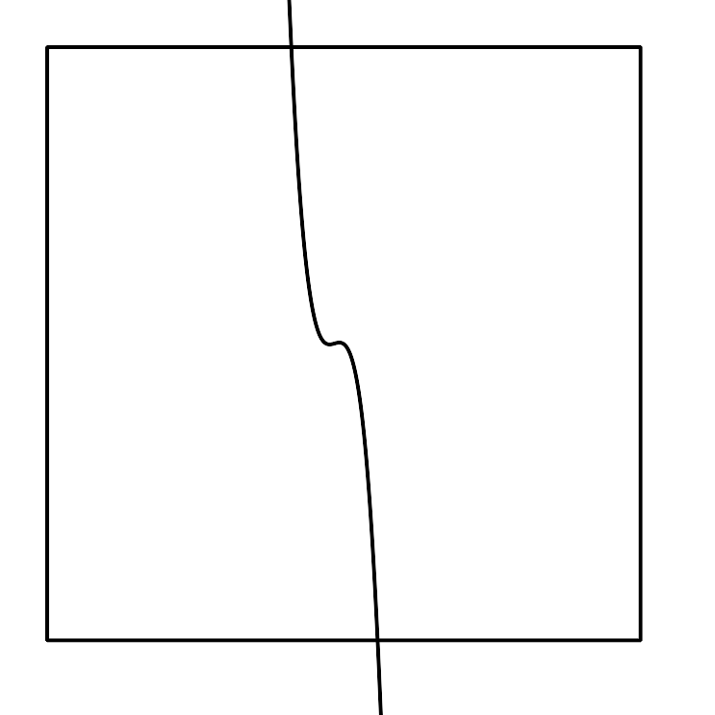

$y=(x−1)(2x+3)(x+4)$
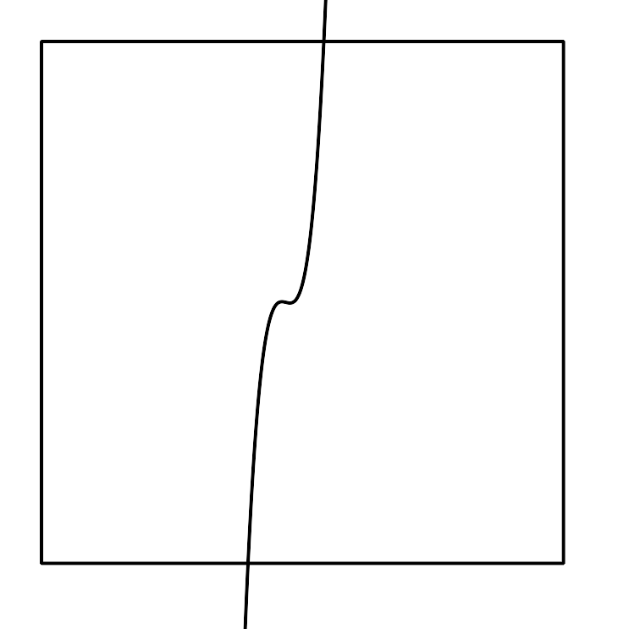
© CC BY 2019 by Illustrative Mathematics®

