Unit 8 Lesson 17: Make and Break Apart 10

WU Estimation Exploration: 5 and 5 makes 10 (Warm up)

Student Task Statement
- How many dots are there?
- 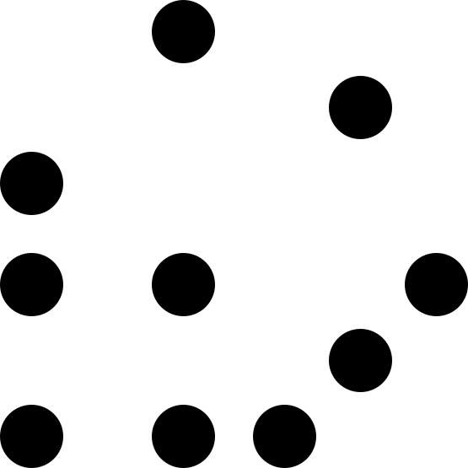
- Record an estimate that is:
- too low | - about right | - too high
- How many dots are there?
- 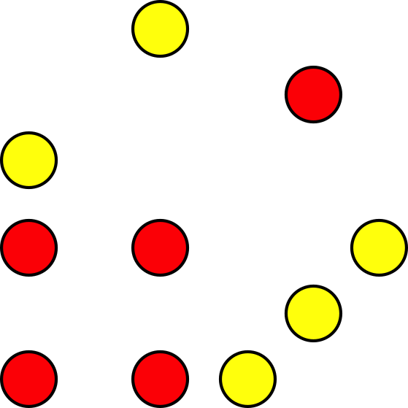
- Record an estimate that is:
- too low | - about right | - too high

1 10 Beads

Student Task Statement

Activity Synthesis

2 Make and Break Apart 10

Student Task Statement
- $7+3=10$
- $10=4+6$
- $9+1=10$
- $10=2+8$
- $\underset{_}{}+\underset{_}{}=10$
- $10=\underset{_}{}+\underset{_}{}$
- $\underset{_}{}+\underset{_}{}=10$
- $\underset{_}{}+\underset{_}{}=10$

3 Centers: Choice Time

Student Task Statement
Choose a center.
Shake and Spill
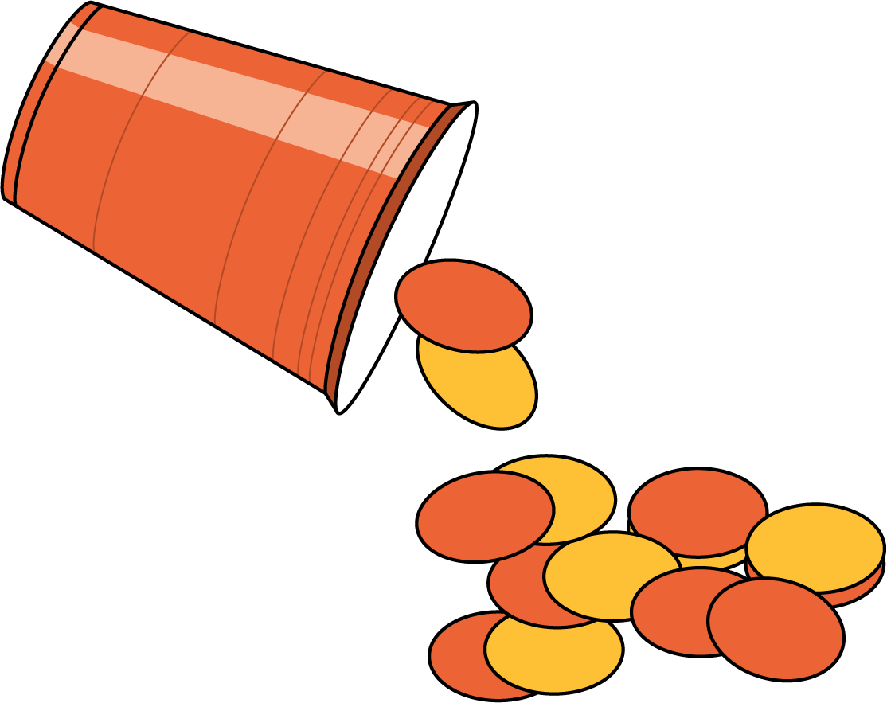
Number Race
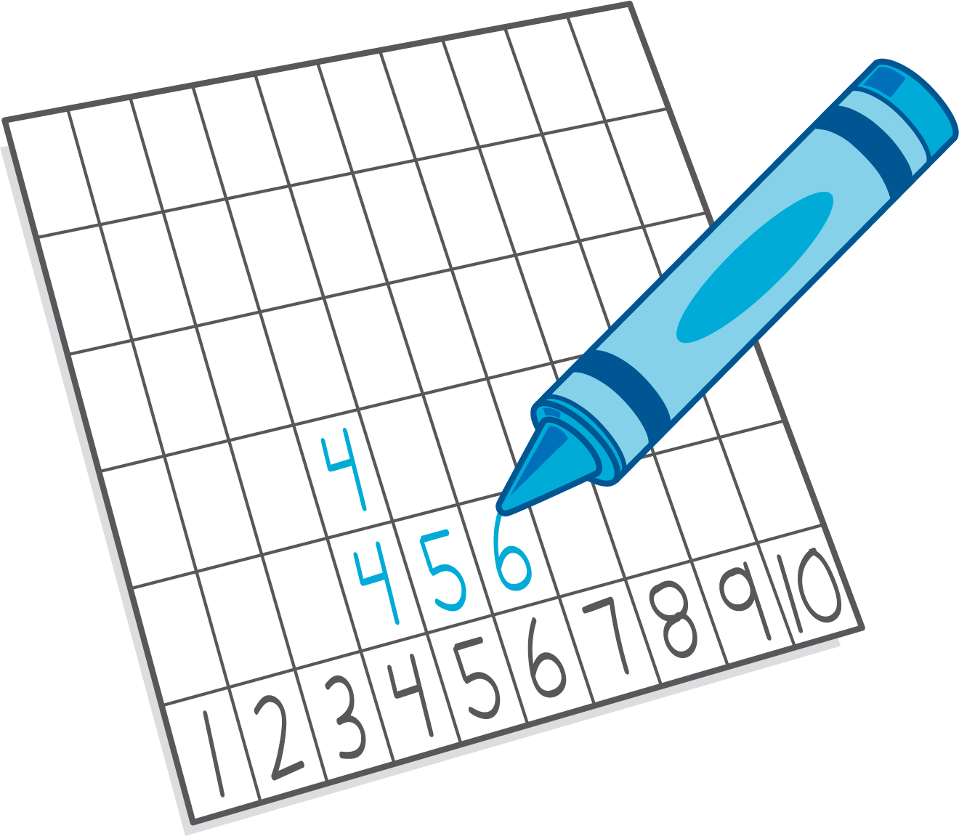
Grab and Count
What's Behind My Back?
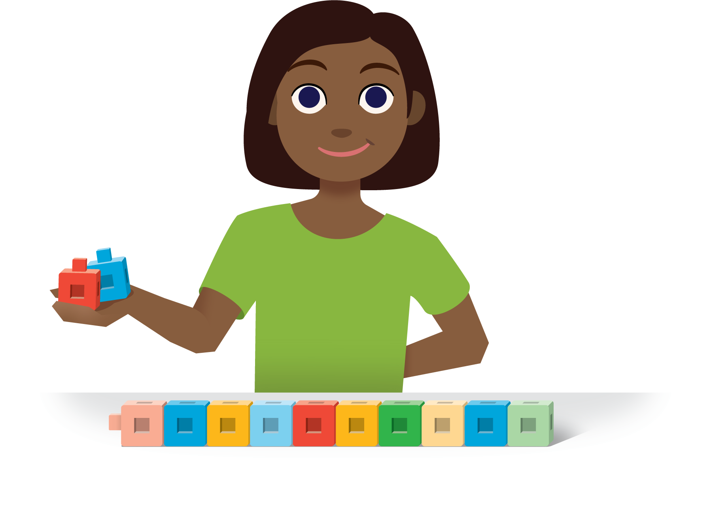
Pattern Blocks
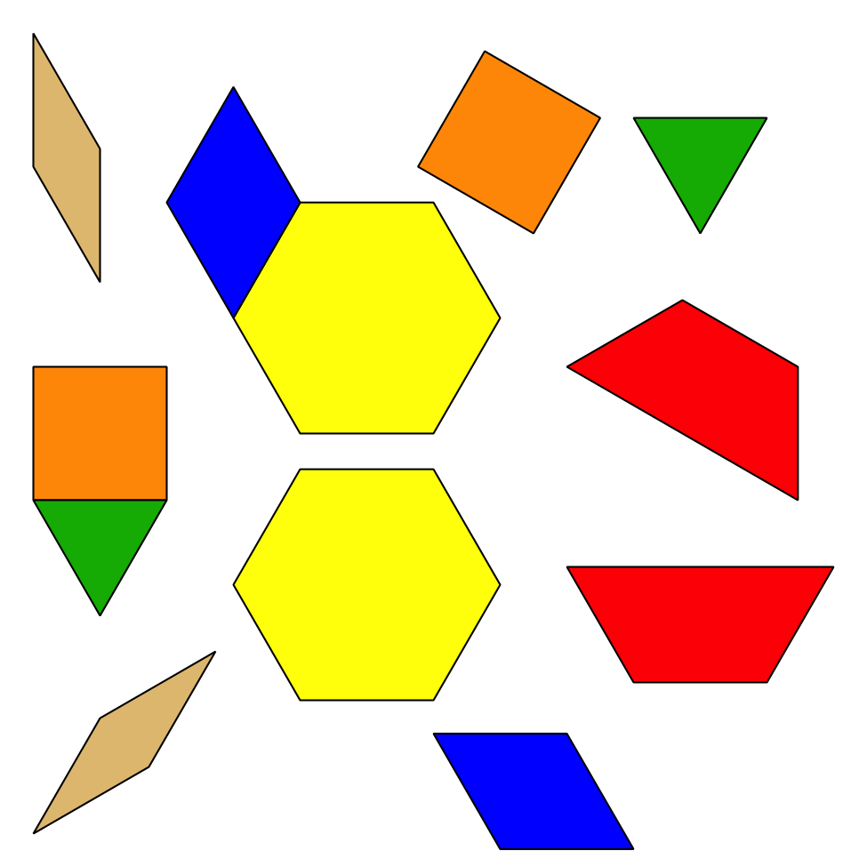
© CC BY 2021 Illustrative Mathematics®

