Lesson 14: Center Day 3
- Let’s notice shapes in books and practice adding and subtracting.

Warm-up: Number Talk: Adding Up to 4 Two-digit Numbers
Find the value of each expression mentally.
- $10+15+20+10$
- $5+30+20$
- $15+20+30$
- $25+15+5+15$

14.2: Centers: Choice Time
Choose a center.
Capture Squares
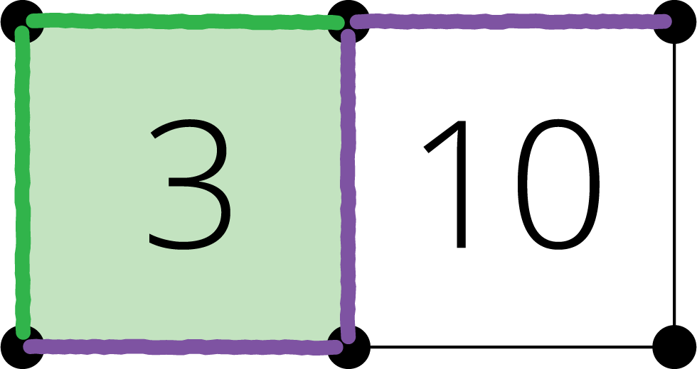
Number Puzzles
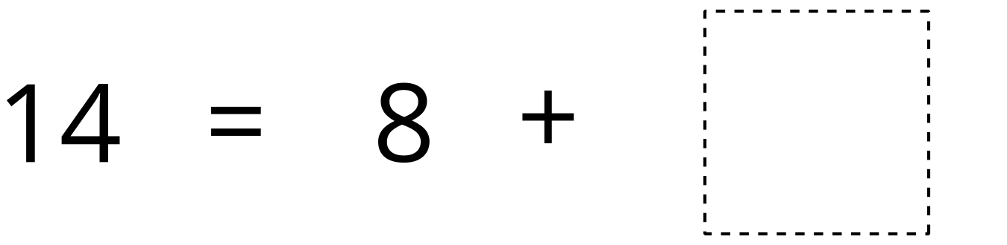
Picture Books
© CC BY 2021 Illustrative Mathematics®

