Unit 8 Lesson 6: Center Day 1

WU Number Talk: Two More (Warm up)

Student Task Statement
Find the value of each expression mentally.
- $2+2+2$
- $2+2+2+2$
- $2+2+2+2+2$
- $2+2+2+2+2+2$

1 Introduce Write Numbers, Skip Count by 2, 5, and 10

Student Task Statement

2 Centers: Choice Time

Student Task Statement
Choose a center.
Write Numbers
Target Numbers
Five in a Row
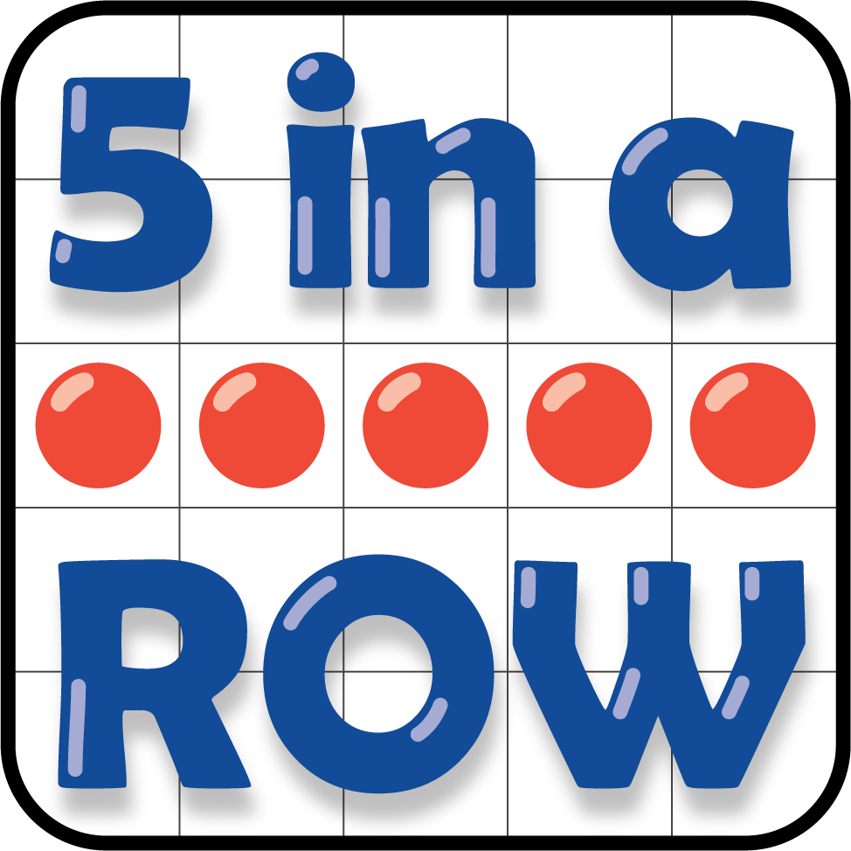
How Close
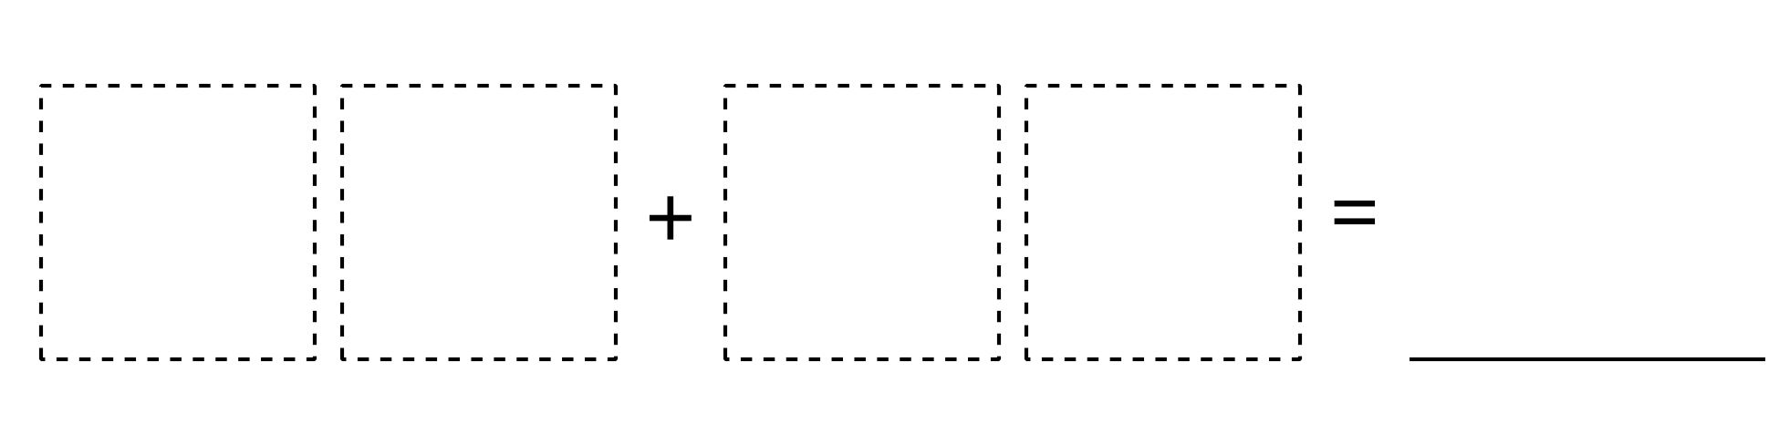
© CC BY 2021 Illustrative Mathematics®

