Lesson 13: Solve Problems With Equal Groups
- Let’s multiply some teen numbers.

Warm-up: Estimation Exploration: Multiply Teens
$4×18$
Record an estimate that is:
too low | about right | too high

13.1: Problems with Teen Numbers
Solve each problem. Show your thinking using objects, a drawing, or a diagram.
- A seller at a farmers market has 7 dozen eggs when they close for the day. How many eggs does the seller have?
- At the farmers market there’s a space for performers to play music with some chairs for people to sit and listen. There are 5 rows of chairs and each row has 15 chairs. How many chairs are there?
- A booth at a farmers market has a table top that has lengths of 4 feet and 16 feet. What is the area of the table top?
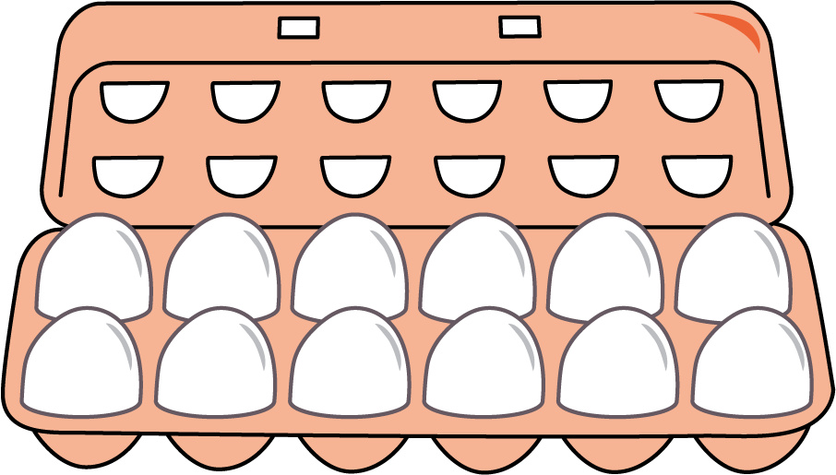

13.2: Gallery Walk: Problems with Teen Numbers
As you visit the posters with your partner, discuss what is the same and what is different about the thinking shown on each poster.
© CC BY 2021 Illustrative Mathematics®

