Lesson 8: Center Day 1
- Let’s work with shapes and add or subtract numbers.

Warm-up: Number Talk: Add 3 Numbers
Find the value of each expression mentally.
- $6+4+8$
- $6+8+4$
- $6+8+5$
- $6+5+9$

8.2: Centers: Choice Time
Choose a center.
Picture Books
How Are They the Same?
Capture Squares
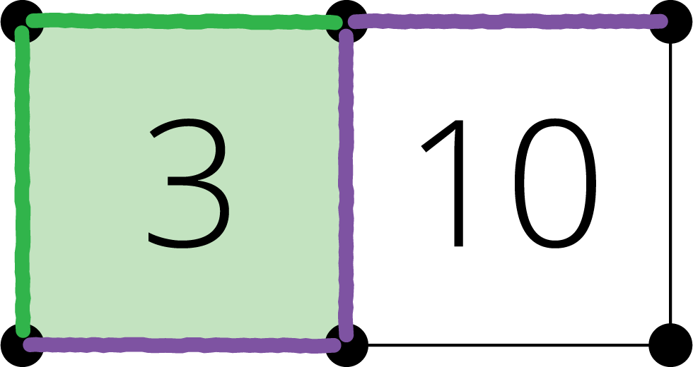
© CC BY 2021 Illustrative Mathematics®

