Lesson 5: Compare and Order Decimals and Fractions
- Let’s put fractions and decimals in order.

Warm-up: Number Talk: Sums of Fractions
Find the value of each expression mentally.
- $\frac{5}{10}+\frac{50}{100}$
- $\frac{5}{10}+\frac{55}{100}$
- $\frac{6}{10}+\frac{50}{100}$
- $\frac{6}{10}+\frac{65}{100}$

5.1: Order Once, Order Twice
Your teacher will give you a set of cards with fractions and decimals.
- Work with your group to order the numbers from least to greatest. Record your ordered numbers.
- Find a group whose cards are different than yours. Combine your cards with theirs. Order the combined set from least to greatest. Record your sorted numbers.
- Use the numbers from your sorted set and <, >, or = symbols to create true comparison statements:
  - $\underset{_}{}<\underset{_}{}$
  - $\underset{_}{}>\underset{_}{}$
  - $\underset{_}{}<\underset{_}{}$
  - $\underset{_}{}>\underset{_}{}$

5.2: Long Jumps
American athlete Carl Lewis won 10 Olympic medals and 10 World Championships in track and field—in 100-meter dash, 200-meter dash, and long jump.
Here are some of his long-jump records from his career:
year | distance (meters)
1979 | 8.13
1980 | 8.35
1982 | 8.7
1983 | 8.79
1984 | 8.24
1987 | 8.6
1991 | 8.87
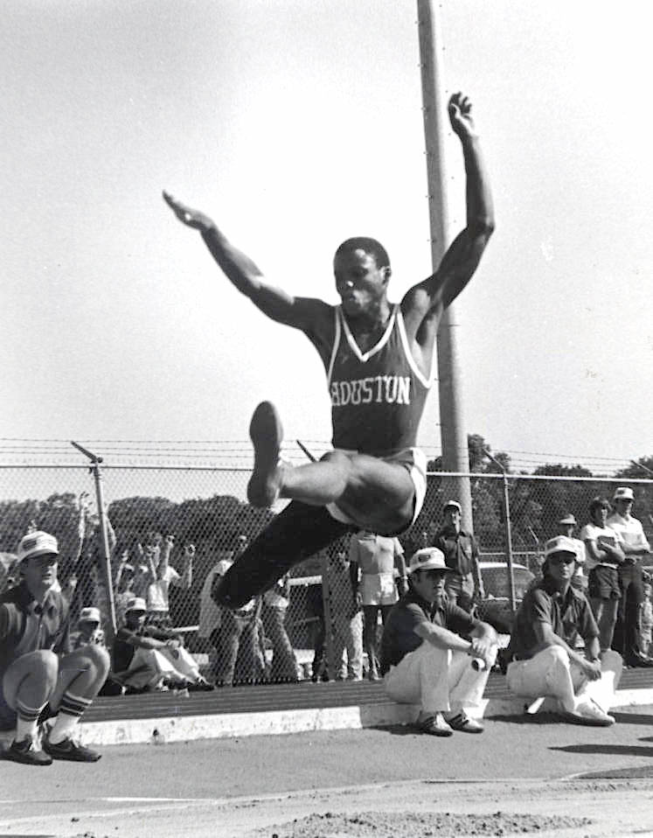
- On this list, which distance is his shortest jump? Which is his best (longest) jump?
- Here are the top distances (in meters) of three other American long jumpers:
  - Bob Beamon: $8\frac{9}{10}$
  - Jarrion Lawson: $8\frac{58}{100}$
  - Mike Powell: $8\frac{95}{100}$
- Compare their records to Carl Lewis’s best jump. Order the distances from greatest to least.

Section Summary
Section Summary
In this section, we learned to express tenths and hundredths as decimals, locate them on a number line, and compare them.
We learned that $\frac{1}{10}$ written as a decimal is 0.1, and that this number is also read “1 tenth.” $\frac{1}{100}$ written as a decimal is 0.01 and is read “1 hundredth.”
The table shows some more examples of tenths and hundredths in their decimal notation. ​​​​
- Because $\frac{5}{10}$ and $\frac{50}{100}$ are equivalent, the decimals 0.5 and 0.50 are also equivalent.
- Likewise, $\frac{17}{10}$ and $\frac{170}{100}$ are equivalent, so 1.7 and 1.70 are also equivalent.
fraction | decimal
$\frac{4}{100}$ | 0.04
$\frac{23}{100}$ | 0.23
$\frac{5}{10}$ | 0.5
$\frac{50}{100}$ | 0.50
$\frac{17}{10}$ | 1.7
$\frac{170}{100}$ | 1.70
Just like fractions, decimals can be located on a number line. Doing so can help us compare them.
For instance, 0.24 is equivalent to $\frac{24}{100}$, which is between $\frac{20}{100}$ and $\frac{30}{100}$ (or between $\frac{2}{10}$ and $\frac{3}{10}$) on the number line. We can see that 0.24 is greater than 0.08 and less than 0.61.
© CC BY 2021 Illustrative Mathematics®

