Lesson 7: Tax and Tip
Let’s learn about sales tax and tips.

7.1: Notice and Wonder: The Price of Sunglasses
You are on vacation and want to buy a pair of sunglasses for $10 or less. You find a pair with a price tag of $10. The cashier says the total cost will be $10.45.
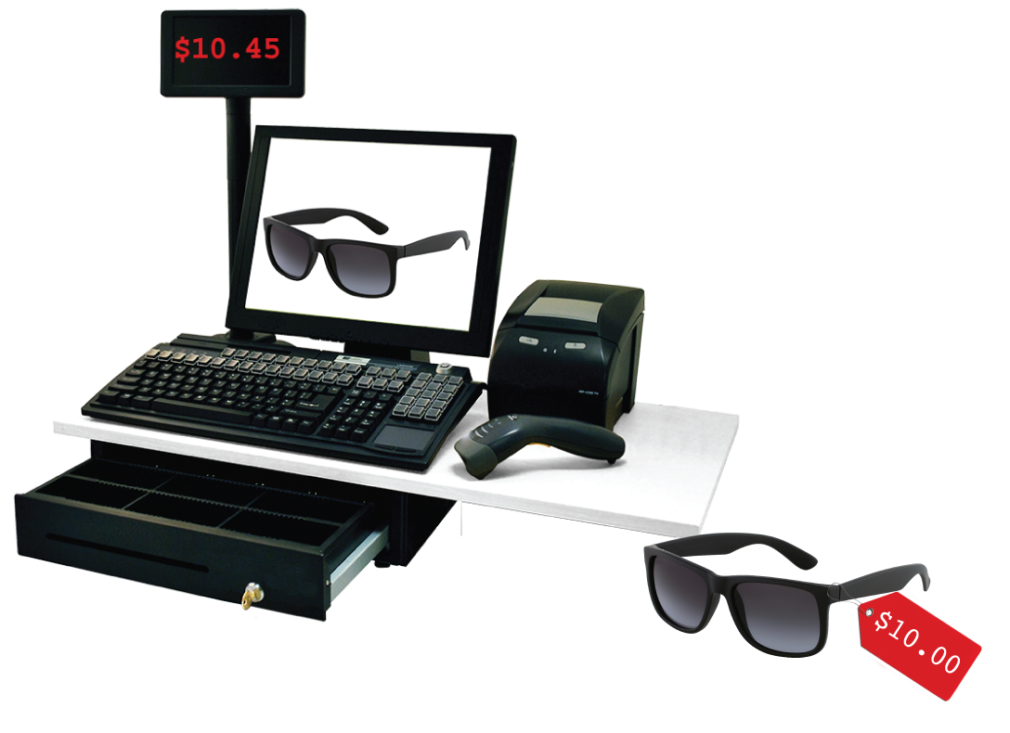
What do you notice? What do you wonder?

7.2: Shopping in Two Different Cities
Different cities have different sales tax rates. Here are the sales tax charges on the same items in two different cities. Complete the tables.
City 1
item | price  (dollars) | sales tax  (dollars) | total cost  (dollars)
paper towels | 8.00 | 0.48 | 8.48
lamp | 25.00 | 1.50
pack of gum | 1.00
laundry soap | 12.00
 | $x$

City 2
item | price  (dollars) | sales tax  (dollars) | total cost  (dollars)
paper towels | 8.00 | 0.64 | 8.64
lamp | 25.00 | 2.00
pack of gum | 1.00
laundry soap | 12.00
 | $x$

7.3: Shopping in a Third City
Here is the sales tax on the same items in City 3.
item | price  (dollars) | sales tax  (dollars)
paper towels | 8.00 | 0.58
lamp | 25.00 | 1.83
pack of gum | 1.00 | 0.07
laundry soap | 12.00
- What is the tax rate in this city?
- For the sales tax on the laundry soap, Kiran says it should be $0.84. Lin says it should be $0.87. Do you agree with either of them? Explain your reasoning.

7.4: Dining at a Restaurant
- Jada has a meal in a restaurant. She adds up the prices listed on the menu for everything they ordered and gets a subtotal of $42.00.
- 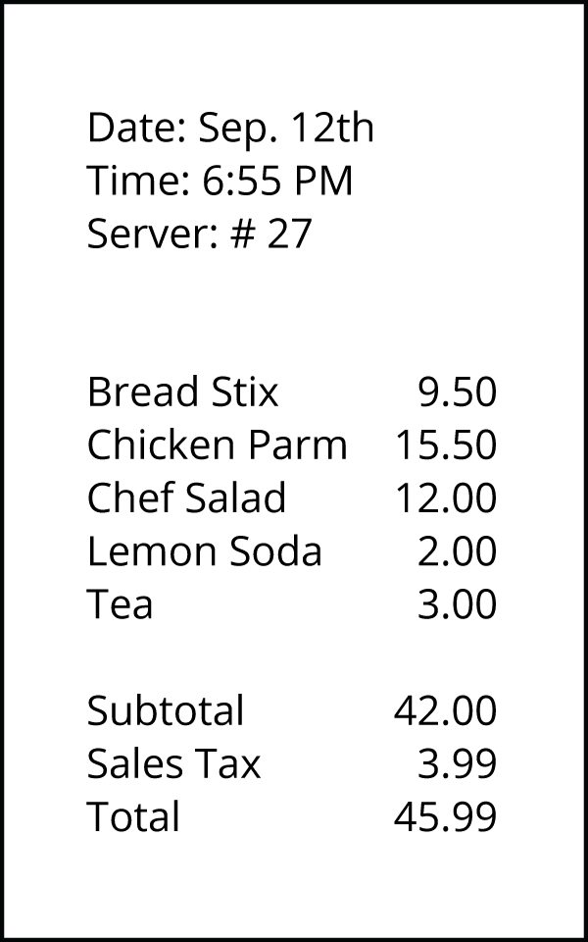
  - When the check comes, it says they also need to pay $3.99 in sales tax. What percentage of the subtotal is the sales tax?
  - After tax, the total is $45.99. What percentage of the subtotal is the total?
  - They actually pay $52.99. The additional $7 is a tip for the server. What percentage of the subtotal is the tip?
- The tax rate at this restaurant is 9.5%.
- 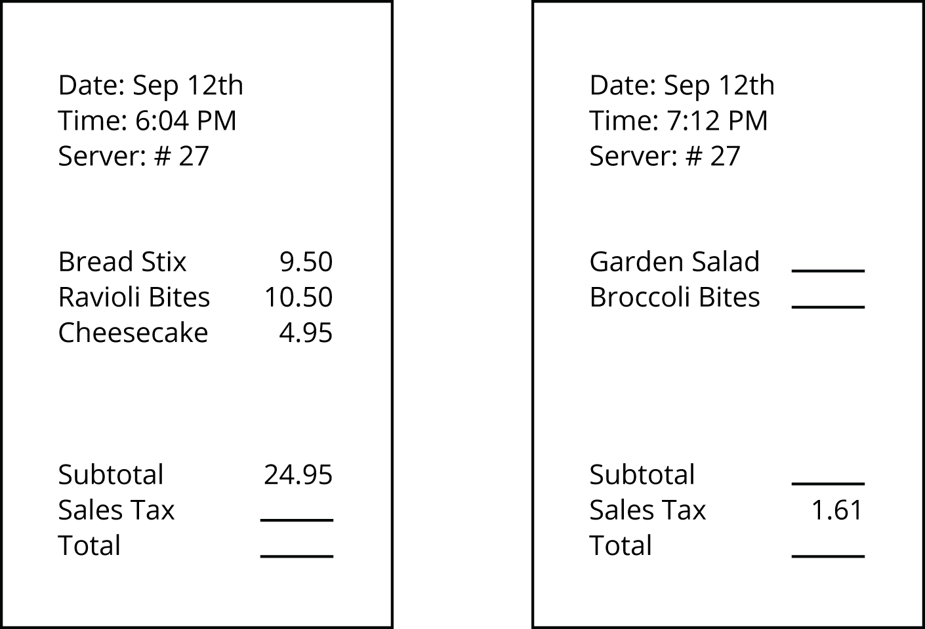
- Another person’s subtotal is $24.95. How much will their sales tax be?
- Some other person’s sales tax is $1.61. How much was their subtotal?

Are you ready for more?
Elena's cousins went to a restaurant. The part of the entire cost of the meal that was tax and tip together was 25% of the cost of the food alone. What could the tax rate and tip rate be?

Lesson 7 Summary
Many places have sales tax. A sales tax is an amount of money that a government agency collects on the sale of certain items. For example, a state might charge a tax on all cars purchased in the state. Often the tax rate is given as a percentage of the cost. For example, a state's tax rate on car sales might be 2%, which means that for every car sold in that state, the buyer has to pay a tax that is 2% of the sales price of the car.
Fractional percentages often arise when a state or city charges a sales tax on a purchase. For example, the sales tax in Arizona is 7.5%. This means that when someone buys something, they have to add 0.075 times the amount on the price tag to determine the total cost of the item.
For example, if the price tag on a T-shirt in Arizona says $11.50, then the sales tax is $\left(0.075\right)⋅11.5=0.8625$, which rounds to 86 cents. The customer pays $11.50+0.86$, or $12.36 for the shirt.
The total cost to the customer is the item price plus the sales tax. We can think of this as a percent increase. For example, in Arizona, the total cost to a customer is 107.5% of the price listed on the tag.
A tipis an amount of money that a person gives someone who provides a service. It is customary in many restaurants to give a tip to the server that is between 10% and 20% of the cost of the meal. If a person plans to leave a 15% tip on a meal, then the total cost will be 115% of the cost of the meal.
© CC BY Open Up Resources. Adaptations CC BY IM.

