Unit 6 Lesson 1 Cumulative Practice Problems
- Here is an equation: $x+4=17$
  - Draw a tape diagram to represent the equation.
  - Which part of the diagram shows the quantity $x$? What about 4? What about 17?
  - How does the diagram show that $x+4$ has the same value as 17?
- Diego is trying to find the value of $x$ in $5⋅x=35$. He draws this diagram but is not certain how to proceed.

  - Complete the tape diagram so it represents the equation $5⋅x=35$.
  - Find the value of $x$.
- Match each equation to one of the two tape diagrams.
  - $x+3=9$
  - $3⋅x=9$
  - $9=3⋅x$
  - $3+x=9$
  - $x=9−3$
  - $x=9÷3$
  - $x+x+x=9$
- 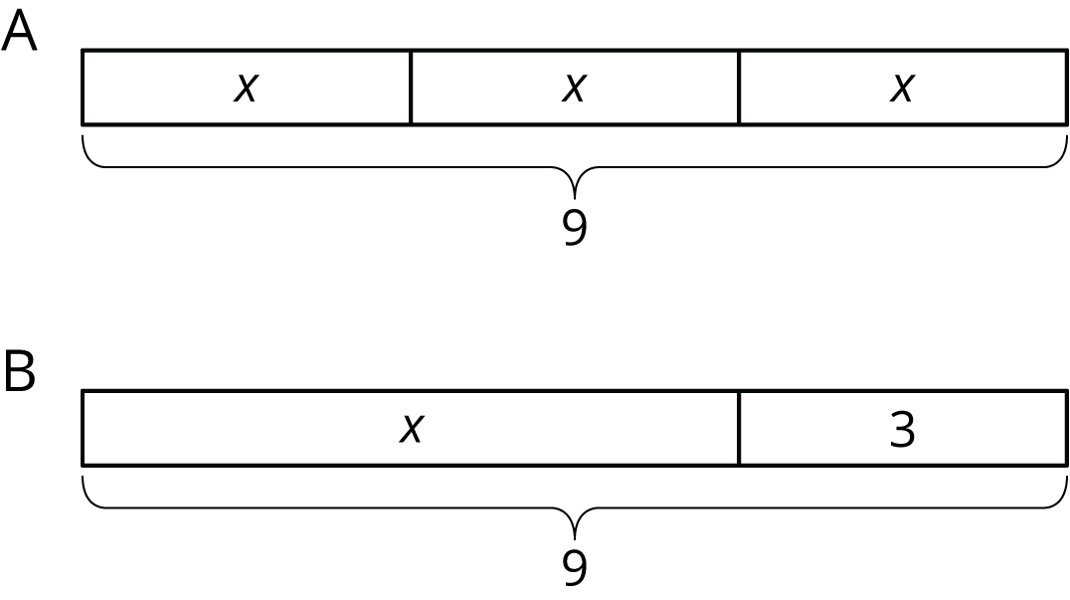
- For each equation, draw a tape diagram and find the unknown value.
  - $x+9=16$
  - $4⋅x=28$
- A shopper paid $2.52 for 4.5 pounds of potatoes, $7.75 for 2.5 pounds of broccoli, and $2.45 for 2.5 pounds of pears. What is the unit price of each item she bought? Show your reasoning.
- (From Unit 5, Lesson 13.)
- A sports drink bottle contains 16.9 fluid ounces. Andre drank 80% of the bottle. How many fluid ounces did Andre drink? Show your reasoning.
- (From Unit 3, Lesson 14.)
- The daily recommended allowance of calcium for a sixth grader is 1,200 mg. One cup of milk has 25% of the recommended daily allowance of calcium. How many milligrams of calcium are in a cup of milk? If you get stuck, consider using the double number line.
- (From Unit 3, Lesson 11.)
© CC BY Open Up Resources. Adaptations CC BY IM.

