Lesson 7: Flat and Solid Shapes
- Let’s build shapes with clay.

Warm-up: Which One Doesn’t Belong: Flat Shapes
Which one doesn’t belong?
A
B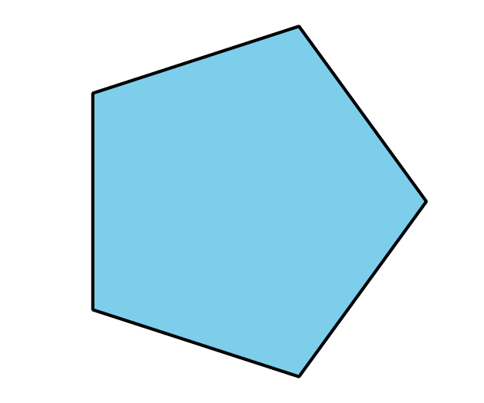
C
D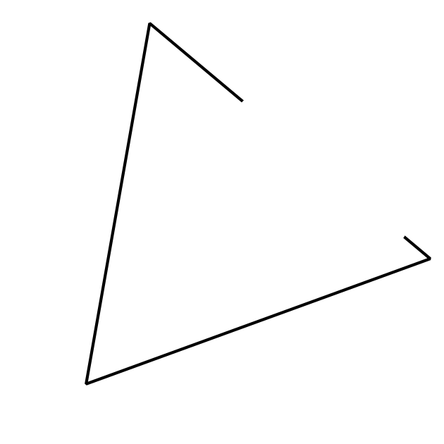

7.2: Sort Flat and Solid Shapes
_______________
_______________

7.3: Centers: Choice Time
Choose a center.
Counting Collections
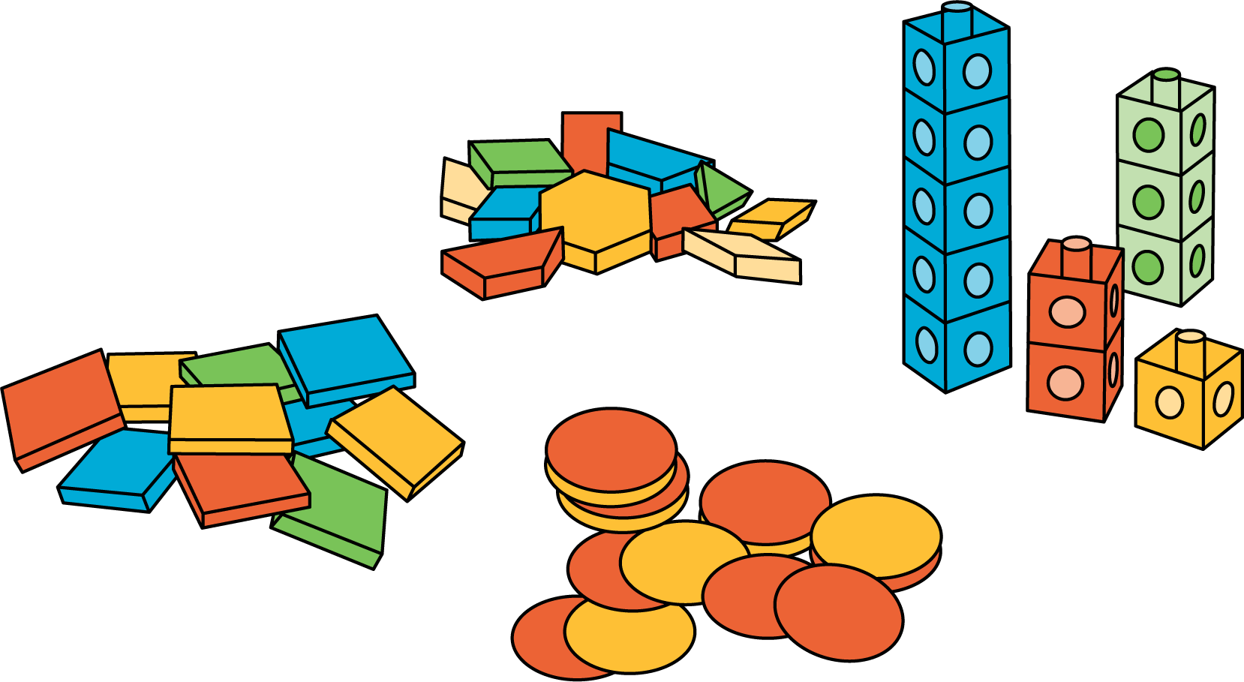
Match Mine
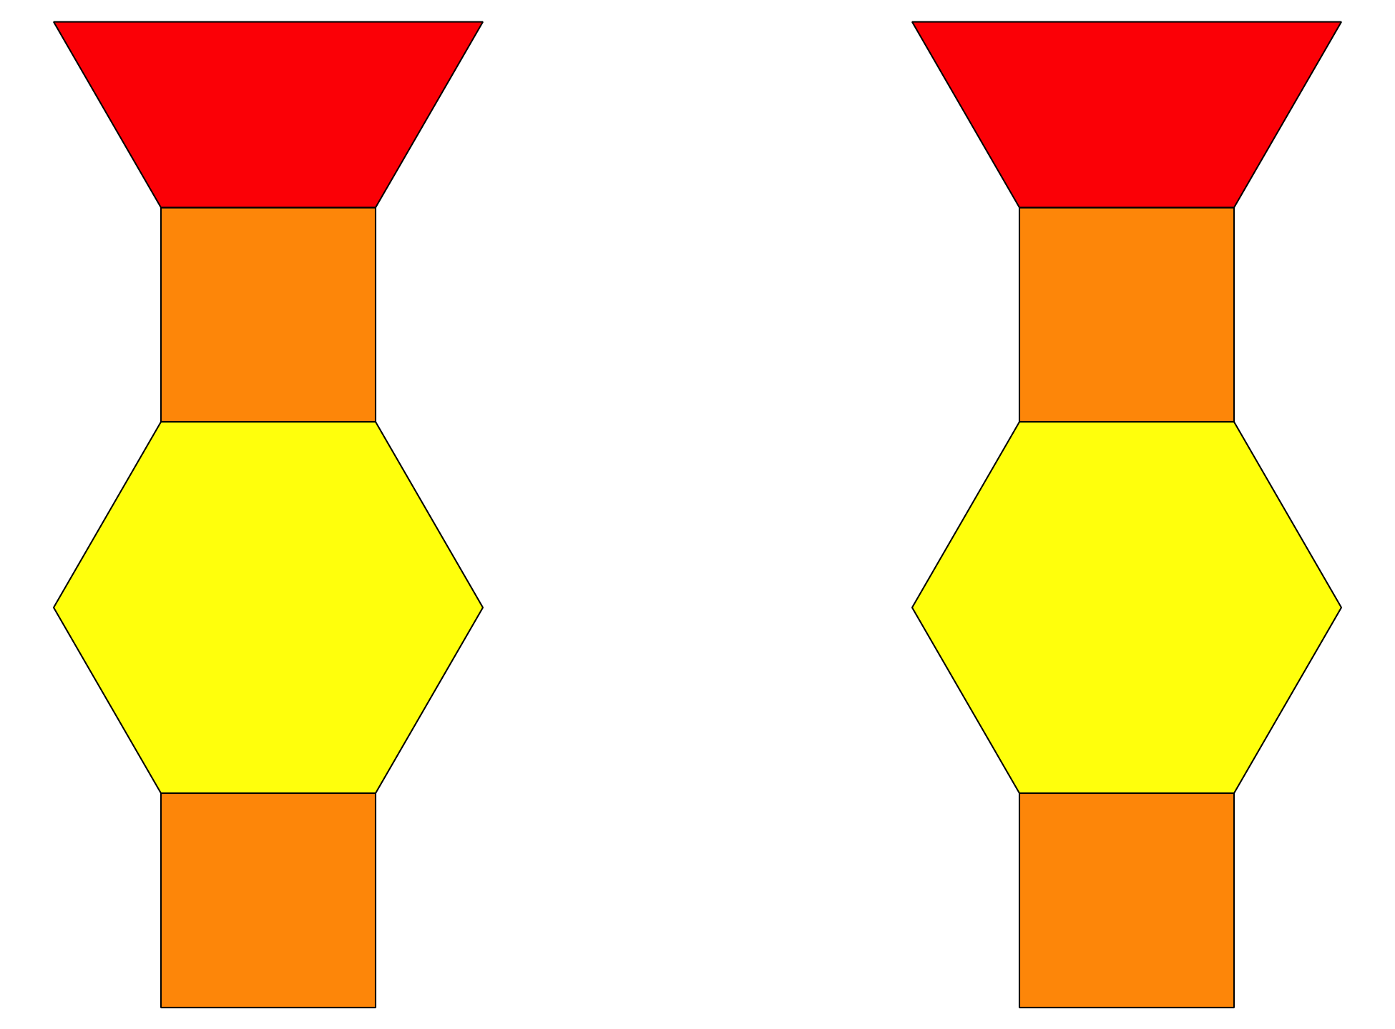
Shake and Spill
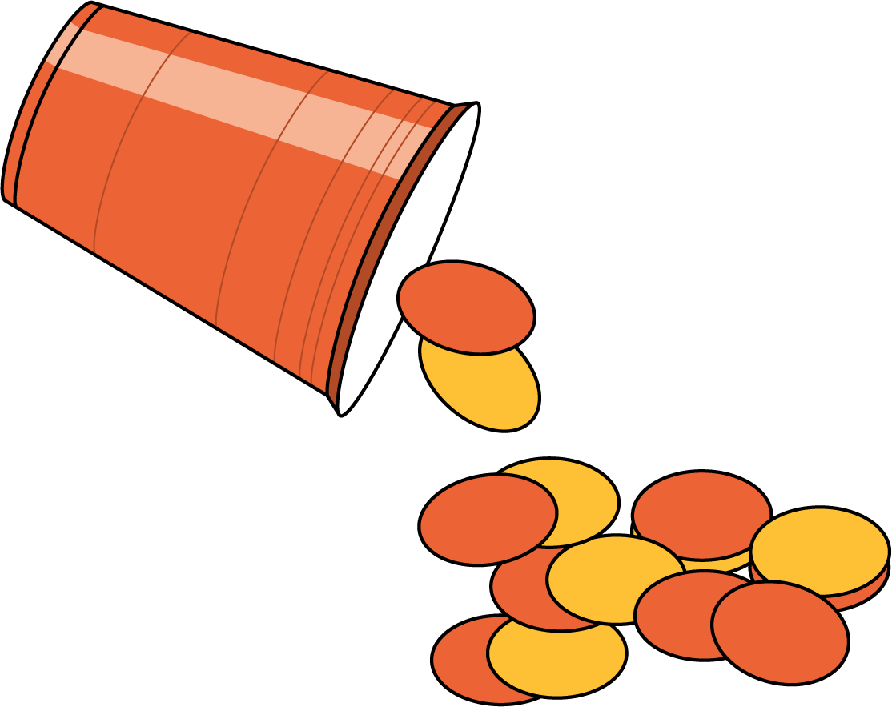
© CC BY 2021 Illustrative Mathematics®

