Lesson 15 Practice Problems
- A right cone has a base with diameter 10 units. The volume of the cone is $100π$ cubic units. What is the length of a segment drawn from the apex to the edge of the circular base?
- A right pyramid has a square base with sides of length 10 units. Each segment connecting the apex to a midpoint of a side of the base has length 13 units. What is the volume of the pyramid?
- For each pair of solids, determine if their volumes are the same or different. If the volumes are different, identify the solid with the greatest volume. Explain your reasoning.
  - A prism and a pyramid have the same height. The pyramid’s base has 3 times the area of the prism's base.
  - A pyramid and a cylinder have bases with the same area. The cylinder’s height is 3 times that of the pyramid.
  - A cone and a cylinder have the same height. The cone’s radius is 3 times the length of the cylinder’s radius.
- A pyramid has a height of 8 inches and a volume of 120 cubic inches. Determine 2 possible shapes, with dimensions, for the base.
- (From Unit 5, Lesson 14.)
- A toy company packages modeling clay in the shape of a rectangular prism with dimensions 6 inches by 1 inch by $\frac{1}{2}$ inch. They want to change the shape to a rectangular pyramid that uses the same amount of clay. Determine 2 sets of possible dimensions for the pyramid.
- (From Unit 5, Lesson 14.)
- These 3 congruent square pyramids can be assembled into a cube with side length 2 feet. What is the volume of each pyramid?
- 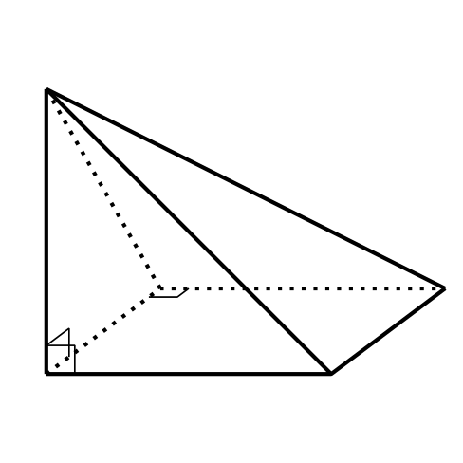
- (From Unit 5, Lesson 12.)
- A monster truck wheel has an area of $324π$ square inches. A toy company wants to create a scaled copy of the monster truck with a wheel area of $9π$ square inches. What scale factor should the company use?
- (From Unit 5, Lesson 7.)
© CC BY 2019 by Illustrative Mathematics®

