Unit 1 Lesson 16 Cumulative Practice Problems
- For each triangle, find the measure of the missing angle.
- 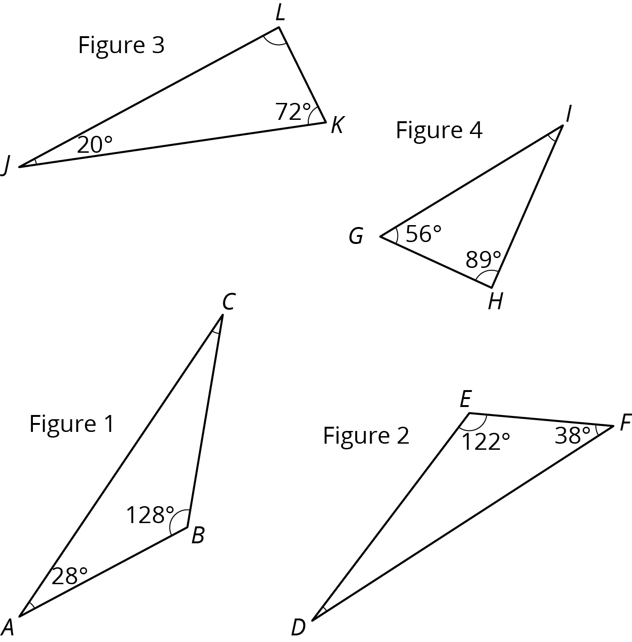
- Is there a triangle with two right angles? Explain your reasoning.
- In this diagram, lines $AB$ and $CD$ are parallel.
- 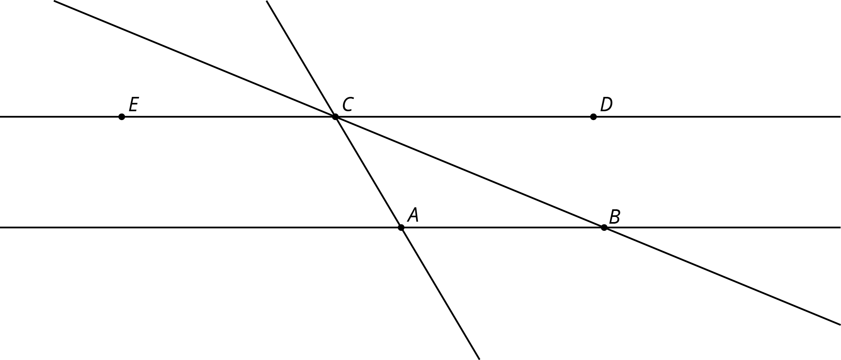
- Angle $ABC$ measures ${35}^{∘}$ and angle $BAC$ measures ${115}^{∘}$.
  - What is $m∠ACE$?
  - What is $m∠DCB$?
  - What is $m∠ACB$?
- Here is a diagram of triangle $DEF$.
  - Find the measures of angles $q$, $r$, and $s$.
  - Find the sum of the measures of angles $q$, $r$, and $s$.
  - What do you notice about these three angles?
- 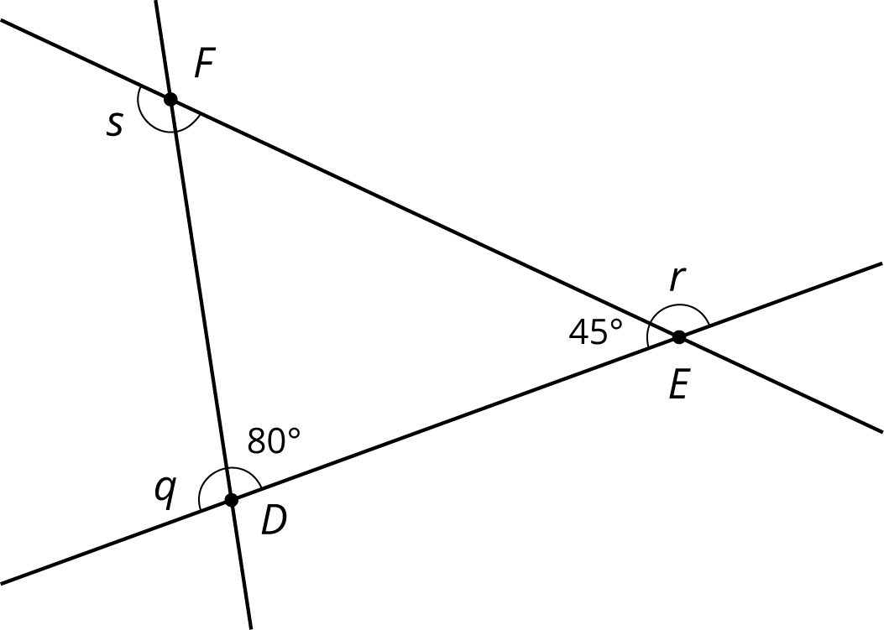
- The two figures are congruent.
  - Label the points $A^{′}$, $B^{′}$ and $C^{′}$ that correspond to $A$, $B$, and $C$ in the figure on the right.
  - 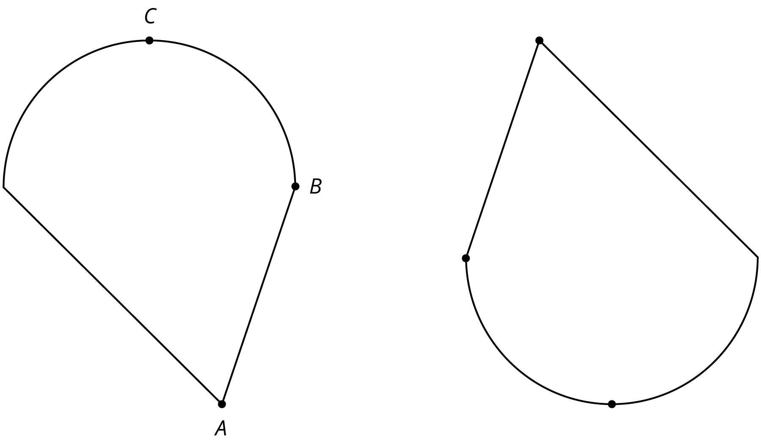
  - If segment $AB$ measures 2 cm, how long is segment $A^{′}B^{′}$? Explain.
  - The point $D$ is shown in addition to $A$ and $C$. How can you find the point $D^{′}$ that corresponds to $D$? Explain your reasoning.
  - 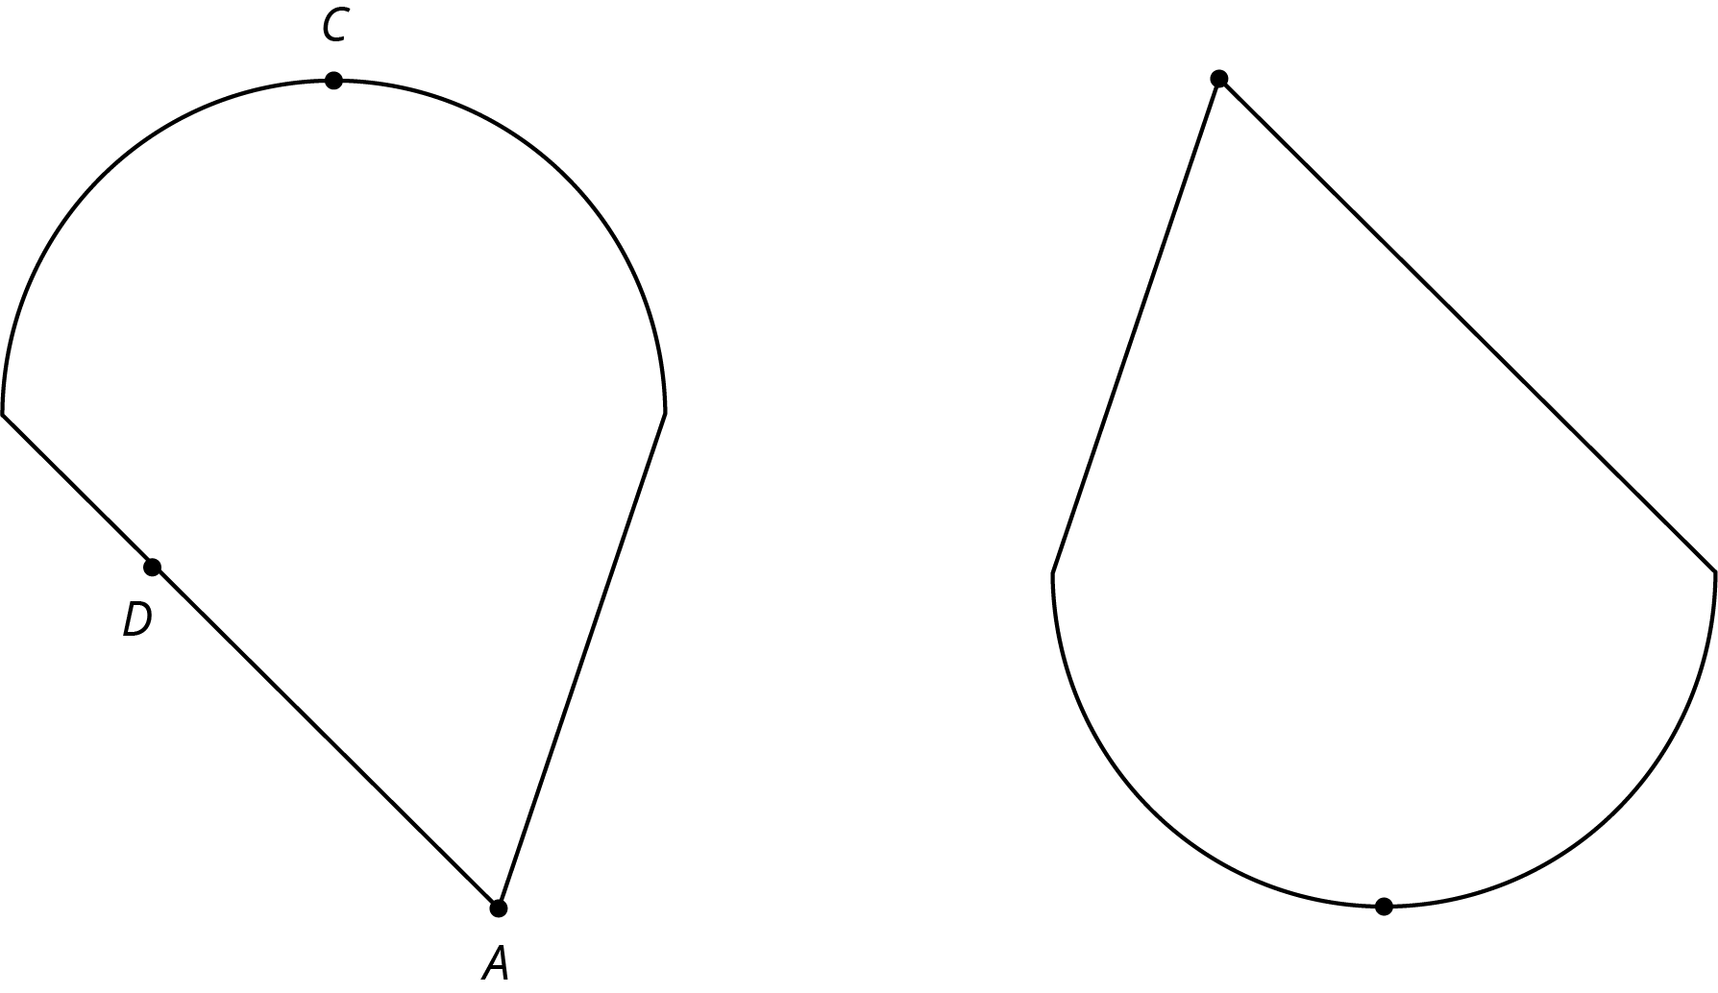
- (From Unit 1, Lesson 13.)
© CC BY Open Up Resources. Adaptations CC BY IM.

