Unit 8 Lesson 18: All the Ways to Make 10

WU Number Talk: Add and Subtract 1 (Warm up)

Student Task Statement
Find the value of each expression.
- $4+1$
- $5+1$
- $8−1$
- $7−1$

1 Ten Pigeons

Student Task Statement
- There are 6 pigeons in the fountain.
There are 4 pigeons on the bench.
How many pigeons are there?
- Show your thinking with objects, drawings, numbers, or words.
- There were 10 pigeons.
Some of the pigeons were in the fountain.
The rest of the pigeons were on the bench.
How many of the pigeons were in the fountain?
Then how many of the pigeons were on the bench?
- Show your thinking with objects, drawings, numbers, or words.

2 All of the Ways to Make 10

Student Task Statement
There were 10 pigeons.
Some of the pigeons were in the fountain.
The rest of the pigeons were on the bench.
How many of the pigeons were in the fountain?
Then how many of the pigeons were on the bench?
Show your thinking with objects, drawings, numbers, or words.

Activity Synthesis
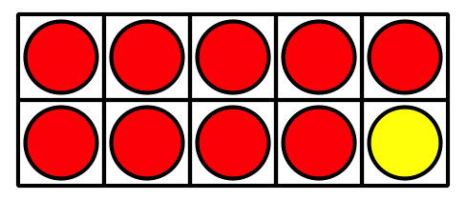
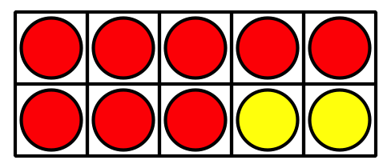

3 Centers: Choice Time

Student Task Statement
Choose a center.
Shake and Spill
Number Race
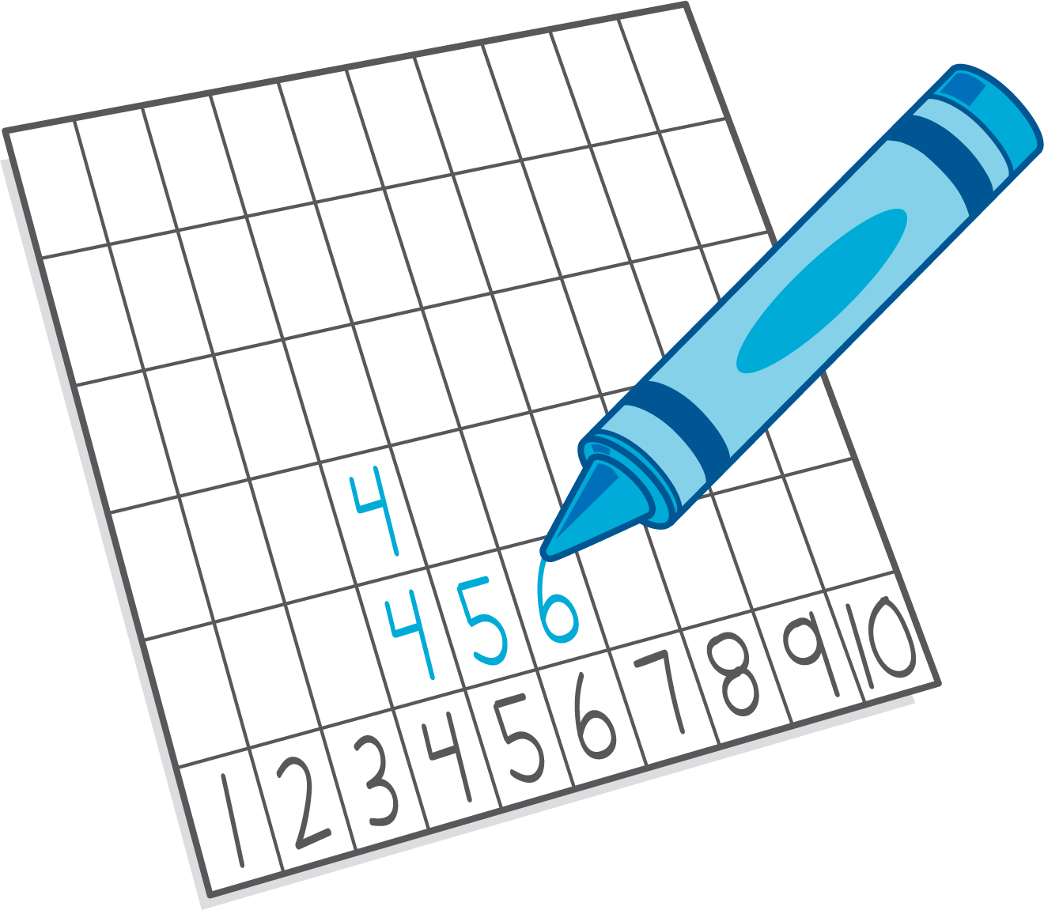
Grab and Count
What's Behind My Back?
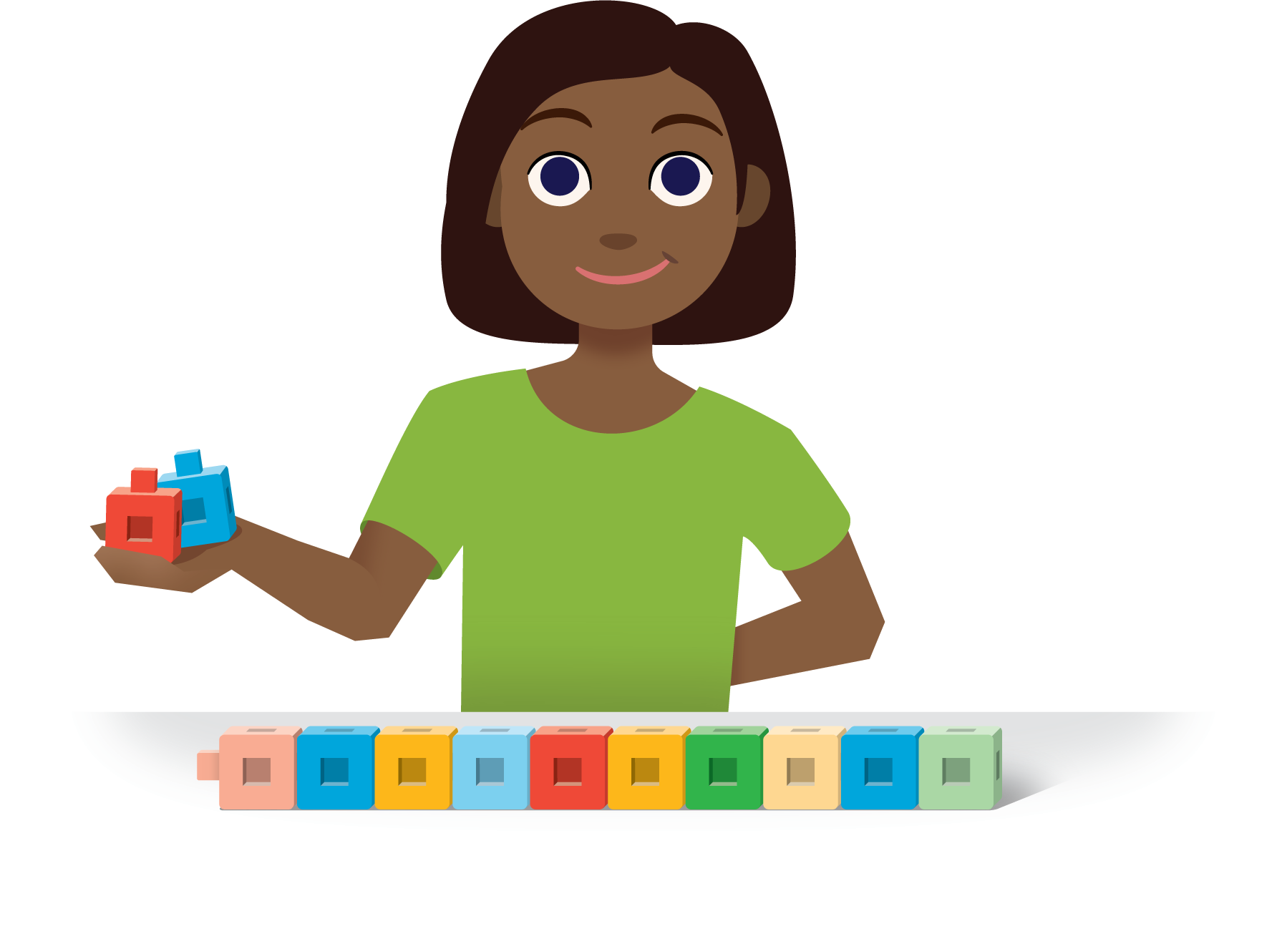
Pattern Blocks
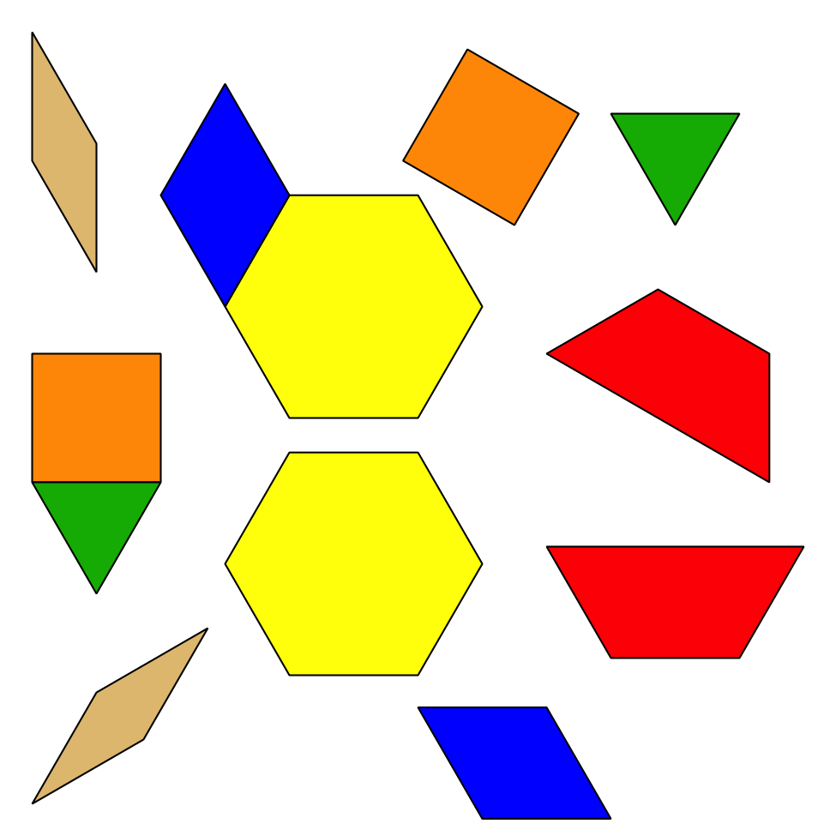
© CC BY 2021 Illustrative Mathematics®

