Unit 5 Lesson 2: How Did You Add?

WU Choral Count: Count Back From 70 (Warm up)

Student Task Statement

1 Find the Value

Student Task Statement
Find the value of $23+45$.
Show your thinking using drawings, numbers, or words.

2 Elena and Andre Represent $63+25$

Student Task Statement
- Here are 2 drawings students made for $63+25$.
- Elena's work
- 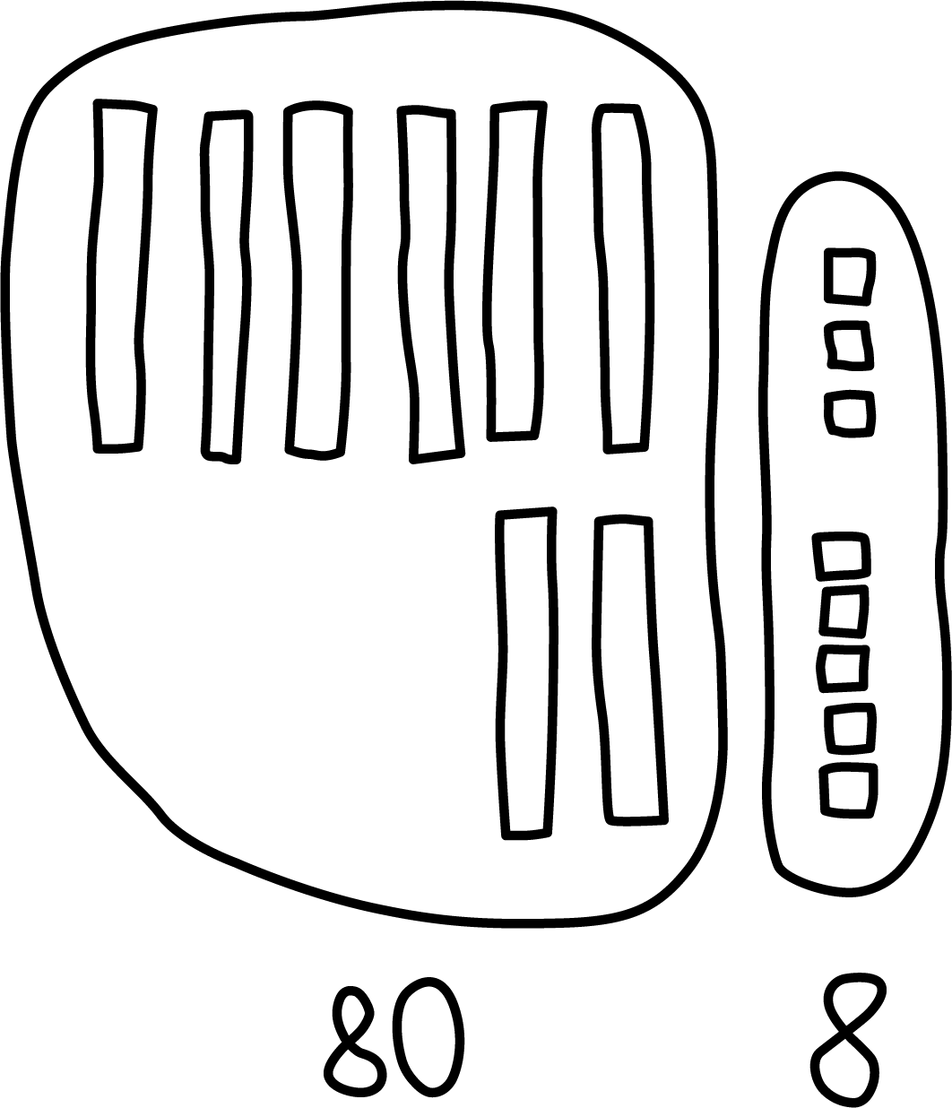
- Andre's work
- 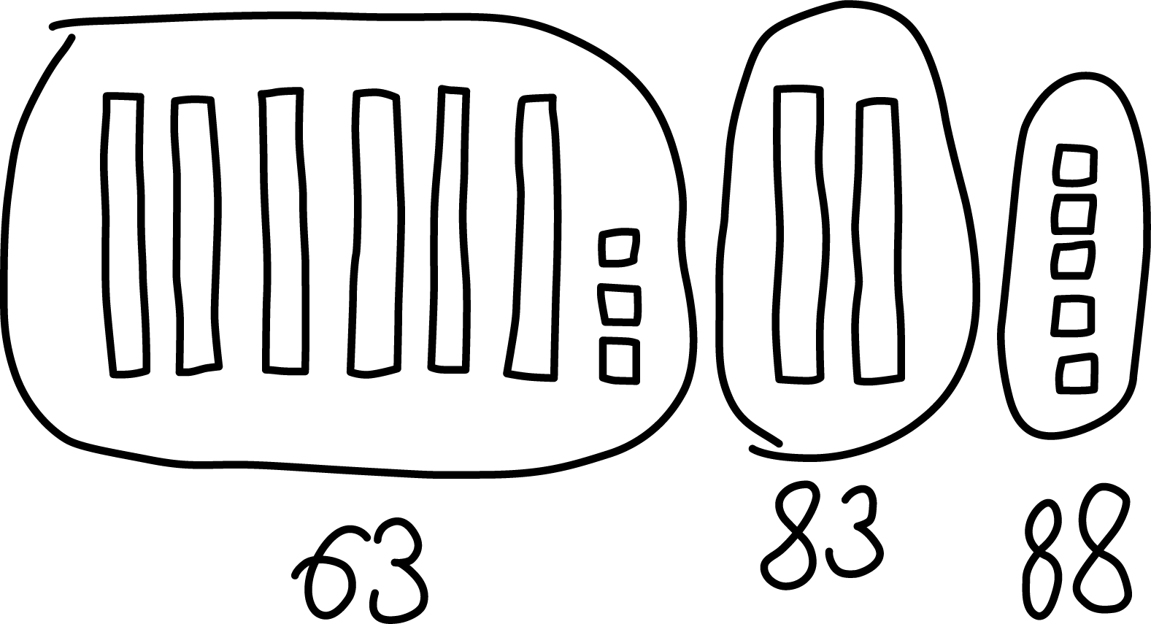
- Which equations go with which drawing?
Be ready to explain your thinking in a way others will understand.
- Set A
$63+20=83$
$83+5=88$
- Set B
$60+20=80$
$3+5=8$
$80+8=88$

3 Introduce Five in a Row, Add Within 100 without Composing

Student Task Statement
© CC BY 2021 Illustrative Mathematics®

