Lesson 15: Identify Pennies, Nickels, and Dimes
- Let’s learn about coins and their values.

Warm-up: What Do You Know About Money?
What do you know about money?

15.1: Show Me the Money
Name the coins in each group and find the value in cents. Show your thinking using numbers, words, drawings, or equations.
- Andre’s coins:
- 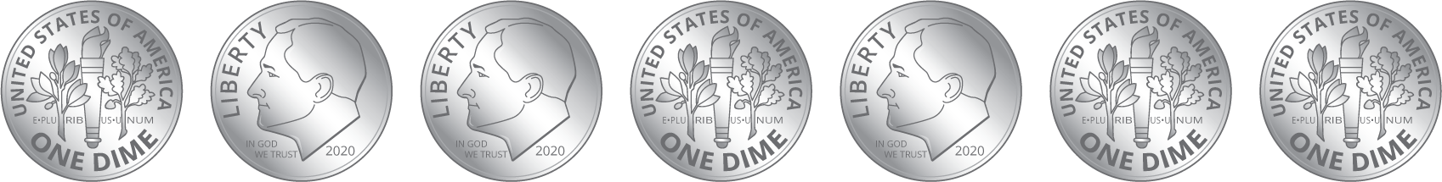
  - Circle the name of the coins in this collection:
  - dimes
  - nickels
  - pennies
  - What is the value of the coins?
- Clare’s coins:
- 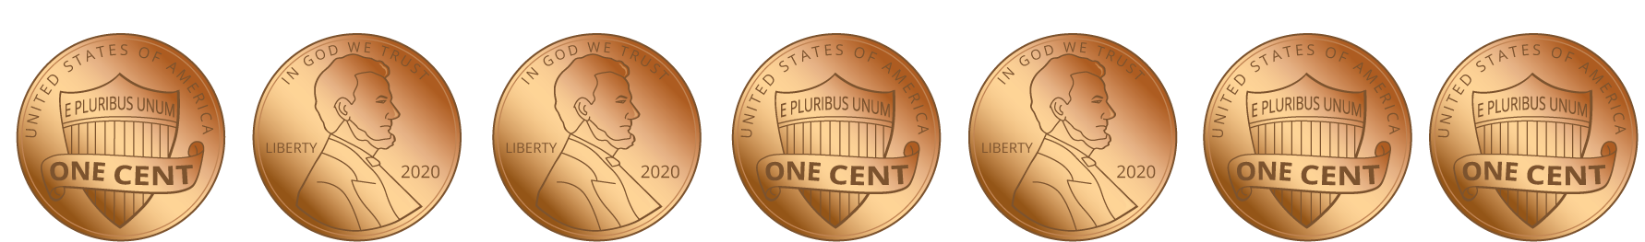
  - Circle the name of the coins in this collection:
  - dimes
  - nickels
  - pennies
  - What is the value of the coins?
- Han’s coins:
- 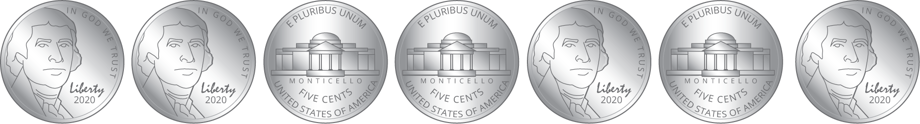
  - Circle the name of the coins in this collection:
  - dimes
  - nickels
  - pennies
  - What is the value of the coins?
- Show 2 different ways to make 10¢ using numbers, words, or drawings.

15.2: Compare Coins
Name the coins in each group and find the value in cents. Show your thinking using numbers, words, drawings, or equations.
- Mai’s coins:
- 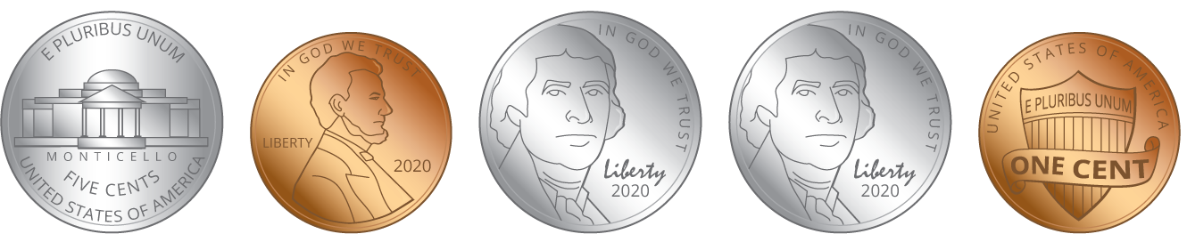
  - Circle the names of the coins in this collection:
  - dimes
  - nickels
  - pennies
  - What is the value of the coins?
- Andre’s coins:
- 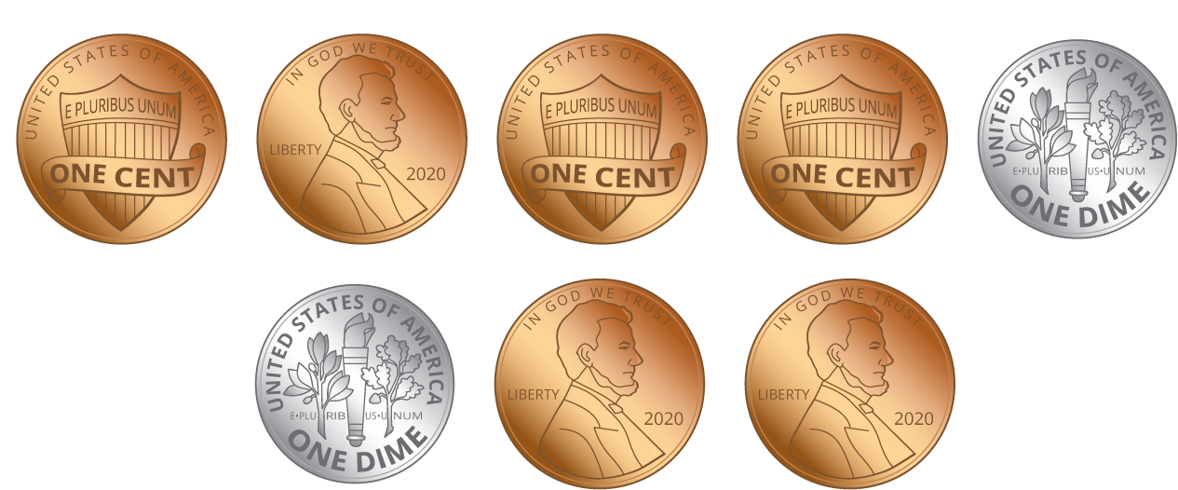
  - Circle the names of the coins in this collection:
  - dimes
  - nickels
  - pennies
  - What is the value of the coins?
- Clare’s coins:
- 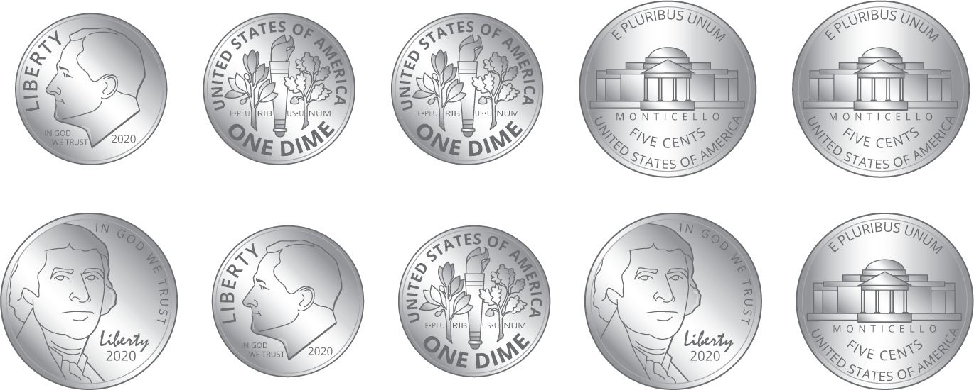
  - Circle the names of the coins in this collection:
  - dimes
  - nickels
  - pennies
  - What is the value of the coins?
- Priya’s coins:
- 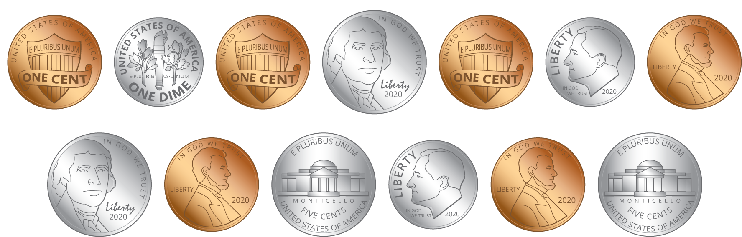
  - Circle the names of the coins in this collection:
  - dimes
  - nickels
  - pennies
  - What is the value of the coins?
- Compare your coin names and how you found the values with your partner.
- Whose group of coins has the least value?
- Who has the most coins? Does this group of coins have the greatest value? Explain.
© CC BY 2021 Illustrative Mathematics®

