Unit 8 Lesson 7: What is an Array?

WU Which One Doesn’t Belong: Counter Collections (Warm up)

Student Task Statement
Which one doesn’t belong?
A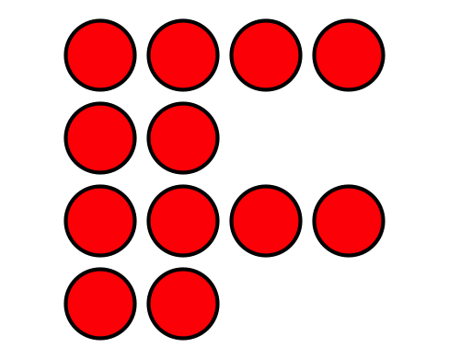
B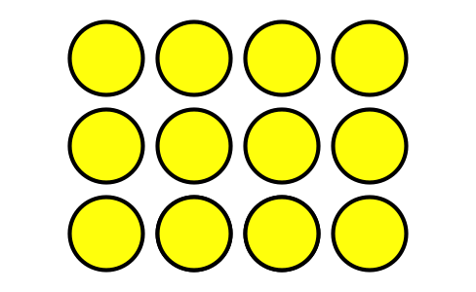
C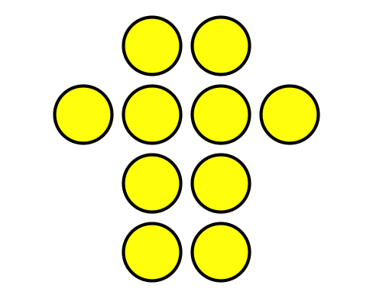
D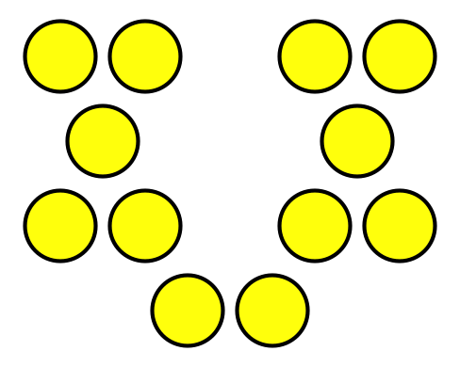

1 What is an Array?

Images for Launch

Student Task Statement
Arrange each set of counters into equal rows with no extra counters.
- How many counters are there in all? _____
- Show how you arranged them using words, drawings, or numbers.
- How many counters are there in all? _____
- Show how you arranged them using words, drawings, or numbers.
- How many counters are there in all? _____
- Show how you arranged them using words, drawings, or numbers.

Activity Synthesis

2 Rows of Counters

Images for Launch

Student Task Statement

- 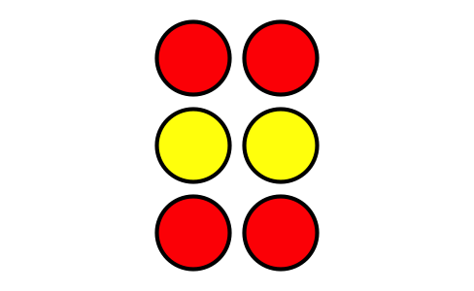
  - How many rows are in this array?
  - How many counters are in each row?
  - How many counters are there in all?

  - How many rows are in this array?
  - How many counters are in each row?
  - How many counters are there in all?
- Use 6 counters to make 2 rows with the same number in each row. How many counters are in each row?
- Use 20 counters to make 4 rows with the same number in each row. How many counters are in each row?

Images for Activity Synthesis
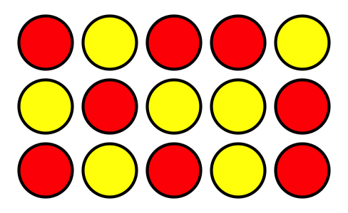
© CC BY 2021 Illustrative Mathematics®

