Lesson 9: Equal Pieces
- Let’s split shapes into equal-size pieces.

Warm-up: Which One Doesn’t Belong: Pieces of Shapes
Which one doesn’t belong?
A
B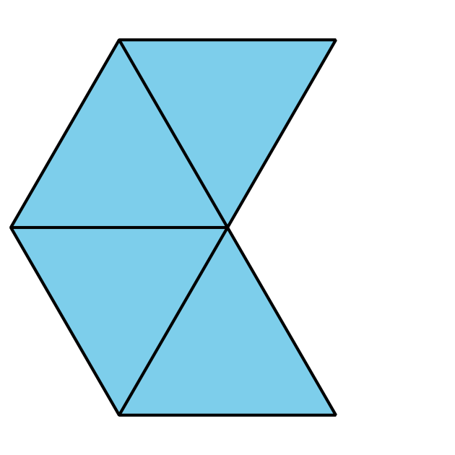
C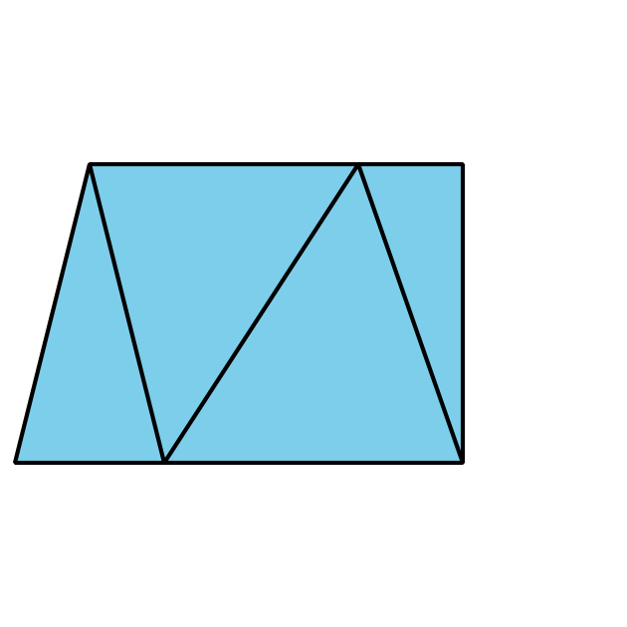
D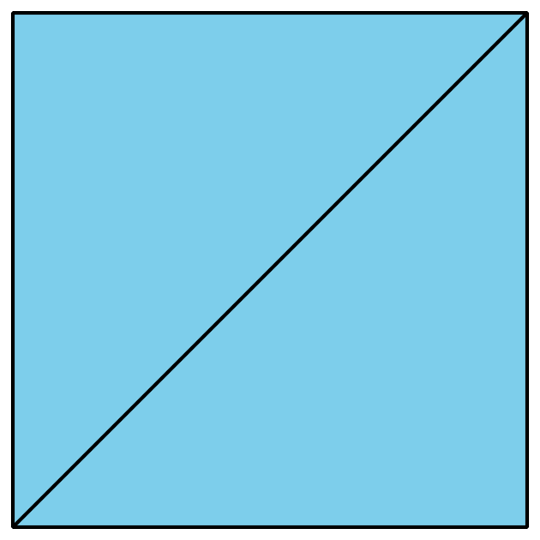

9.1: Build a Circle
Synthesis:
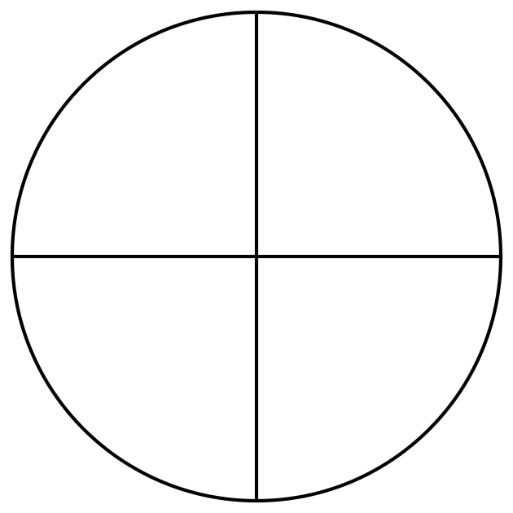
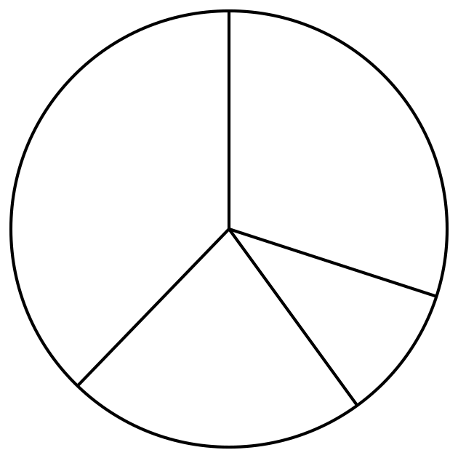
Which of these shows equal pieces that make a circle?

9.2: Fold into Equal Pieces
- Cut out one circle and one square.
- Fold each shape so that there are 2 equal pieces.
- Be ready to explain how you know your shape has 2 equal pieces.
- Cut out one circle and one square.
- Fold each shape so that there are 4 equal pieces.
- Be ready to explain how you know your shape has 4 equal pieces.
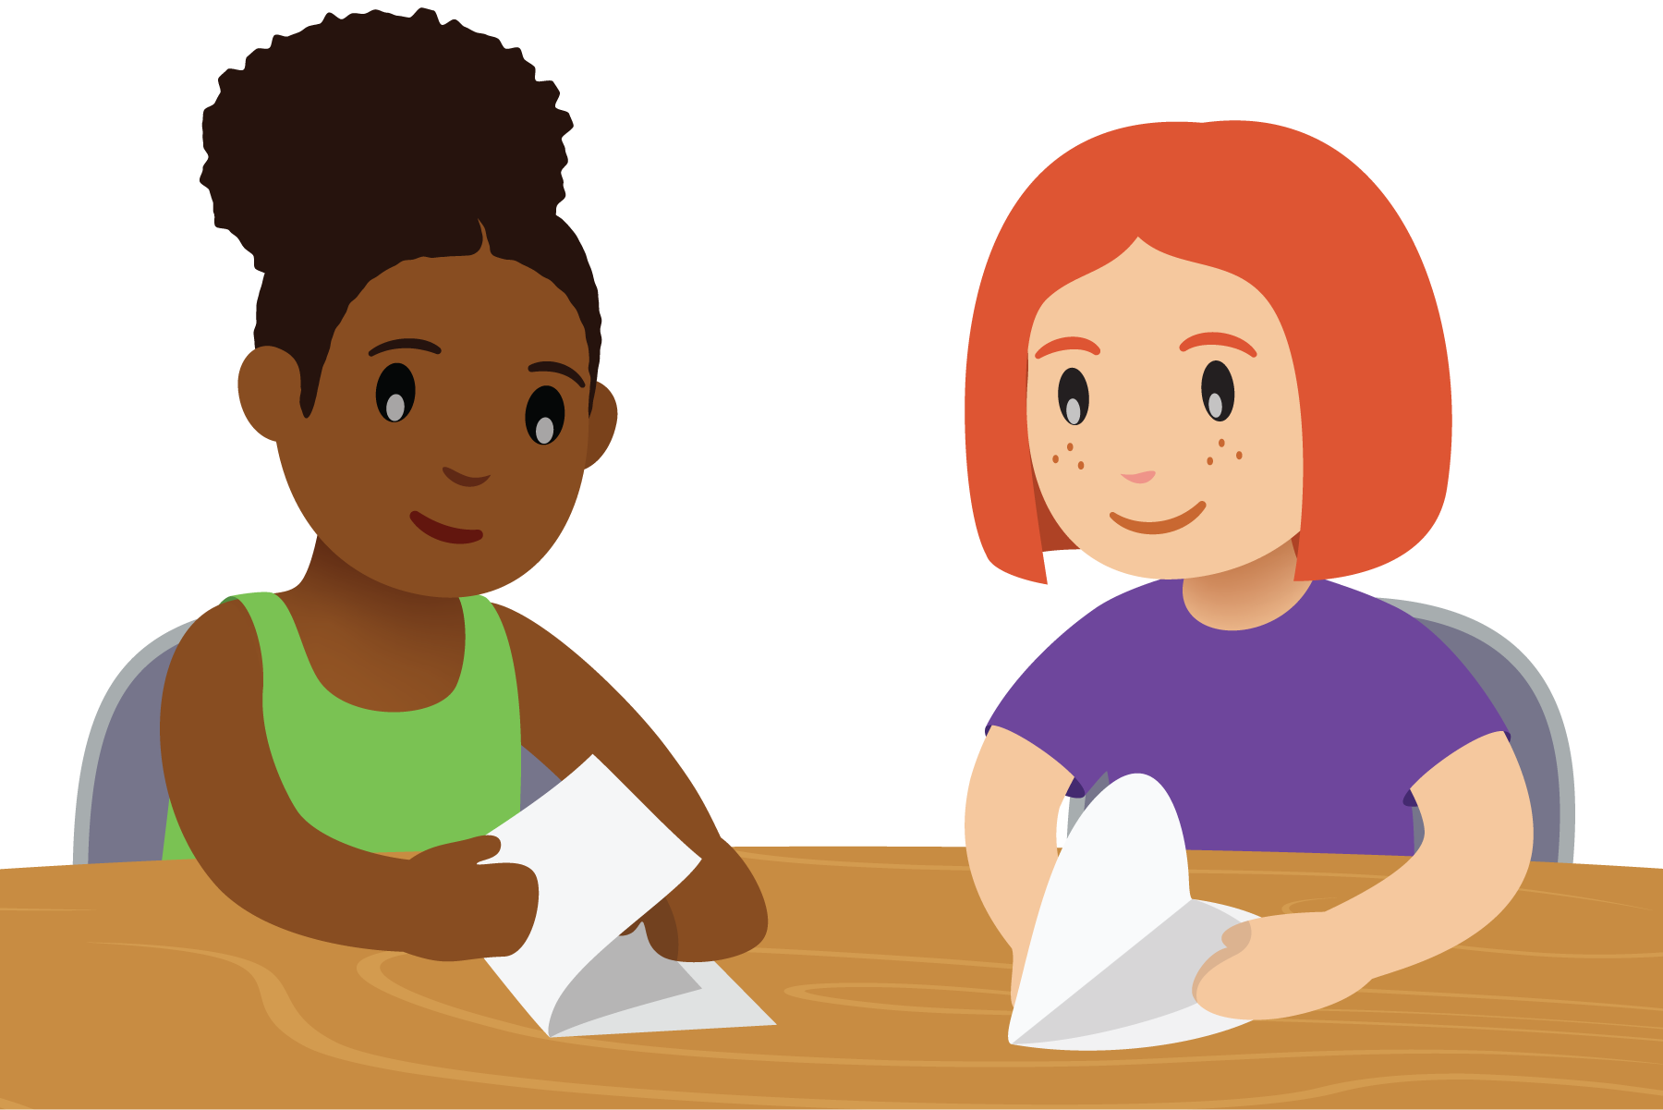

9.3: Halves or Fourths
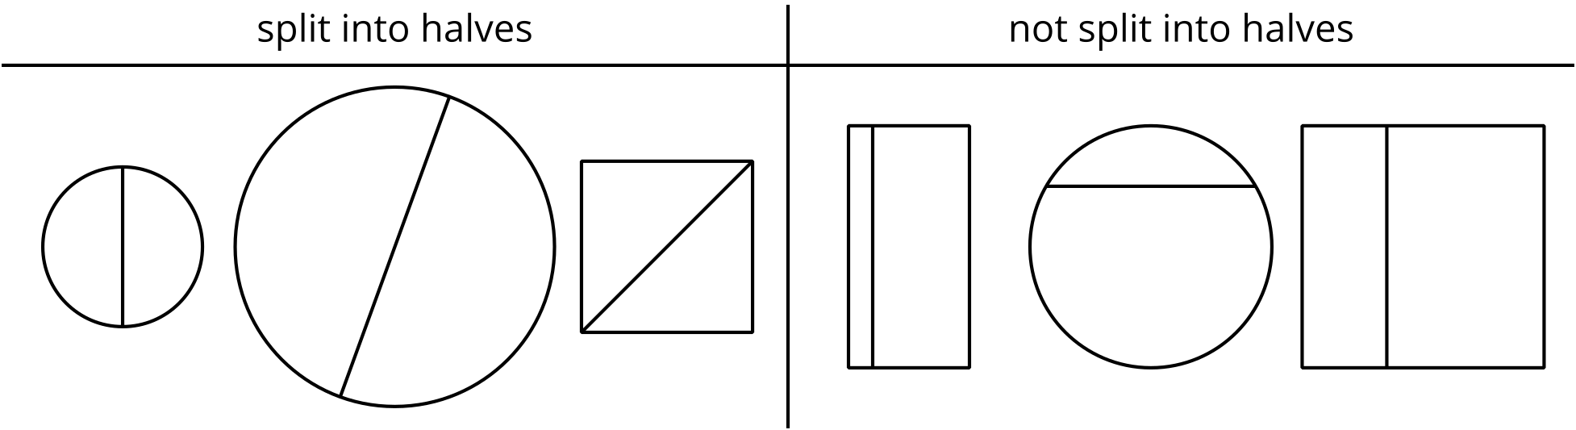
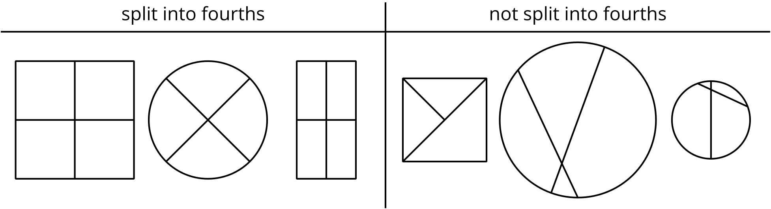

- Split each shape into halves.
- Split each shape into fourths.
- Split each shape into fourths.
- Split each shape into halves.
- Split each shape into halves.
- Split each shape into fourths.
© CC BY 2021 Illustrative Mathematics®

