Lesson 8: Percentage Situations
Let's find unknown percentages.

8.1: Tax, Tip, and Discount
What percentage of the car price is the tax?
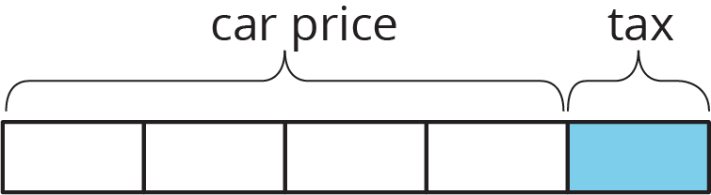
What percentage of the food cost is the tip?
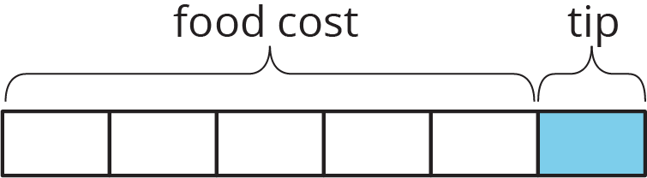
What percentage of the shirt cost is the discount?
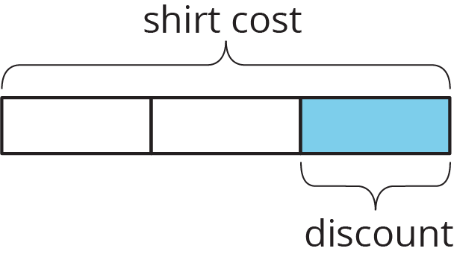

8.2: A Car Dealership
A car dealership pays a wholesale price of $12,000 to purchase a vehicle.
- The car dealership wants to make a 32% profit.
  - By how much will they mark up the price of the vehicle?
  - After the markup, what is the retail price of the vehicle?
- During a special sales event, the dealership offers a 10% discount off of the retail price. After the discount, how much will a customer pay for this vehicle?

Are you ready for more?
This car dealership pays the salesperson a bonus for selling the car equal to 6.5% of the sale price. How much commission did the salesperson lose when they decided to offer a 10% discount on the price of the car?

8.3: Commission at a Gym
- For each gym membership sold, the gym keeps $42 and the employee who sold it gets $8. What is the commission the employee earned as a percentage of the total cost of the gym membership?
- If an employee sells a family pass for $135, what is the amount of the commission they get to keep?

8.4: Info Gap: Sporting Goods
Your teacher will give you either a problem card or a data card. Do not show or read your card to your partner.
If your teacher gives you the problem card:
- Silently read your card and think about what information you need to be able to answer the question.
- Ask your partner for the specific information that you need.
- Explain how you are using the information to solve the problem.
- Continue to ask questions until you have enough information to solve the problem.
- Share the problem card and solve the problem independently.
- Read the data card and discuss your reasoning.
If your teacher gives you the data card:
- Silently read your card.
- Ask your partner “What specific information do you need?” and wait for them to ask for information.
- If your partner asks for information that is not on the card, do not do the calculations for them. Tell them you don’t have that information.
- Before sharing the information, ask “Why do you need that information?” Listen to your partner’s reasoning and ask clarifying questions.
- Read the problem card and solve the problem independently.
- Share the data card and discuss your reasoning.
Pause here so your teacher can review your work. Ask your teacher for a new set of cards and repeat the activity, trading roles with your partner.

8.5: Card Sort: Percentage Situations
Your teacher will give you a set of cards. Take turns with your partner matching a situation with a descriptor. For each match, explain your reasoning to your partner. If you disagree, work to reach an agreement.

Lesson 8 Summary
There are many everyday situations in which a percentage of an amount of money is added to or subtracted from that amount, in order to be paid to some other person or organization:
 | goes to | how it works
sales tax | the government | added to the price of the item
gratuity (tip) | the server | added to the cost of the meal
interest | the lender (or account holder) | added to the balance of the loan, credit card, or bank account
markup | the seller | added to the price of an item so the seller can make a profit
markdown (discount) | the customer | subtracted from the price of an item to encourage the customer to buy it
commission | the salesperson | subtracted from the payment that is collected
For example, if a restaurant bill is $34 and the customer pays $40, they left 6 dollars as a tip for the server. That is 18% of $34, so they left an 18% tip. From the customer's perspective, we can think of this as an 18% increase of the restaurant bill. If we know the initial amount and the final amount, we can also find the percent increase or percent decrease. For example, a plant was 12 inches tall and grew to be 15 inches tall. What percent increase is this? Here are two ways to solve this problem:
The plant grew 3 inches, because $15−12=3$. We can divide this growth by the original height, $3÷12=0.25$. So the height of the plant increased by 25%.
The plant's new height is 125% of the original height, because $15÷12=1.25$. This means the height increased by 25%, because $1.25−1=0.25$.
Here are two ways to solve the problem: A rope was 2.4 meters long. Someone cut it down to 1.9 meters. What percent decrease is this?
The rope is now $2.4−1.9$, or 0.5 meters shorter. We can divide this decrease by the original length, $0.5÷2.4=0.208\overset{¯}{3}$. So the length of the rope decreased by approximately 20.8%.
The rope's new length is about 79.2% of the original length, because $1.9÷2.4=0.791\overset{¯}{6}$. The length decreased by approximately 20.8%, because $1−0.792=0.208$.
© CC BY Open Up Resources. Adaptations CC BY IM.

