Lesson 1: Midamos en mitades de pulgada

Standards Alignments
Addressing | 3.MD.B.4
Building Towards | 3.MD.B.4

Teacher-facing Learning Goals
- Measure lengths using a ruler marked with halves of an inch.

Student-facing Learning Goals
- Midamos la longitud de algunos objetos del salón.

Lesson Purpose
The purpose of this lesson is for students to measure lengths that are fractions of an inch and relate these measurements to fractions on a number line.
In grade 2, students learned how to measure lengths to the nearest inch. They also learned how to represent fractions on the number line in the previous unit.
In this lesson, students start by measuring the length of objects using an inch ruler. As students find objects whose length is not a whole number of inches, they consider how to partition the inches to get a more precise measurement. Students then partition a ruler to show halves of an inch and use the ruler to measure lengths to the nearest half of an inch. The lesson synthesis introduces students to mixed numbers as numbers that combine whole numbers and fractions less than 1.
Students use the rulers they make in this lesson again in future lessons.

Access for:

Students with Disabilities
- Engagement (Activity 1)

English Learners
- MLR2 (Activity 2)

Instructional Routines
What Do You Know About _____? (Warm-up)

Materials to Gather
- Materials from a previous activity: Activity 2

Materials to Copy
- Measure Around the Room (groups of 5): Activity 1

Lesson Timeline
Warm-up | 10 min
Activity 1 | 15 min
Activity 2 | 20 min
Lesson Synthesis | 10 min
Cool-down | 5 min

Teacher Reflection Question
In the last unit, students learned how to represent fractions on diagrams and number lines. In what ways did you see students applying that experience here?

Cool-down
(to be completed at the end of the lesson) 5min
Longitud en mitades de pulgada

Standards Alignments
Addressing | 3.MD.B.4

Student-facing Task Statement
¿Cuál es la longitud del rectángulo?
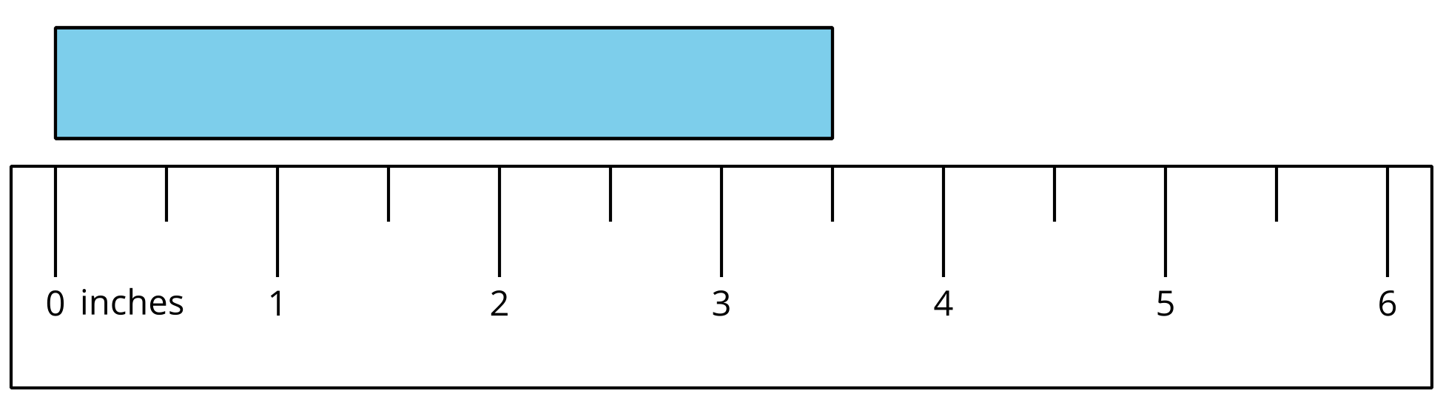

Student Responses
$\frac{7}{2}$ inches or $3\frac{1}{2}$ inches

