Lesson 1 Practice Problems
- When rectangle $ABCD$ is reflected across line $EF$, the image is $DCBA$. How do you know that segment $AB$ is congruent to segment $DC$?
  - A rectangle has 2 pairs of parallel sides.
  - Any 2 sides of a rectangle are congruent.
  - Congruent parts of congruent figures are corresponding.
  - Corresponding parts of congruent figures are congruent.
- Triangle $FGH$ is the image of isosceles triangle $FEH$ after a reflection across line $HF$. Select all the statements that are a result of corresponding parts of congruent triangles being congruent.

- $\overline{FE}≅\overline{HE}$
  - $EFGH$ is a rectangle.
  - $EFGH$ has 4 congruent sides.
  - Diagonal $FH$ bisects angles $EFG$ and $EHG$.
  - Diagonal $FH$ is perpendicular to side $FE$.
  - Angle $FEH$ is congruent to angle $FGH$.
- Reflect right triangle $ABC$ across line $BC$. Classify triangle $ACA^{′}$ according to its side lengths. Explain how you know.
- Triangles $FAD$ and $DCE$ are translations of triangle $ABC$
- 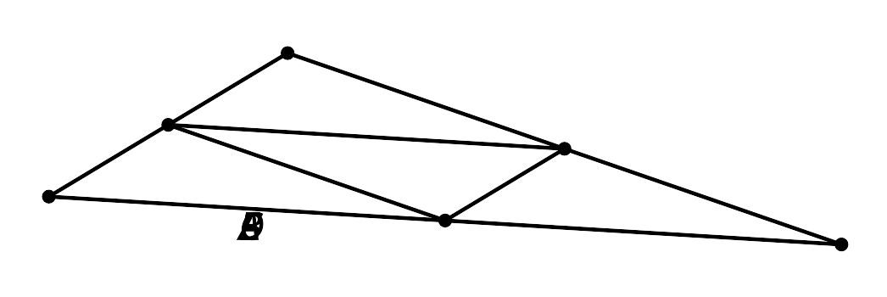
- Select all the statements that must be true.
  - Points $B$, $A$, and $F$ are collinear.
  - The measure of angle $BCA$ is the same as the measure of angle $CED$.
  - Line $AD$ is parallel to line $BC$.
  - The measure of angle $CED$ is the same as the measure of angle $FAD$.
  - The measure of angle $DAC$ is the same as the measure of angle $BCA$.
  - Triangle $ADC$ is a reflection of triangle $FAD$.
- (From Unit 1, Lesson 21.)
- Triangle $ABC$ is congruent to triangles $BAD$ and $CEA$.
- 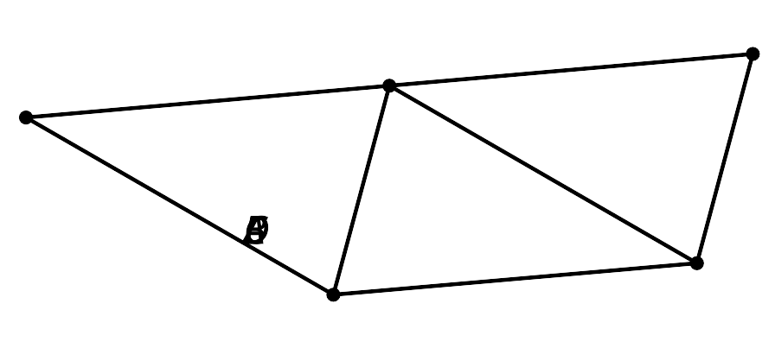
  - Explain why points $D$, $A$, and $E$ are collinear.
  - Explain why line $DE$ is parallel to line $BC$.
- (From Unit 1, Lesson 21.)
  - Identify a figure that is the result of a rigid transformation of quadrilateral $ABCD$.
  - Describe a rigid transformation that would take $ABCD$ to that figure.
- (From Unit 1, Lesson 18.)
© CC BY 2019 by Illustrative Mathematics®

