Lesson 8: Compare Weight
- Let’s figure out which object is heavier and which is lighter.

Warm-up: Notice and Wonder: Seesaw
What do you notice?
What do you wonder?
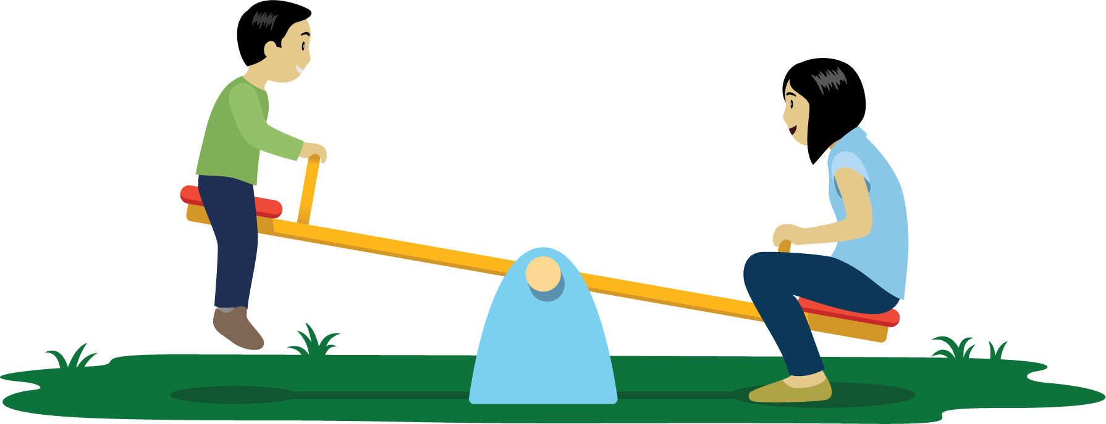

8.2: Compare Weights
Choose 2 objects.
Figure out which object is heavier and which is lighter.
Draw a picture of each object.
Circle the object that is heavier.
____________________
____________________
____________________
____________________
____________________
____________________
____________________
____________________

8.3: Centers: Choice Time
Choose a center.
Counting Collections
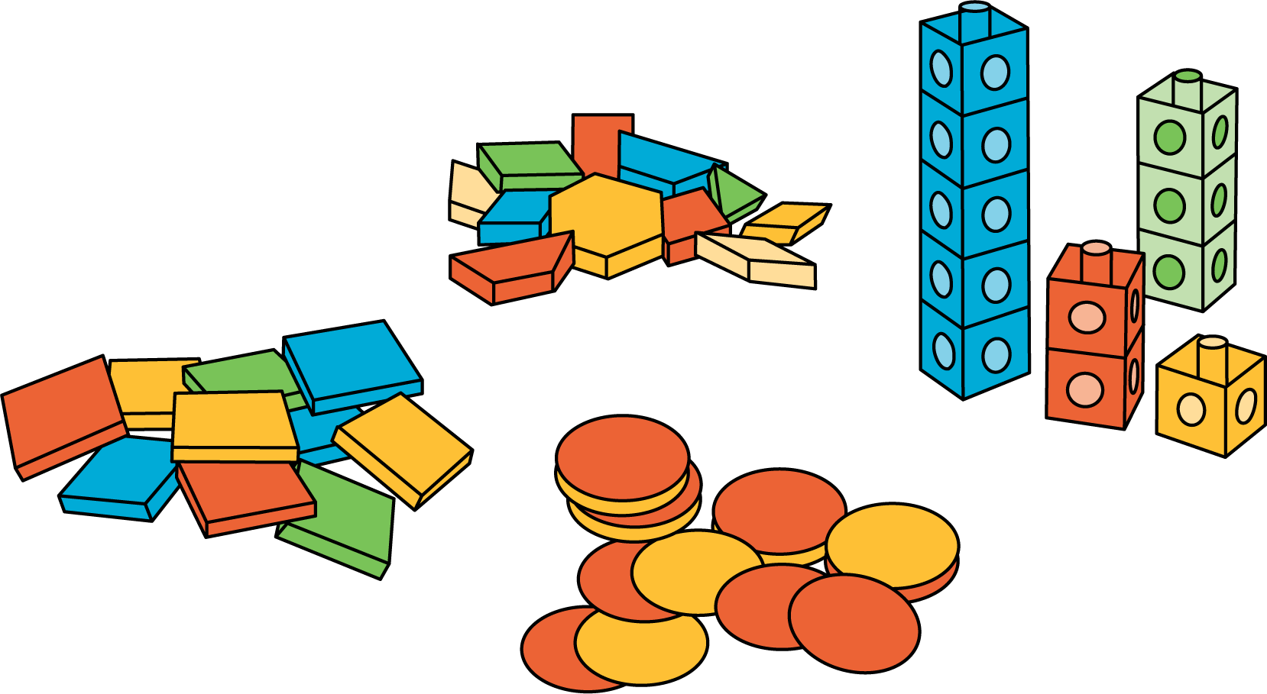
Match Mine
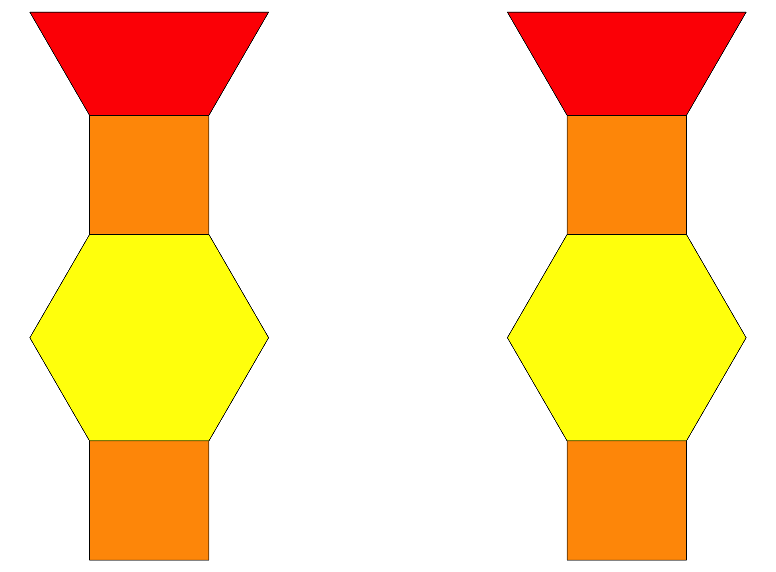
Shake and Spill
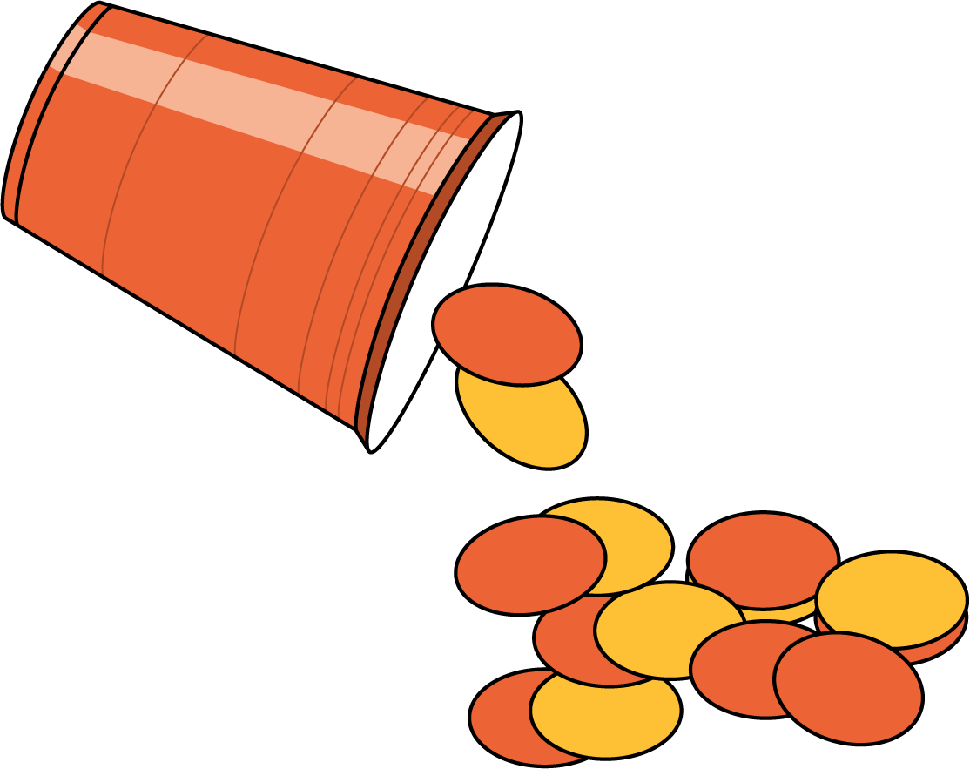
© CC BY 2021 Illustrative Mathematics®

