Unit 1 Lesson 1: Add and Subtract Within 10

WU What Do You Know About Math? (Warm up)

Student Task Statement
What do you know about math?

1 Check It Off: Add or Subtract within 10

Student Task Statement
- Pick 2 cards and find the value of the sum or difference.
- Check off the number you found and write the expression.
- The person who checks off the most numbers wins.
 | Found it! | Expression
0
1
2
3
4
5
6
7
8
9
10

2 What’s the Value?

Student Task Statement
- Match each expression to the value of the sum or difference.
  - $5+3$
  - $3−1$
  - $10−1$
  - $4+5$
  - $6+3$
  - $6−5$
  - $1+6$
  - $9−5$
  - $8−5$
  - $3+6$
  - 9
  - 3
  - 8
  - 7
  - 1
  - 4
  - 2
- Circle all the addition expressions that have a value of 10.
- 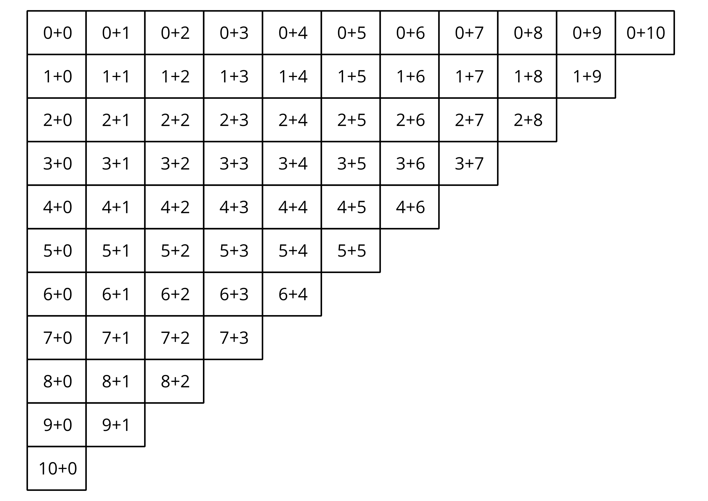
- What patterns do you see in the numbers in the expressions that have a value of 10?
© CC BY 2021 Illustrative Mathematics®

