Lesson 16: Identify Quarters
- Let’s learn about quarters and find the value of different sets of coins.

16.1: How Much is a Quarter Worth?
Write the names and values of the coins you know.
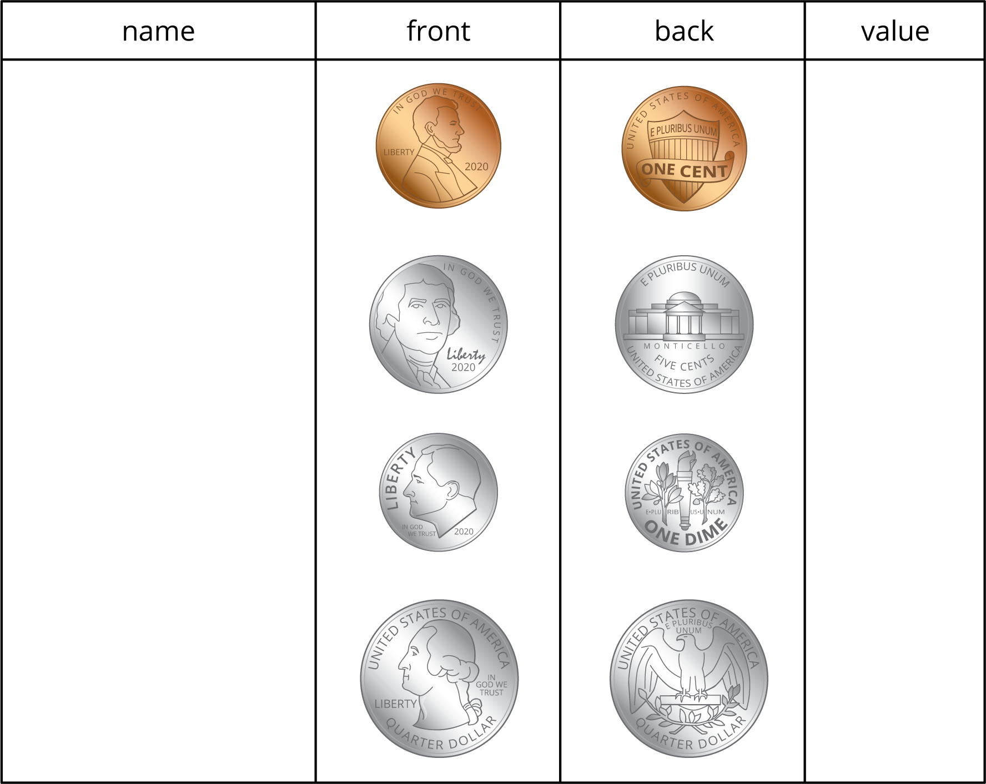
Complete the table so each row shows a value in cents and two different groups of coins that have that value.
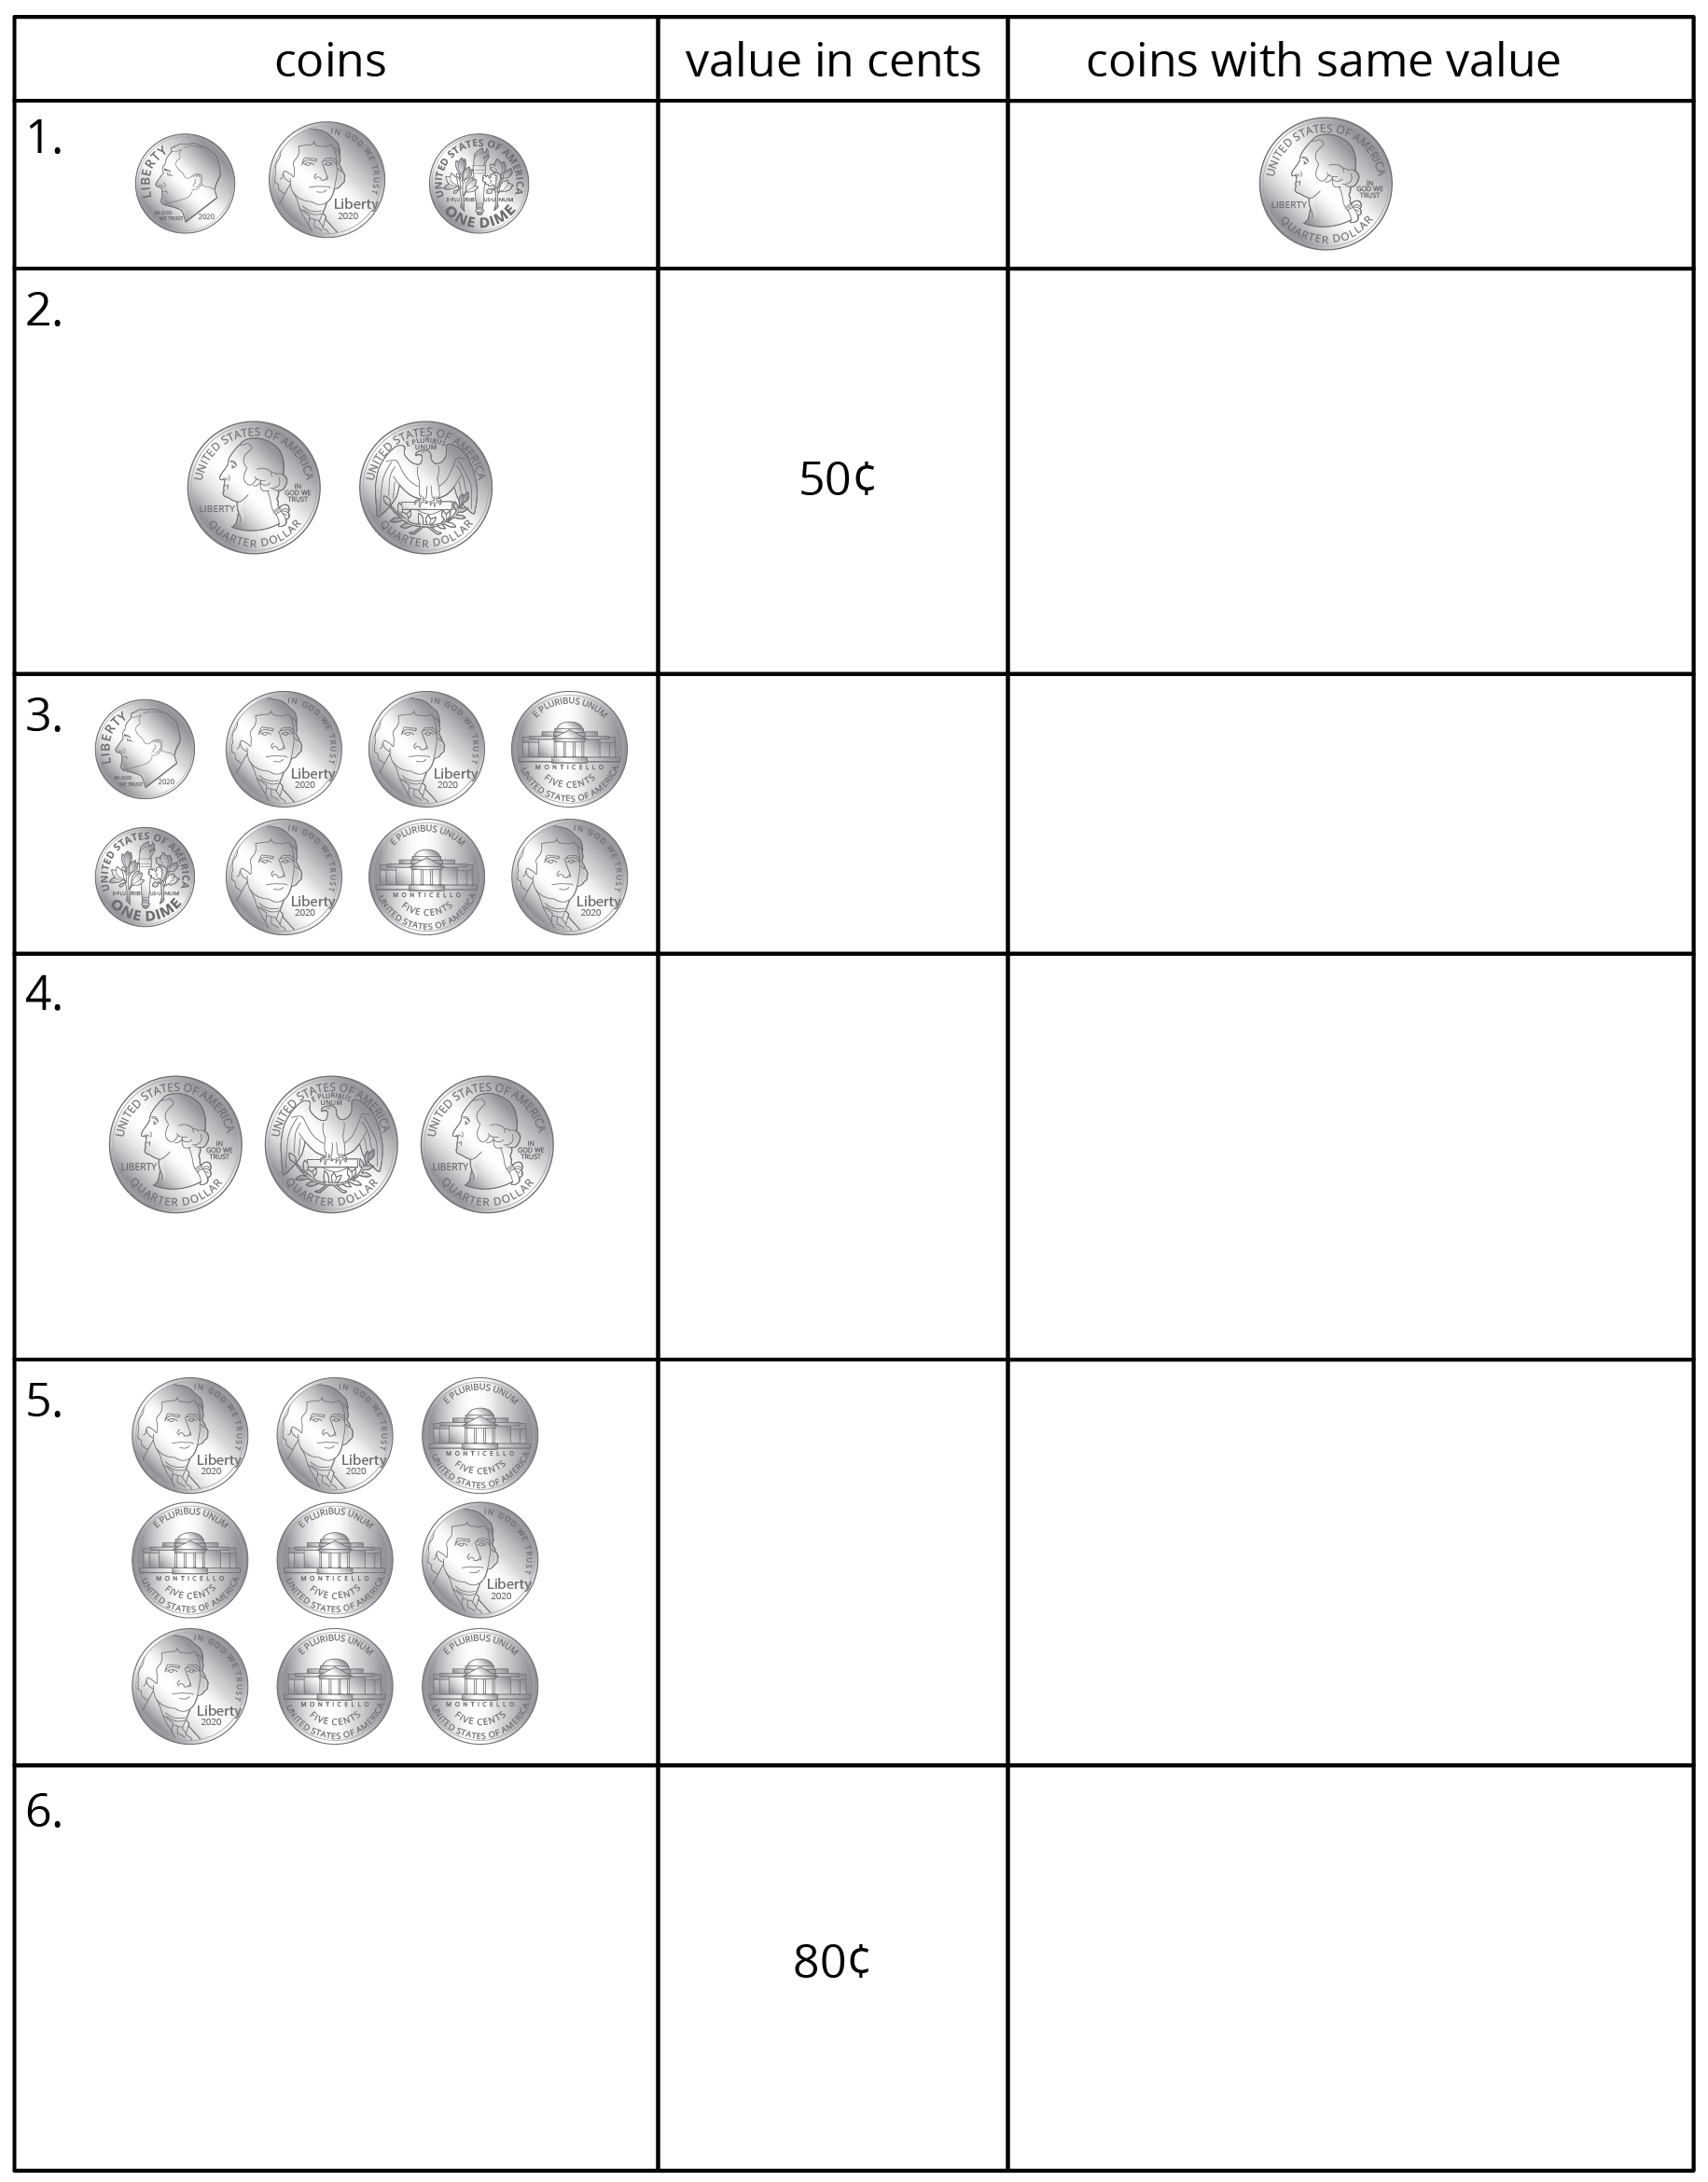

16.2: More Coins to Compare
- Elena's Coins
- 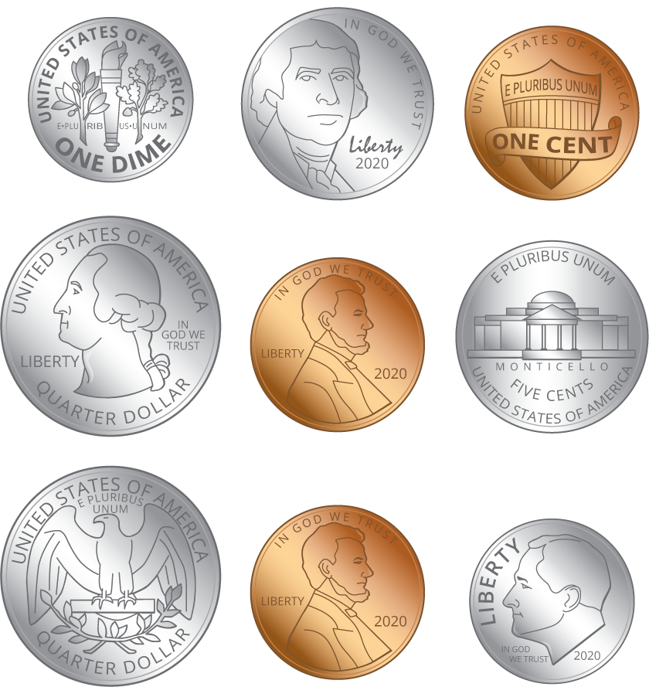
- Elena has:
- quarters
- dimes
- nickels
- pennies
- How many cents? Show your thinking.
- Tyler's Coins
- 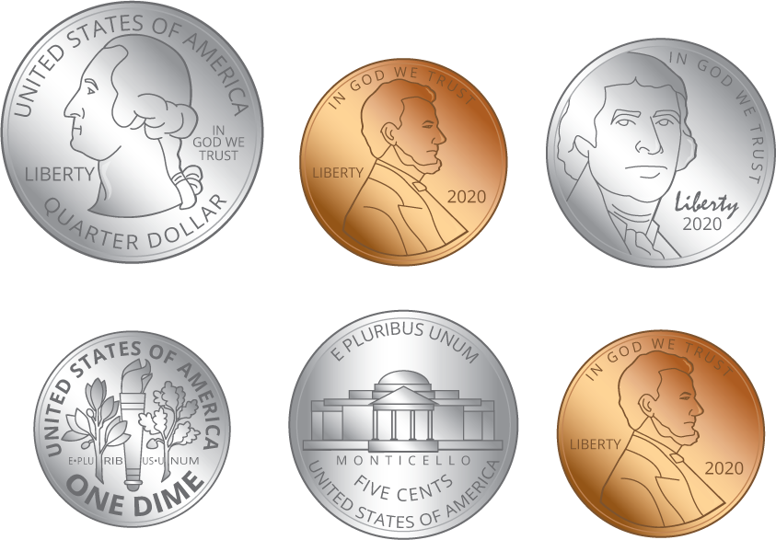
- Tyler has:
- quarters
- dimes
- nickels
- pennies
- How many cents? Show your thinking.
- Make your own set of coins with a value of 97¢.
- I used:
- quarters
- dimes
- nickels
- pennies
- Make your own set of coins with a value of 66¢. Use the fewest number of coins possible.
- I used:
- quarters
- dimes
- nickels
- pennies
© CC BY 2021 Illustrative Mathematics®

