Unit 8 Lesson 8: Count Columns and Objects in Columns

WU Estimation Exploration: Rearrange the Dots (Warm up)

Student Task Statement
How many counters do you see?
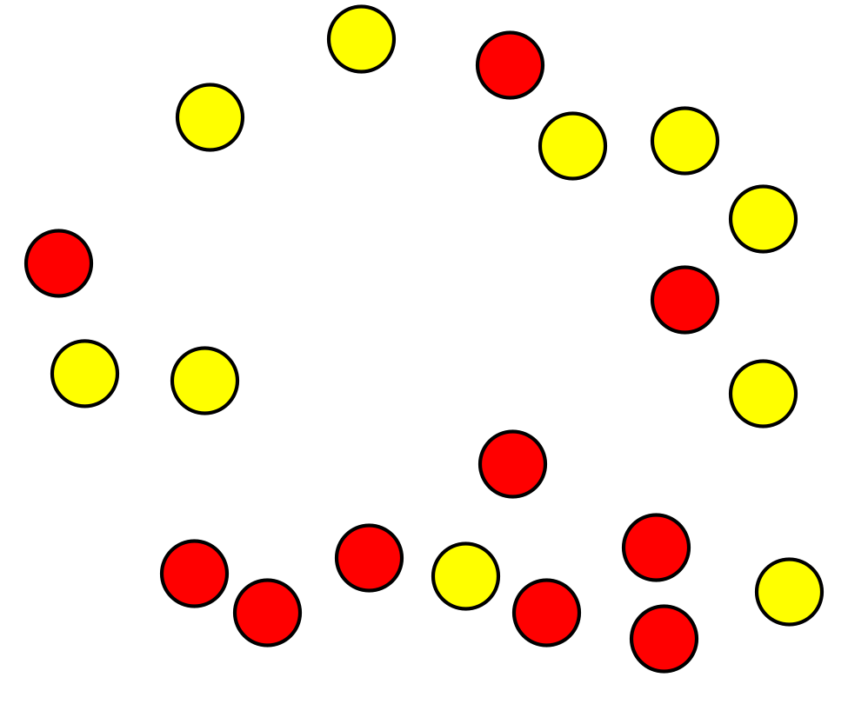
Record an estimate that is:
too low | about right | too high

1 Count by Columns

Images for Launch
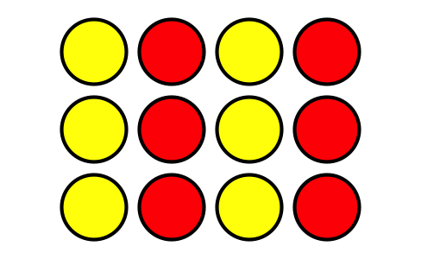

Student Task Statement

- 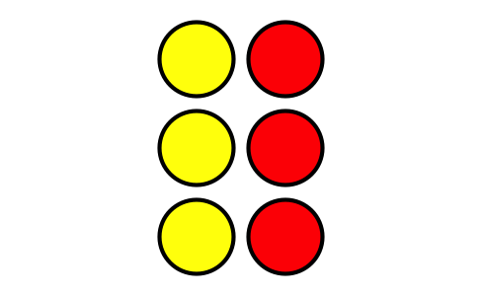
  - How many columns are in this array?
  - How many counters are in each column?
  - How many counters are there in all?

- 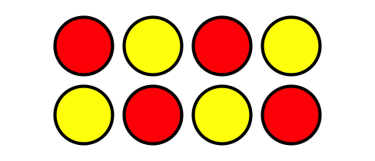
  - How many columns are in this array?
  - How many counters are in each column?
  - How many counters are there in all?
- Use 10 counters to make 2 columns with the same number in each column.
  - How many counters are in each column?
  - How many rows are in the array?
  - How could you count these counters without counting by ones?
- Use 15 counters to make 3 columns with the same number in each column.
  - How many counters are in each column?
  - How many rows are in the array?
  - How many counters are in each row?
  - How could you count these counters without counting by ones?

2 Guess My Array

Student Task Statement
Four students talked about their arrays.
- Han said, “My array has an even number of counters. It has 2 rows with 6 counters in each row.”
- Priya said, “My array has more than 10 counters. It has 4 rows with 3 counters in each row.”
- Elena said, “My array is very tall. It has 6 counters in each column.”
- Kiran said, “My array has more columns than rows. It has 3 rows.”
- Which array belongs to which student? Write the name of each student below their array.
- A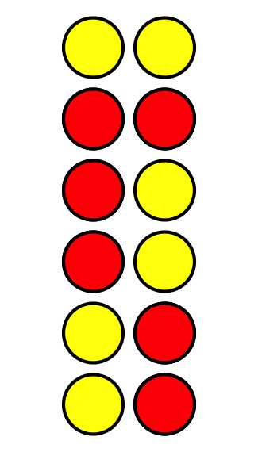
- B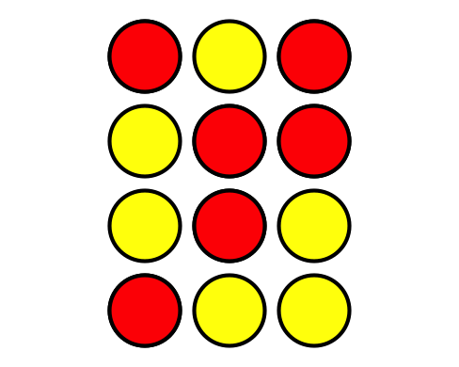
- C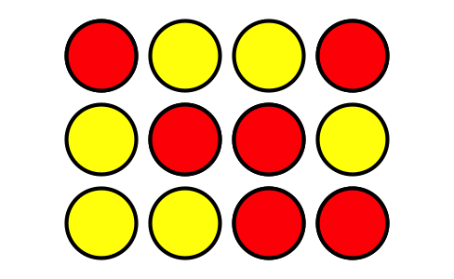
- D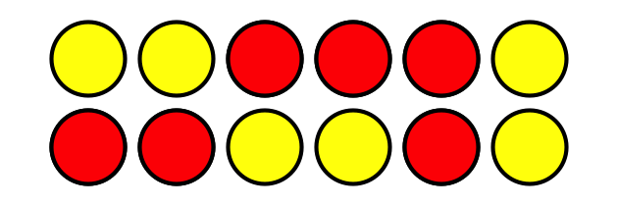
- Each student used _____ counters to make an array.
- Make an array using up to 25 counters, but don’t let your partner see.
- Give your partner clues about your array, so they can try to make it. Compare to see if your partner made the same array.
- Be prepared to explain how you knew the total number of counters.

Images for Activity Synthesis
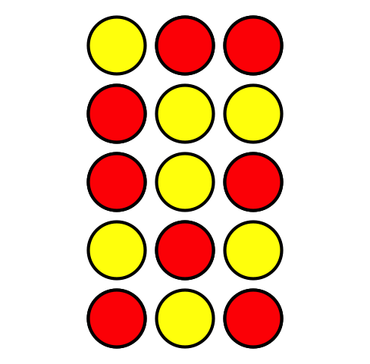
© CC BY 2021 Illustrative Mathematics®

