Lesson 15: Equal Groups, Larger Numbers
- Let’s solve some problems with equal groups that have larger numbers.

Warm-up: Which One Doesn’t Belong: Rectangles
Which one doesn’t belong?
A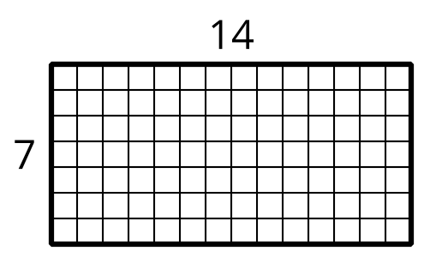
B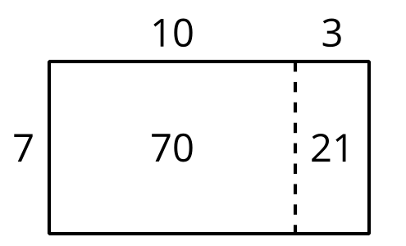
C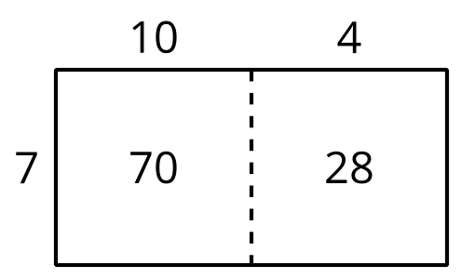
D

15.1: Equal Groups, Larger Numbers
Solve each problem. Explain or show your reasoning.
- Noah sees a large painted mural that has side lengths of 15 feet and 4 feet. What is the area of the mural?
- Noah’s family buys a mosaic that has 12 rows and 8 columns of 1 inch tiles. What is the area of the mosaic?
- At the art festival, Noah uses sidewalk chalk to help decorate a rectangular piece of sidewalk that is 6 feet by 14 feet. What is the area of the piece of sidewalk that Noah helped decorate?
- At the art festival, Noah buys a pack of stickers. There are 5 sheets and each sheet has 16 stickers. How many stickers are in the pack?

15.2: Gallery Walk: Equal Groups, Larger Numbers
As you visit the posters with your partner, discuss what is the same and what is different about the thinking shown on each poster.
© CC BY 2021 Illustrative Mathematics®

