Lesson 10: One of the Pieces, All of the Pieces
- Let’s describe equal pieces of shapes.

Warm-up: Which One Doesn’t Belong: Split Shapes
Which one doesn’t belong?
A
B
C
D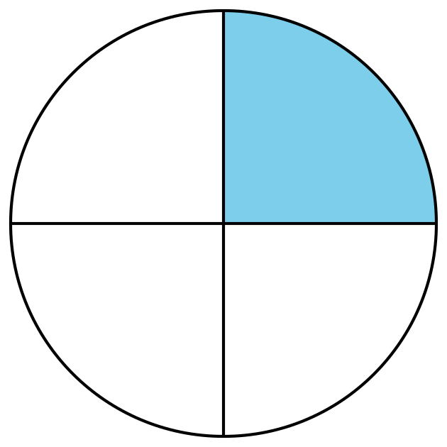

10.1: Color a Piece
- Split the square into halves.
- Color in one of the halves.
How much of the square is colored in?
- Split the circle into fourths.
- Color in one of the fourths.
How much of the circle is colored in?

10.2: Card Sort: Shaded Pieces
- Sort the cards into categories in a way that makes sense to you. Explain how you sorted the cards.
- Sort your cards into these categories.
Write the letter of each card in the space for its category.
A fourth or quarter is shaded
A half is shaded
The whole shape is shaded
Not equal pieces

10.3: Describe Equal Pieces
Here are some ways to describe the shapes.
- split into fourths
- split into halves
- split into quarters
- a half shaded
- a quarter shaded
- a fourth shaded
- two of the halves shaded
- four of the fourths shaded
Label each shape with at least one phrase from the lists.

- 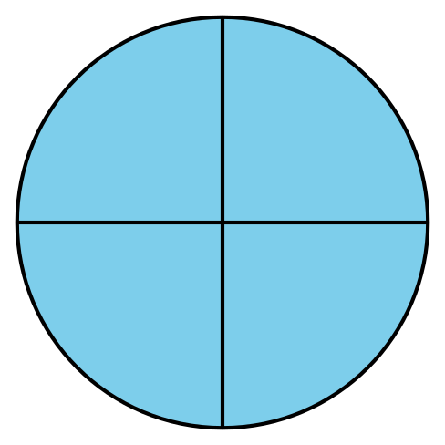

- 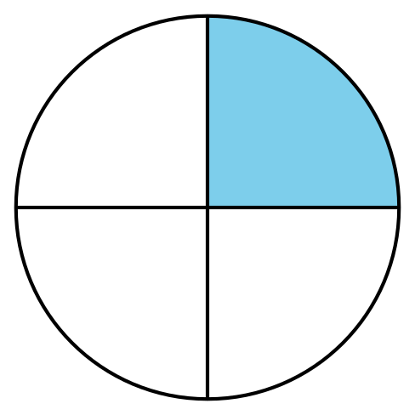

- 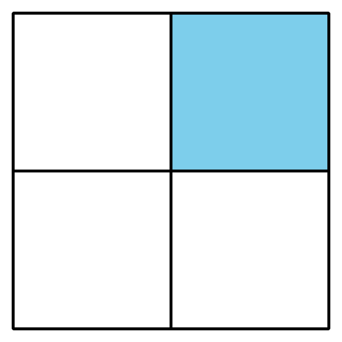

- 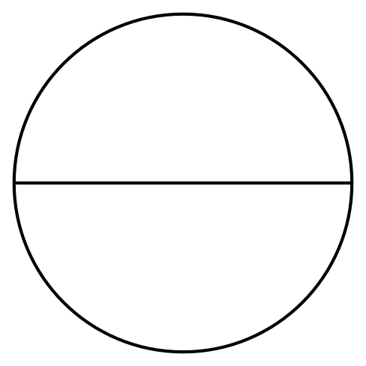
© CC BY 2021 Illustrative Mathematics®

