Unit 4 Lesson 10 Cumulative Practice Problems
  - Use the base-2 log table (printed in the lesson) to approximate the value of each exponential expression.
    - $2^{5}$
    - $2^{3.7}$
    - $2^{4.25}$
  - Use the base-2 log table to find or approximate the value of each logarithm.
    - ${\text{log}}_{2}4$
    - ${\text{log}}_{2}17$
    - ${\text{log}}_{2}35$
- Here is a logarithmic expression: ${\text{log}}_{2}64$.
  - How do we say the expression in words?
  - Explain in your own words what the expression means.
  - What is the value of this expression?
  - What is ${\text{log}}_{10}(100)$? What about ${\text{log}}_{100}(10)$?
  - What is ${\text{log}}_{2}(4)$? What about ${\text{log}}_{4}(2)$?
  - Express $b$ as a power of $a$ if $a^{2}=b$.
- In order for an investment, which is increasing in value exponentially, to increase by a factor of 5 in 20 years, about what percent does it need to grow each year? Explain how you know.
- (From Unit 4, Lesson 4.)
- Here is the graph of the amount of a chemical remaining after it was first measured. The chemical decays exponentially.
- 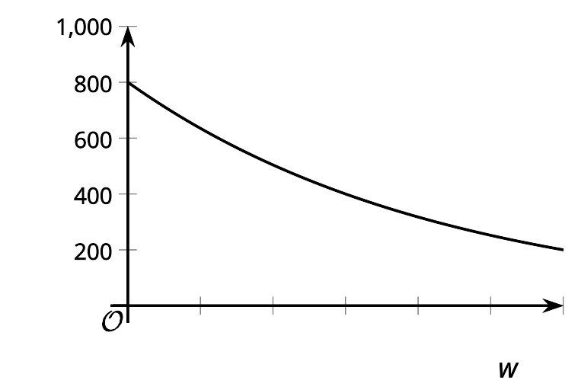
- What is the approximate half-life of the chemical? Explain how you know.
- (From Unit 4, Lesson 7.)
- Find each missing exponent.
  - ${10}^{?}=100$
  - ${10}^{?}=0.01$
  - ${\left(\frac{1}{10}\right)}^{?}=\frac{1}{1,000}$
  - $2^{?}=\frac{1}{2}$
  - ${\left(\frac{1}{2}\right)}^{?}=2$
- (From Unit 4, Lesson 8.)
- Explain why ${\text{log}}_{10}1=0$.
- (From Unit 4, Lesson 9.)
- How are the two equations ${10}^{2}=100$ and ${\text{log}}_{10}(100)=2$ related?
- (From Unit 4, Lesson 9.)
© CC BY 2019 by Illustrative Mathematics

