Unit 8 Lesson 8: Finding Unknown Side Lengths

1 Which One Doesn’t Belong: Equations (Warm up)

Student Task Statement
Which one doesn’t belong?
$3^{2}+b^{2}=5^{2}$
$b^{2}=5^{2}−3^{2}$
$3^{2}+5^{2}=b^{2}$
$3^{2}+4^{2}=5^{2}$

2 Which One Is the Hypotenuse?

Student Task Statement
Label all the hypotenuses with $c$.
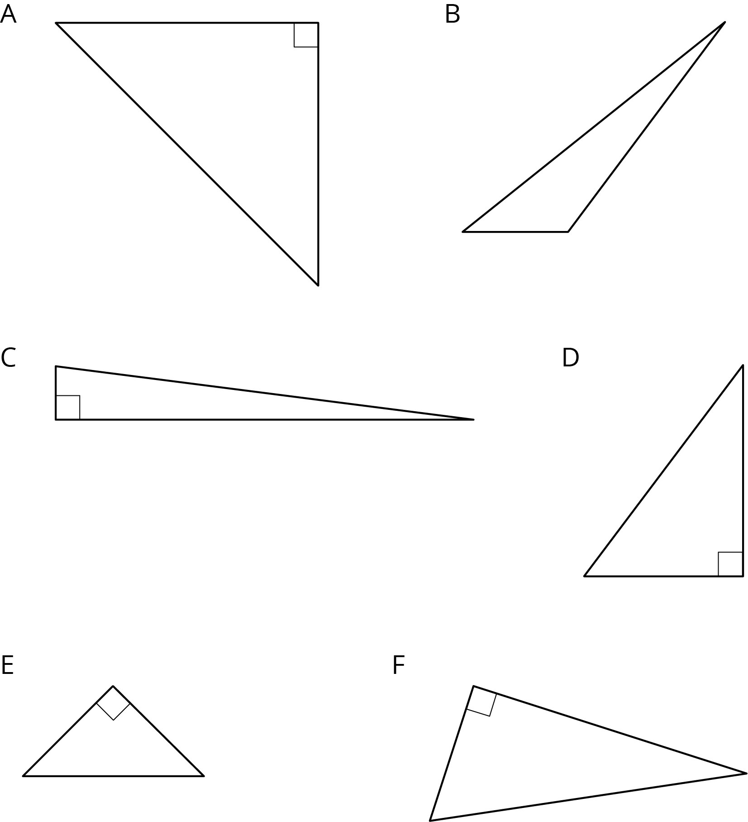

3 Find the Missing Side Lengths

Student Task Statement
- Find $c$.
- 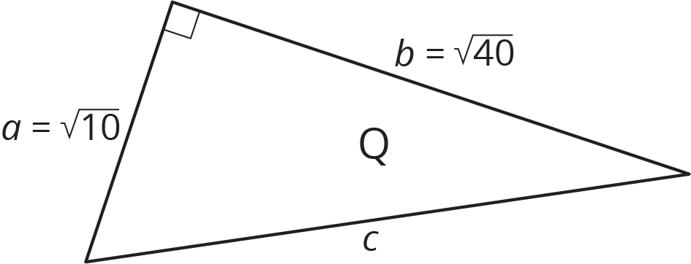

- Find $b$.
- 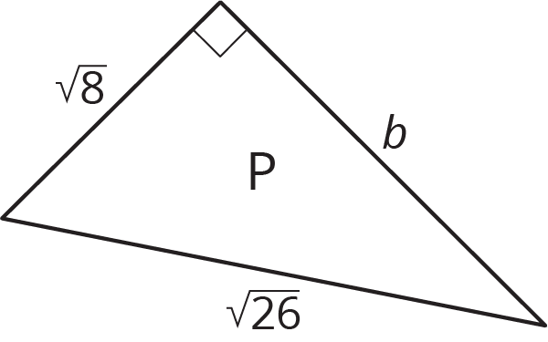
- A right triangle has sides of length 2.4 cm and 6.5 cm. What is the length of the hypotenuse?
- A right triangle has a side of length $\frac{1}{4}$ and a hypotenuse of length $\frac{1}{3}$. What is the length of the other side?
- Find the value of $x$ in the figure.
- 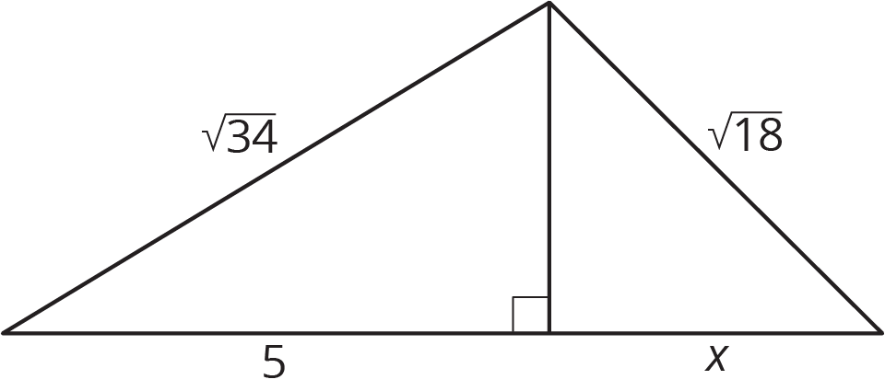

© CC BY Open Up Resources. Adaptations CC BY IM.

