Unit 8 Lesson 6: Estimating Probabilities Using Simulation

1 Which One Doesn’t Belong: Spinners (Warm up)

Student Task Statement
Which spinner doesn't belong?
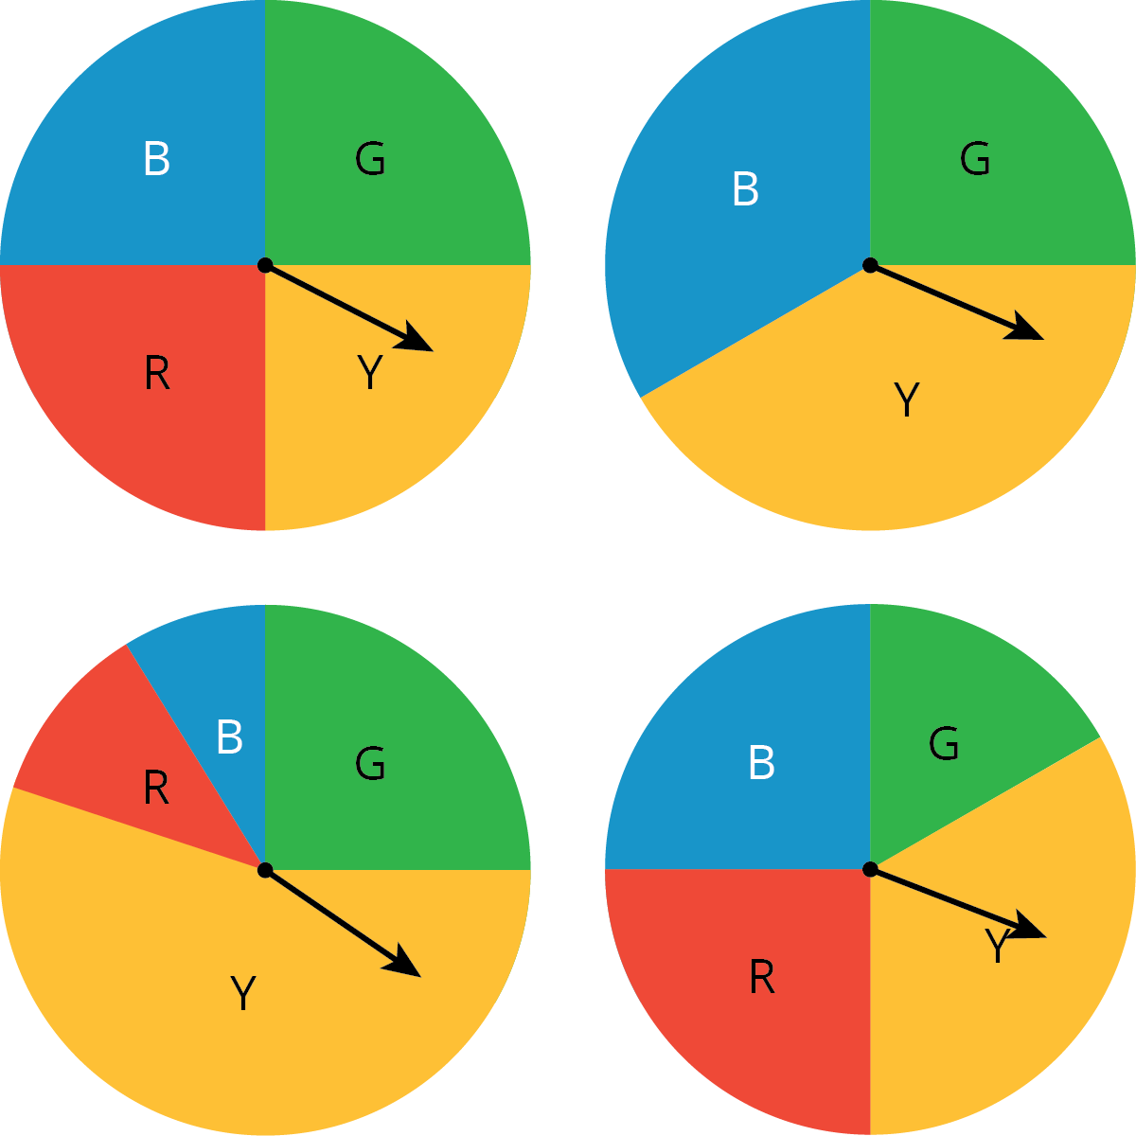

2 Diego’s Walk

Student Task Statement
Your teacher will give your group the supplies for one of the three different simulations. Follow these instructions to simulate 15 days of Diego’s walk. The first 3 days have been done for you.
- Simulate one day:
  - If your group gets a bag of papers, reach into the bag, and select one paper without looking inside.
  - If your group gets a spinner, spin the spinner, and see where it stops.
  - If your group gets two number cubes, roll both cubes, and add the numbers that land face up. A sum of 2–8 means Diego has to wait.
- Record in the table whether or not Diego had to wait more than 1 minute.
- Calculate the total number of days and the cumulative fraction of days that Diego has had to wait so far.
- On the graph, plot the number of days and the fraction that Diego has had to wait. Connect each point by a line.
- If your group has the bag of papers, put the paper back into the bag, and shake the bag to mix up the papers.
- Pass the supplies to the next person in the group.
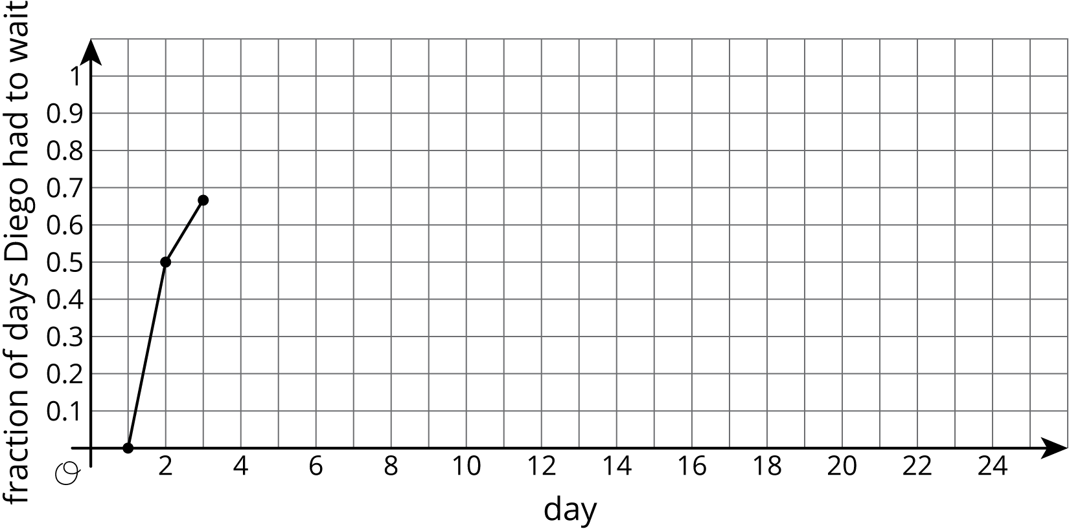
day | Does Diego have  to wait more  than 1 minute? | total number  of days Diego  had to wait | fraction  of days Diego  had to wait
1 | no | 0 | $\frac{0}{1}=$ 0.00
2 | yes | 1 | $\frac{1}{2}=$ 0.50
3 | yes | 2 | $\frac{2}{3}≈$ 0.67
4
5
6
7
8
9
10
11
12
13
14
15
- Based on the data you have collected, do you think the fraction of days Diego has to wait after the 16th day will be closer to 0.9 or 0.7? Explain or show your reasoning.
- Continue the simulation for 10 more days. Record your results in this table and on the graph from earlier.
- day | - Does Diego have  to wait more  than 1 minute? | - total number  of days Diego  had to wait | - fraction  of days Diego  had to wait
- 16
- 17
- 18
- 19
- 20
- 21
- 22
- 23
- 24
- 25
- What do you notice about the graph?
- Based on the graph, estimate the probability that Diego will have to wait more than 1 minute to cross the crosswalk.

3 Designing Experiments

Student Task Statement
For each situation, describe a chance experiment that would fairly represent it.
- Six people are going out to lunch together. One of them will be selected at random to choose which restaurant to go to. Who gets to choose?
- After a robot stands up, it is equally likely to step forward with its left foot or its right foot. Which foot will it use for its first step?
- In a computer game, there are three tunnels. Each time the level loads, the computer randomly selects one of the tunnels to lead to the castle. Which tunnel is it?
- Your school is taking 4 buses of students on a field trip. Will you be assigned to the same bus that your math teacher is riding on?
© CC BY Open Up Resources. Adaptations CC BY IM.

