Lesson 2: Midamos en cuartos de pulgada

Standards Alignments
Addressing | 3.MD.B.4

Teacher-facing Learning Goals
- Measure lengths using rulers marked with fourths of an inch.

Student-facing Learning Goals
- Midamos longitudes en cuartos de pulgada.

Lesson Purpose
The purpose of this lesson is for students to measure length using a ruler marked with fourths of an inch.
In the previous lesson, students applied what they knew about fractions to partition inches into halves and measure lengths to the nearest half inch. In this lesson, students partition inches into fourths and measure lengths to both the nearest fourth and half of an inch.
Students are likely to see that they can use the ruler partitioned into fourths to measure lengths in whole numbers of inches, halves of an inch, and fourths of an inch, rather than to use separate rulers for different fractions. Some students may use fraction equivalence to describe the same length in half of an inch and fourth of an inch, which is helpful but not essential at this point. Focus the conversation on choosing the nearest quarter inch to describe the length of the object being measured. Students will consider the equivalence of $\frac{1}{2}$ inch and $\frac{2}{4}$ inch in the next lesson.

Access for:

Students with Disabilities
- Representation (Activity 2)

English Learners
- MLR2 (Activity 1)

Instructional Routines
Estimation Exploration (Warm-up)

Materials to Gather
- Materials from a previous activity: Activity 2
- Materials from a previous lesson: Activity 1, Activity 2

Lesson Timeline
Warm-up | 10 min
Activity 1 | 20 min
Activity 2 | 20 min
Lesson Synthesis | 5 min
Cool-down | 5 min

Teacher Reflection Question
How effective were your questions in supporting students’ thinking today? What did students say or do that showed they were effective?

Cool-down
(to be completed at the end of the lesson) 5min
¿Cuál regla?

Standards Alignments
Addressing | 3.MD.B.4

Student-facing Task Statement
- ¿Cuál regla usarías para medir la longitud del lápiz? Explica cómo razonaste.
- 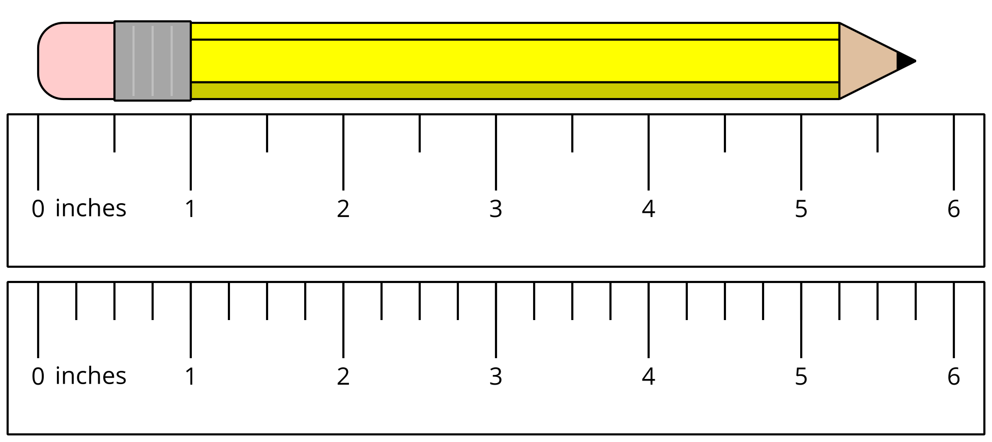
- ¿Cuál es la longitud del lápiz?

Student Responses
- I would use the ruler with quarter inches because the tip of the pencil falls in between the half-inch marks.
- $5\frac{3}{4}$ inches or $\frac{23}{4}$ inches

