Lesson 3 Practice Problems
- Triangle $ABC$ is congruent to triangle $EDF$. So, Kiran knows that there is a sequence of rigid motions that takes $ABC$ to $EDF$.
- Select all true statements after the transformations:
  - Angle $A$ coincides with angle $F$.
  - Angle $B$ coincides with angle $D$.
  - Segment $AC$ coincides with segment $EF$.
  - Segment $BC$ coincides with segment $ED$.
  - Segment $AB$ coincides with segment $ED$.
- A rotation by angle $ACE$ using point $C$ as the center takes triangle $CBA$ onto triangle $CDE$.
  - Explain why the image of ray $CA$ lines up with ray $CE$.
  - Explain why the image of $A$ coincides with $E$.
  - Is triangle $CBA$ congruent to triangle $CDE$? Explain your reasoning.
- The triangles are congruent. Which sequence of rigid motions will take triangle $XYZ$ onto triangle $BCA$?
  - Translate $XYZ$ using directed line segment $YC$. Rotate $X^{′}Y^{′}Z^{′}$ using $C$ as the center so that $X^{′}$ coincides with $B$. Reflect $X^{″}Y^{″}Z^{″}$ across line $CB$.
  - Translate $XYZ$ using directed line segment $YC$. Rotate $X^{′}Y^{′}Z^{′}$ using $C$ as the center so that $X^{′}$ coincides with $B$. Reflect $X^{″}Y^{″}Z^{″}$ across line $AC$.
  - Translate $XYZ$ using directed line segment $YC$. Rotate $X^{′}Y^{′}Z^{′}$ using $C$ as the center so that $X^{′}$ coincides with $A$. Reflect $X^{″}Y^{″}Z^{″}$ across line $CB$.
  - Translate $XYZ$ using directed line segment $YC$. Rotate $X^{′}Y^{′}Z^{′}$ using $C$ as the center so that $X^{′}$ coincides with $A$. Reflect $X^{″}Y^{″}Z^{″}$ across line $AC$.
- Triangle $HEF$ is the image of triangle $FGH$ after a 180 degree rotation around point $K$. Select all statements that must be true.
  - Triangle $HGF$ is congruent to triangle $FEH$.
  - Triangle $GFH$ is congruent to triangle $EFH$.
  - Angle $KHE$ is congruent to angle $KHG$.
  - Angle $GHK$ is congruent to angle $EFK$.
  - Segment $EH$ is congruent to segment $GH$.
  - Segment $HG$ is congruent to segment $FE$.
  - Segment $FH$ is congruent to segment $HF$.
- (From Unit 2, Lesson 2.)
- Line $SD$ is a line of symmetry for figure $ASMHZDPX$. Tyler says that $ASDPX$ is congruent to $SMDZH$ because sides $AS$ and $MS$ are corresponding.
  - Why is Tyler's congruence statement incorrect?
  - Write a correct congruence statement for the pentagons.
- (From Unit 2, Lesson 2.)
- Triangle $ABC$ is congruent to triangle $DEF$. Select all the statements that are a result of corresponding parts of congruent triangles being congruent.
  - Segment $AC$ is congruent to segment $EF$.
  - Segment $BC$ is congruent to segment $EF$.
  - Angle $BAC$ is congruent to angle $EDF$.
  - Angle $BCA$ is congruent to angle $EDF$.
  - Angle $CBA$ is congruent to angle $FED$.
- (From Unit 2, Lesson 1.)
- When triangle $ABC$ is reflected across line $AB$, the image is triangle $ABD$. Why is angle $ACD$ congruent to angle $ADB$?
  - Corresponding parts of congruent figures are congruent.
  - Congruent parts of congruent figures are corresponding.
  - Segment $AB$ is a perpendicular bisector of segment $DC$.
  - An isosceles triangle has a pair of congruent angles.
- (From Unit 2, Lesson 1.)
- Line $DE$ is parallel to line $BC$.
  - What is the measure of angle $EAC$?
  - What is the measure of angle $DAB$?
- 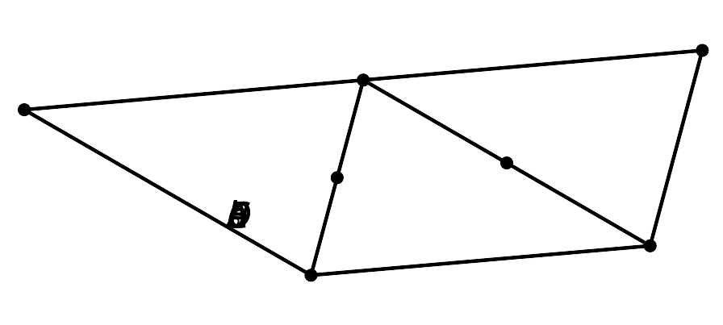
- (From Unit 1, Lesson 21.)
© CC BY 2019 by Illustrative Mathematics®

