Unit 4 Lesson 5: Efficiently Solving Inequalities

1 Lots of Negatives (Warm up)

Student Task Statement
Here is an inequality: $\text{-}x≥\text{-}4$.
- Predict what you think the solutions on the number line will look like.
- Select all the values that are solutions to $\text{-}x≥\text{-}4$:
  - 3
  - -3
  - 4
  - -4
  - 4.001
  - -4.001
- Graph the solutions to the inequality on the number line:
- 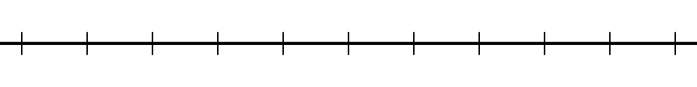

2 Inequalities with Tables

Student Task Statement
- Let's investigate the inequality $x−3>\text{-}2$.
- $x$ | - -4 | - -3 | - -2 | - -1 | - 0 | - 1 | - 2 | - 3 | - 4
- $x−3$ | - -7 |  | - -5 |  |  |  | - -1 |  | - 1
  - Complete the table.
  - For which values of $x$ is it true that $x−3=\text{-}2$?
  - For which values of $x$ is it true that $x−3>\text{-}2$?
  - Graph the solutions to $x−3>\text{-}2$ on the number line:
- Here is an inequality: $2x<6$.
  - Predict which values of $x$ will make the inequality $2x<6$ true.
  - Complete the table. Does it match your prediction?
- $x$ | - -4 | - -3 | - -2 | - -1 | - 0 | - 1 | - 2 | - 3 | - 4
  - $2x$
  - Graph the solutions to $2x<6$ on the number line:
- Here is an inequality: $\text{-}2x<6$.
  - Predict which values of $x$ will make the inequality $\text{-}2x<6$ true.
  - Complete the table. Does it match your prediction?
- $x$ | - -4 | - -3 | - -2 | - -1 | - 0 | - 1 | - 2 | - 3 | - 4
  - $\text{-}2x$
  - Graph the solutions to $\text{-}2x<6$ on the number line:
  - How are the solutions to $2x<6$ different from the solutions to $\text{-}2x<6$?

3 Which Side are the Solutions?

Student Task Statement
- Let’s investigate $\text{-}4x+5≥25$.
  - Solve $\text{-}4x+5=25$.
  - Is $\text{-}4x+5≥25$ true when $x$ is 0? What about when $x$ is 7? What about when $x$ is -7?
  - Graph the solutions to $\text{-}4x+5≥25$ on the number line.
- Let's investigate $\frac{4}{3}x+3<\frac{23}{3}$.
  - Solve $\frac{4}{3}x+3=\frac{23}{3}$.
  - Is $\frac{4}{3}x+3<\frac{23}{3}$ true when $x$ is 0?
  - Graph the solutions to $\frac{4}{3}x+3<\frac{23}{3}$ on the number line.
- Solve the inequality $3\left(x+4\right)>17.4$ and graph the solutions on the number line.
- Solve the inequality $\text{-}3\left(x−\frac{4}{3}\right)≤6$ and graph the solutions on the number line.
© CC BY Open Up Resources. Adaptations CC BY IM.

