Lesson 10: Identify and Describe Solid Shapes
- Let’s make and describe solid shapes.

Warm-up: Number Talk: Add within 5
Find the value of each expression.
- 2 + 3
- 3 + 2
- 4 + 1
- 5 + 0

10.3: Centers: Choice Time
Choose a center.
Geoblocks
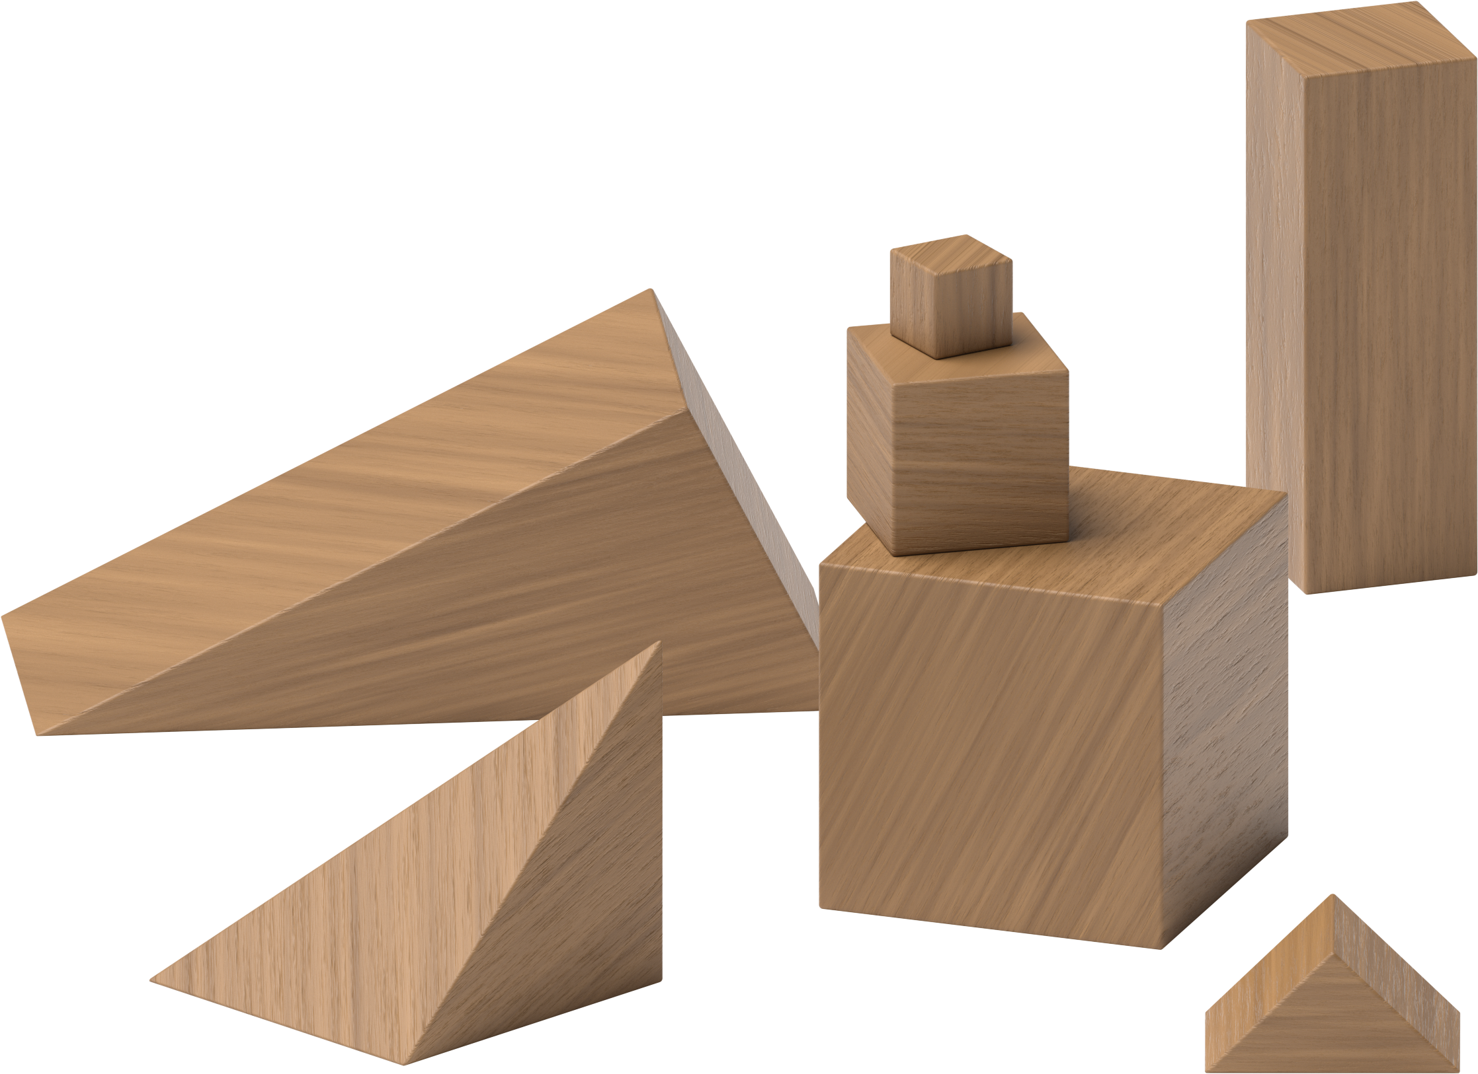
Counting Collections
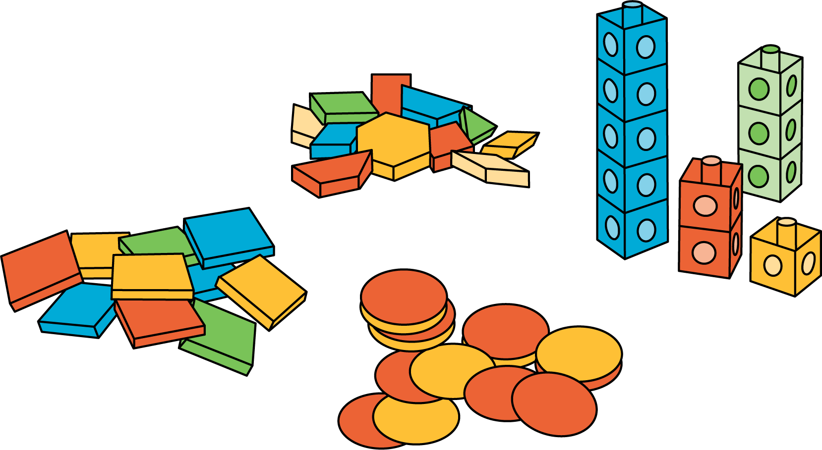
Match Mine
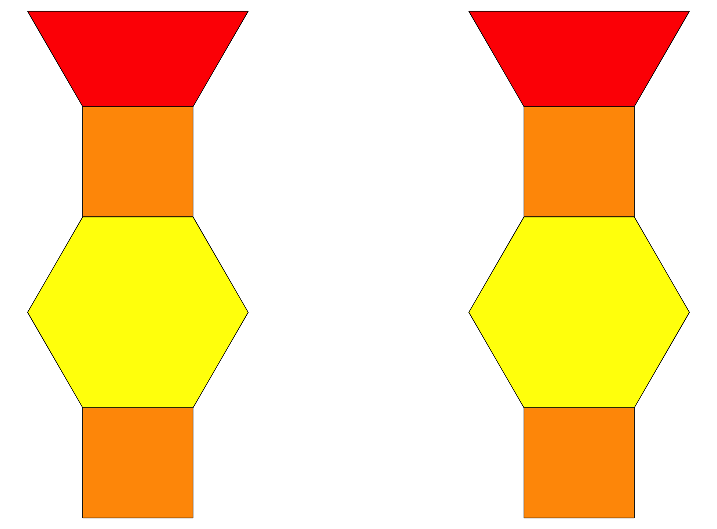
Shake and Spill
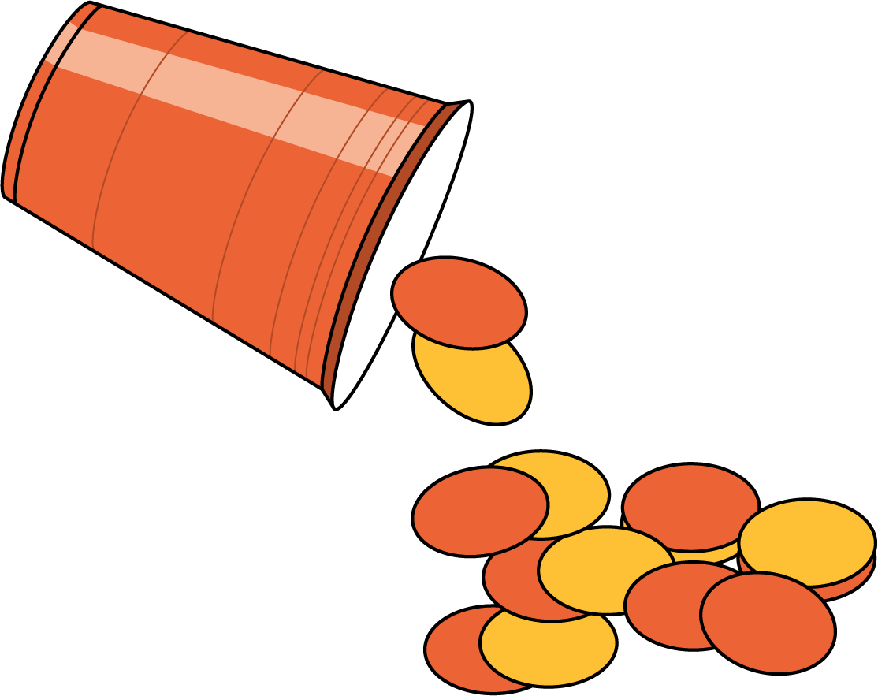
© CC BY 2021 Illustrative Mathematics®

