Lesson 18 Practice Problems
- A cube with side length 5 centimeters has a density of 3 grams per cubic centimeter. What is its mass?
- (From Unit 5, Lesson 17.)
- Rectangular prism $A$ measures 5 inches by 5 inches by 6 inches. Rectangular prism $B$ measures 2 inches by 4 inches by 6 inches.
  - Before doing any calculations, predict which prism has greater surface area to volume ratio.
  - Calculate the surface area, volume, and surface area to volume ratio for each prism.
- (From Unit 5, Lesson 16.)
- A right cone has a base with radius 4 units. The volume of the cone is $16π$ cubic units. What is the length of a segment drawn from the apex to the edge of the circular base?
- (From Unit 5, Lesson 15.)
- A right pyramid has a square base with sides of length 10 units. Each segment connecting the apex to a midpoint of a side of the base has length 13 units. What is the volume of the pyramid?
  - 1300 cubic units
  - 1200 cubic units
  - $\frac{1300}{3}$ cubic units
  - 400 cubic units
- (From Unit 5, Lesson 15.)
- A solid can be constructed with 2 squares and 4 congruent, non-rectangular parallelograms. What is the name of this solid?
  - cube
  - right rectangular prism
  - right square prism
  - oblique square prism
- (From Unit 5, Lesson 12.)
- Diego is deciding which of 2 juice containers he should buy. One container is in the shape of a cylinder with radius 2.5 centimeters and height 10.5 centimeters. The second container is in the shape of a rectangular prism. The prism also has height 10.5 centimeters. Its length is 4 centimeters and its width is 6 centimeters.
- Which juice container has the larger volume?
- (From Unit 5, Lesson 10.)
- A parallelogram has an area of 1 square centimeter. Write an equation where $y$ is the scale factor required for a dilation of the parallelogram to have an area of $x$ square units. Sketch a graph representing the equation.
- (From Unit 5, Lesson 5.)
- Suppose several solids are divided into thin slices, all in the same direction. For each set of slices, decide what kind of solid they came from.
  - a set of similar rectangles, decreasing in size to a single point, ordered from greatest in size to smallest
  - a set of congruent triangles
  - a set of congruent squares
  - a set of circles, decreasing in size to a single point, ordered from greatest in size to smallest
- (From Unit 5, Lesson 2.)
- Four solids on the list have the same volume. Select these solids.

- Solid A
- 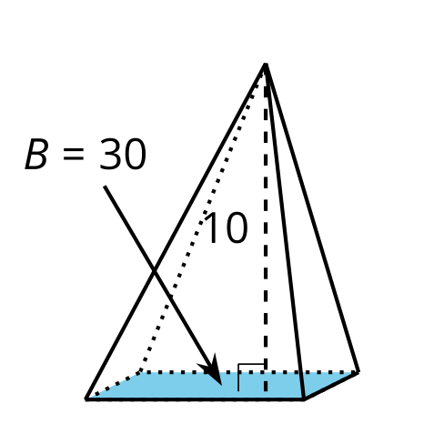

- Solid B
- 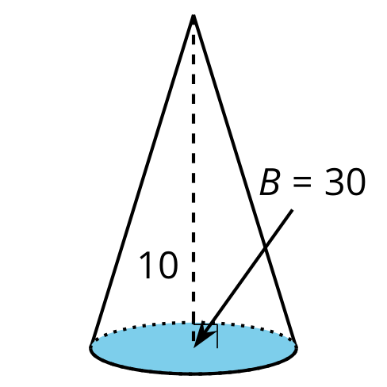

- Solid C
- 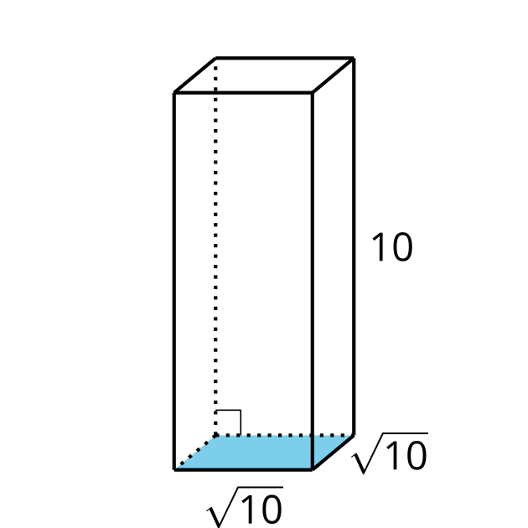

- Solid D
- 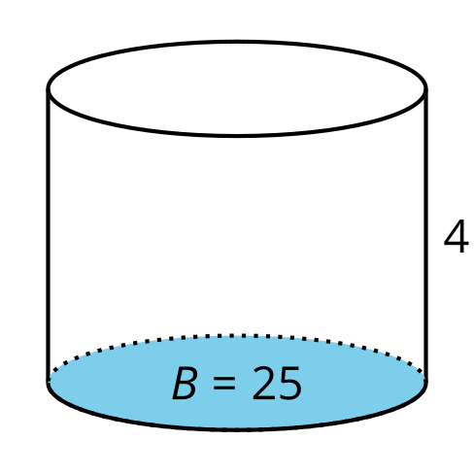

- Solid E
- 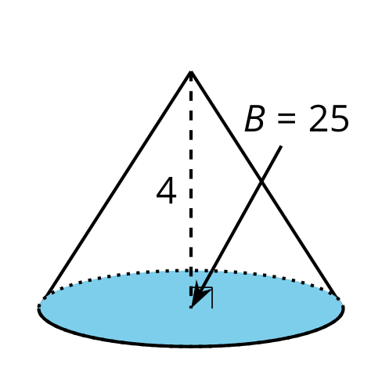

  - Solid A
  - Solid B
  - Solid C
  - Solid D
  - Solid E
- (From Unit 5, Lesson 13.)
© CC BY 2019 by Illustrative Mathematics®

