Unit 8 Lesson 21: Compose and Decompose Numbers 11–19

WU Which One Doesn’t Belong: Numbers 11–20 (Warm up)

Student Task Statement
Which one doesn’t belong?
A
B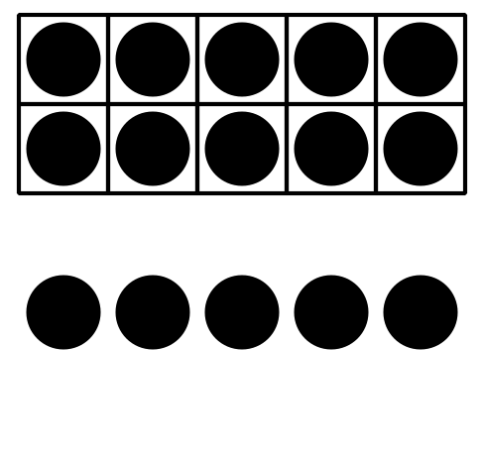
C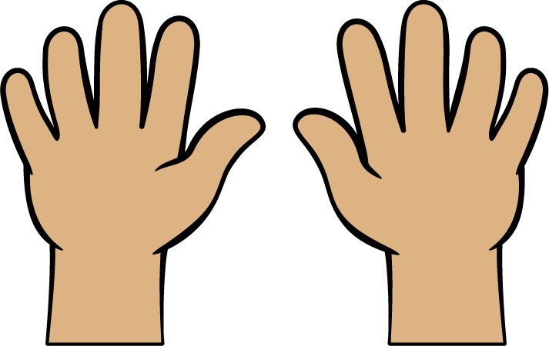
D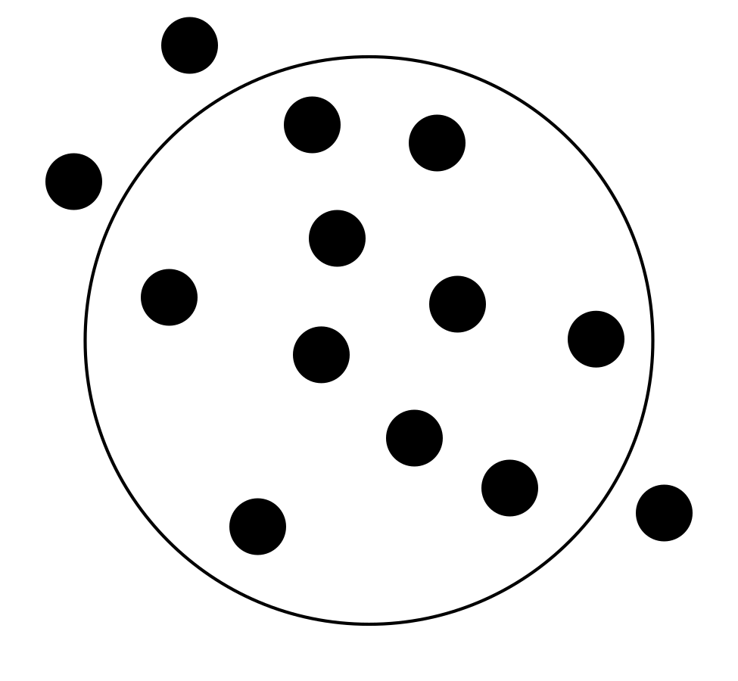

1 Where Will They Sit?

Student Task Statement
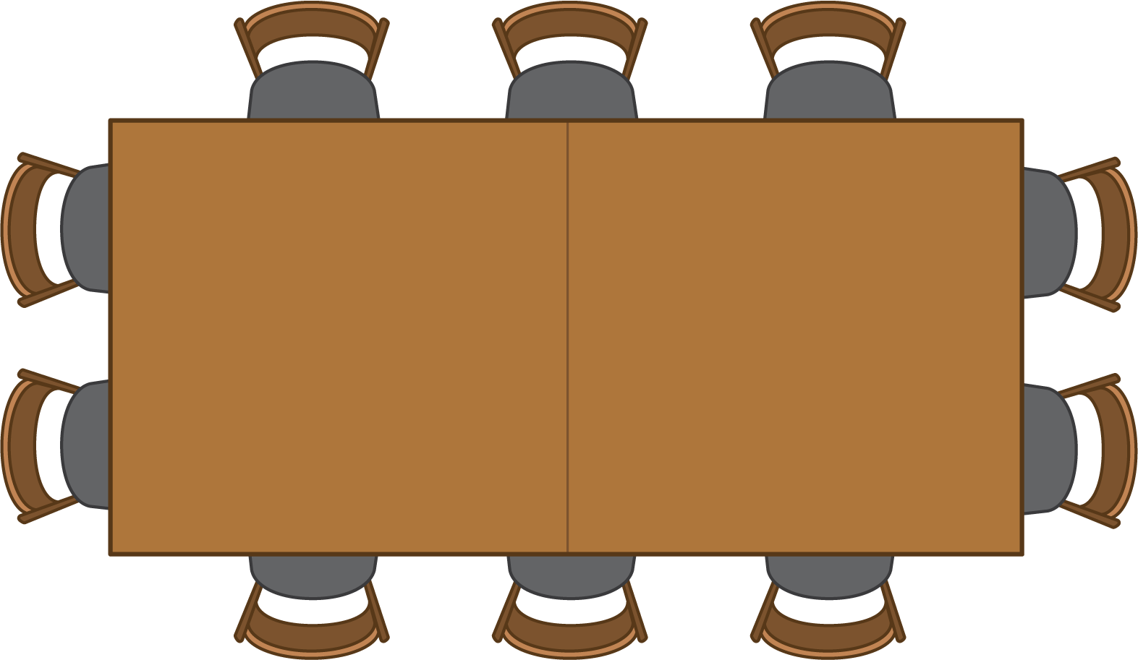
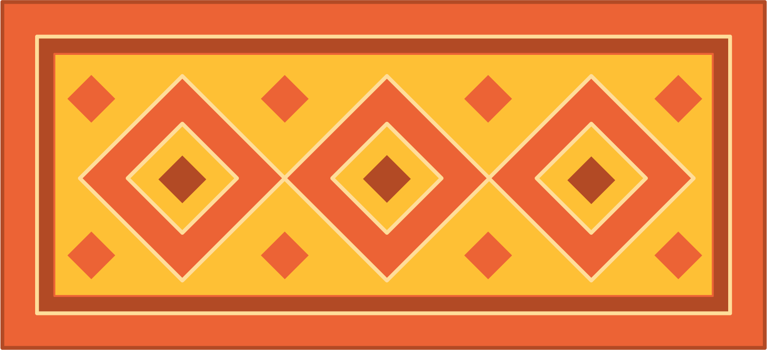

- $\underset{_}{}$
- $+$
- $\underset{_}{}$
- =la _

- $\underset{_}{}$
- $+$
- $\underset{_}{}$
- =la _

- $\underset{_}{}$
- $+$
- $\underset{_}{}$
- =la _

- $\underset{_}{}$
- $+$
- $\underset{_}{}$
- =la _

- $\underset{_}{}$
- $+$
- $\underset{_}{}$
- =la _

- $\underset{_}{}$
- $+$
- $\underset{_}{}$
- =la _

2 Finish the Equations (Optional)

Student Task Statement
- $17=10+\underset{_}{}$
- $19=\underset{_}{}+9$
- $10+\underset{_}{}=14$
- $\underset{_}{}+2=12$
- $11=\underset{_}{}+1$
- $15=10+\underset{_}{}$

3 Centers: Choice Time

Student Task Statement
Choose a center.
Shake and Spill
Number Race
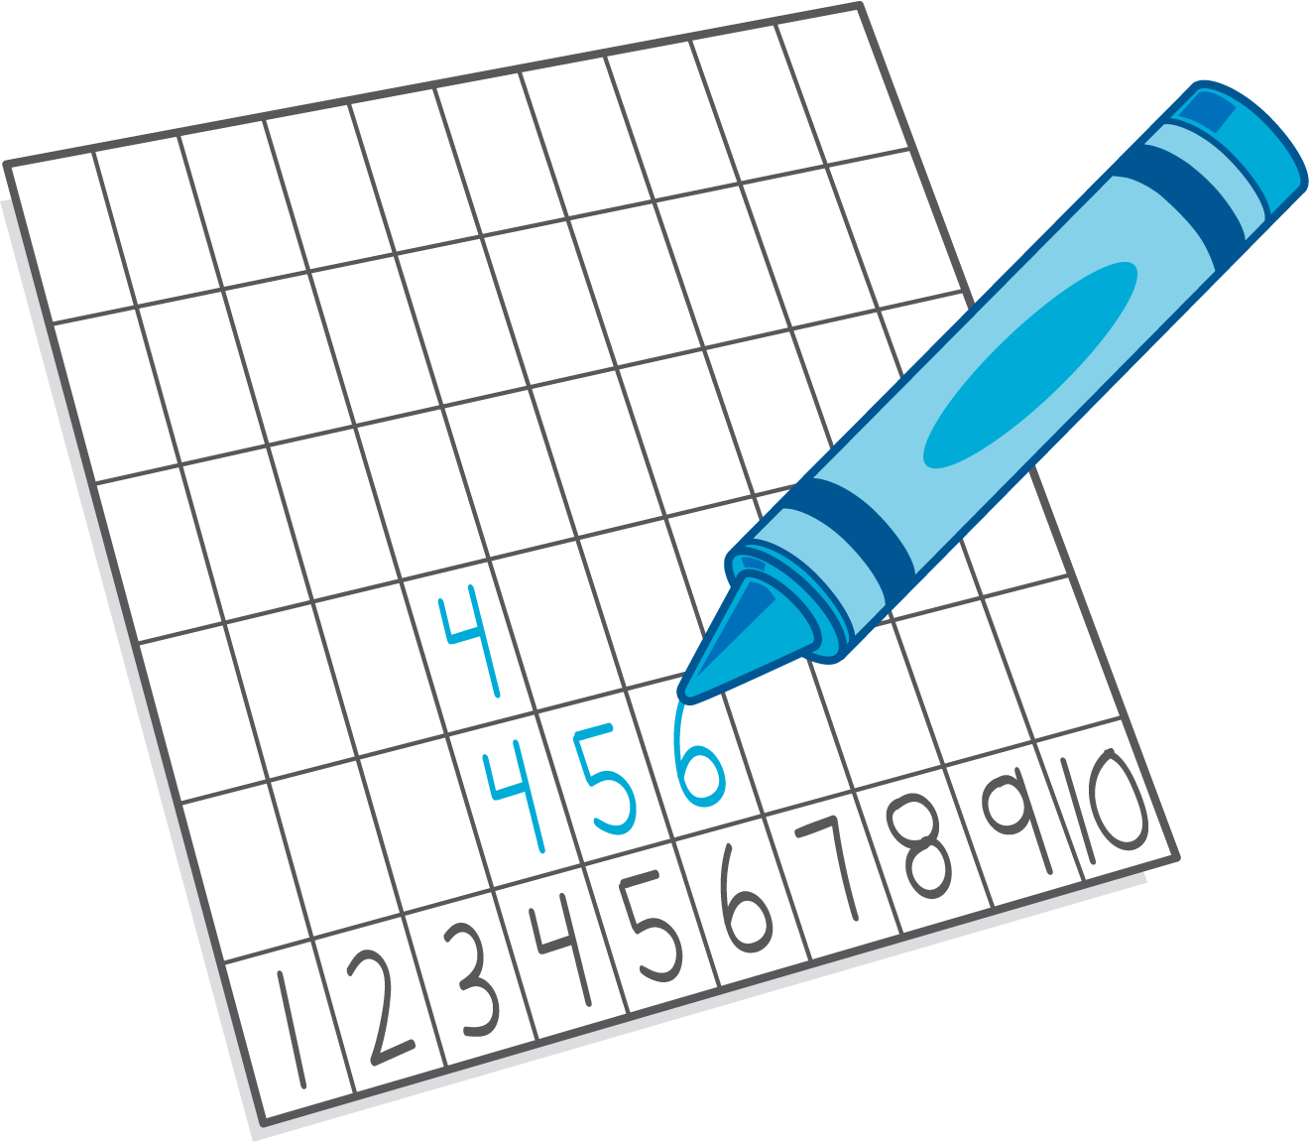
Grab and Count
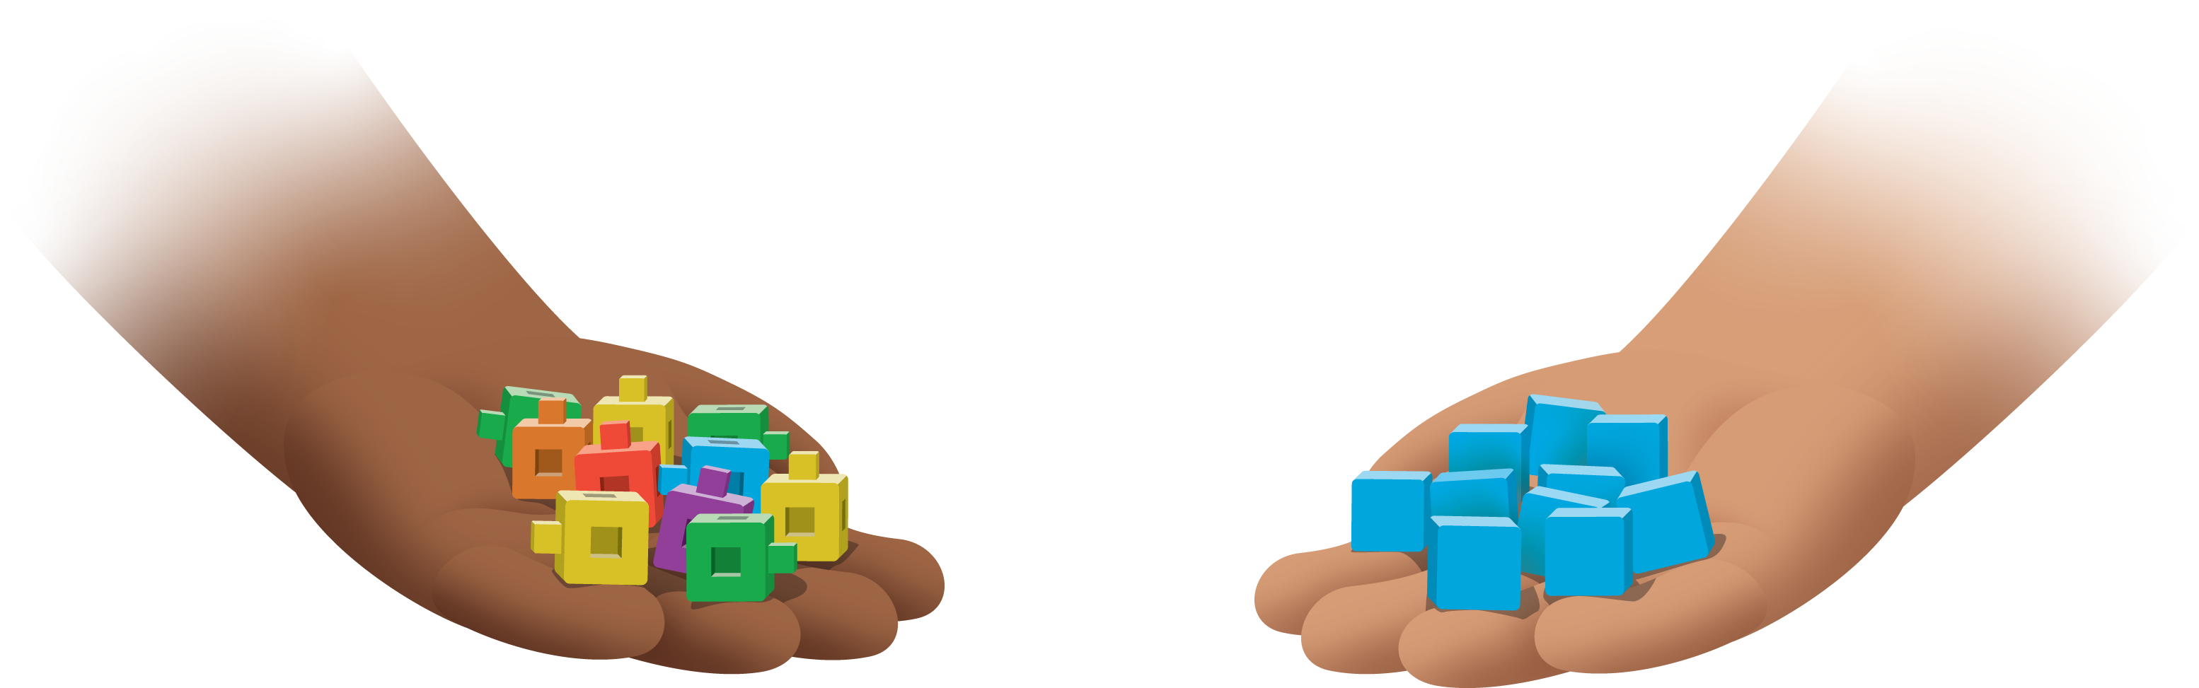
What's Behind My Back?
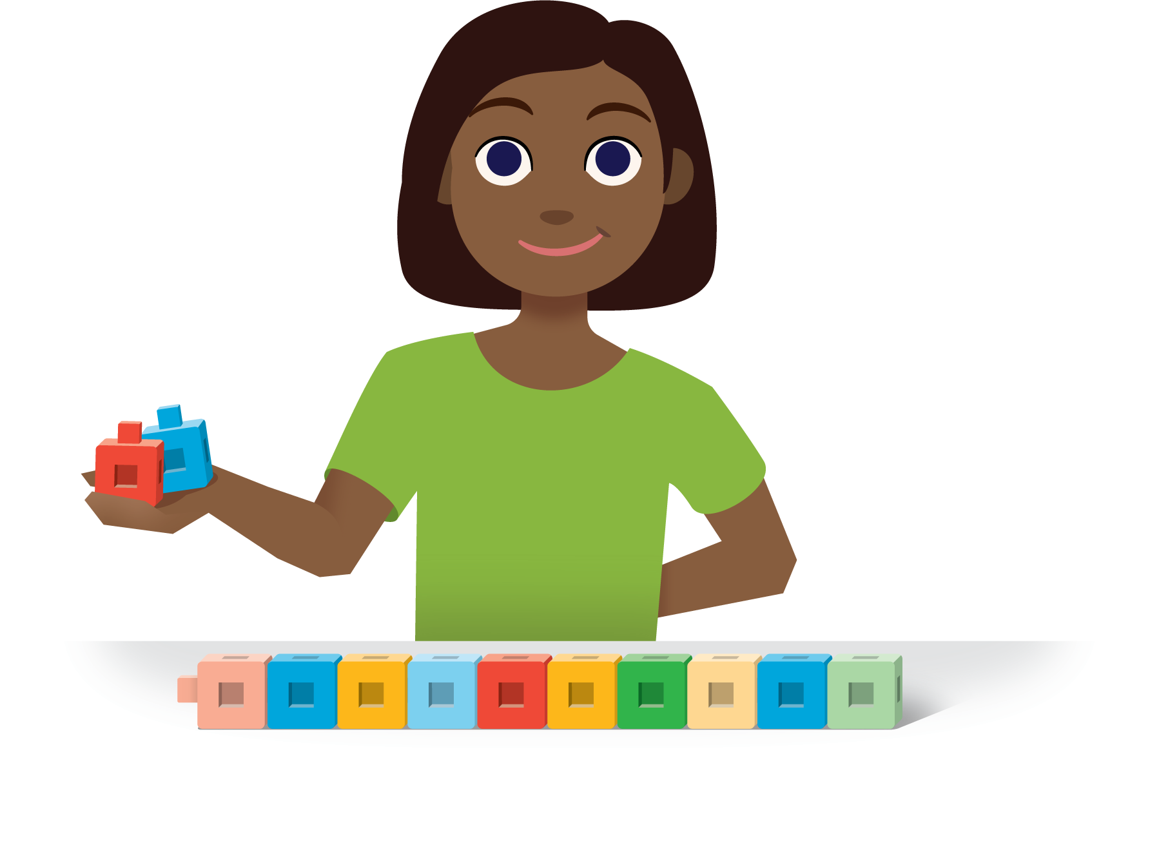
Pattern Blocks
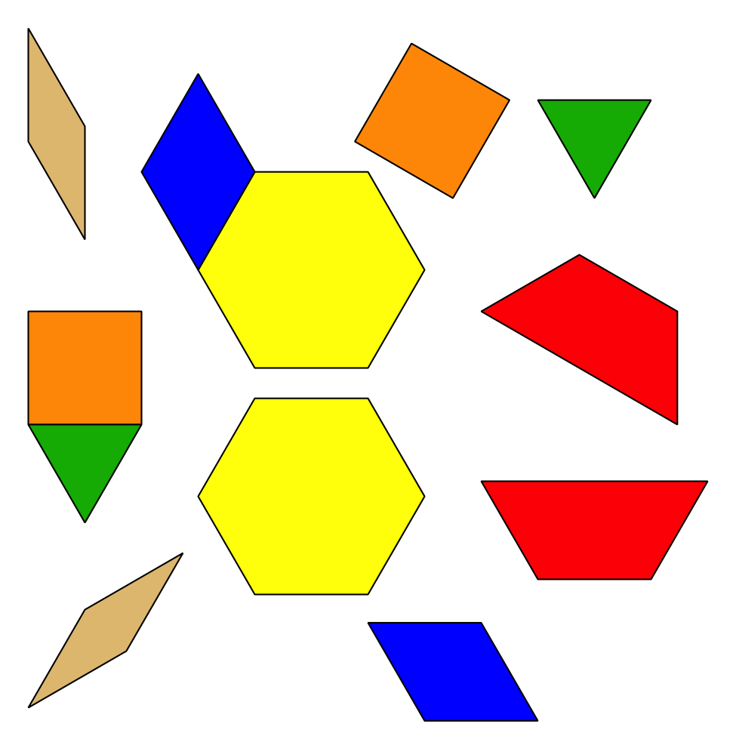
© CC BY 2021 Illustrative Mathematics®

