Unit 5 Lesson 5: Make a Ten

WU How Many Do You See: Many 10-frames (Warm up)

Student Task Statement
How many do you see?
How do you see them?
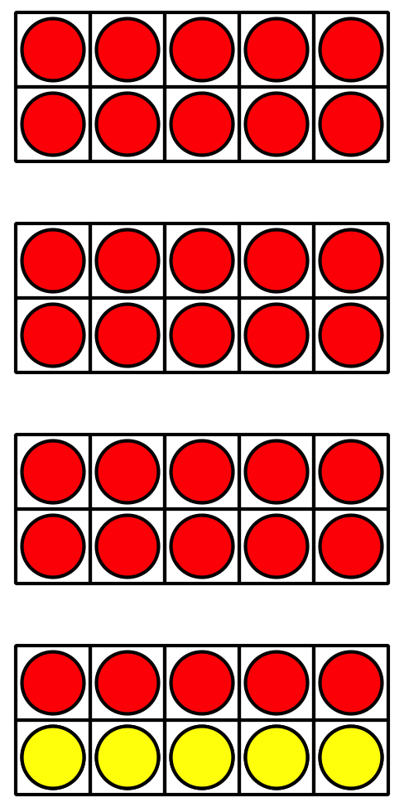
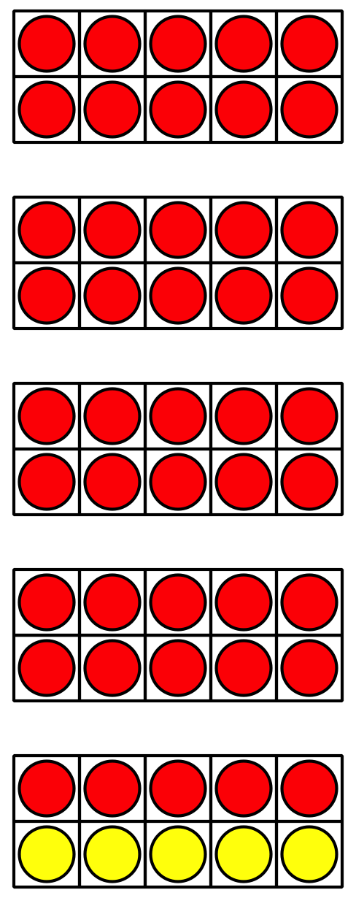
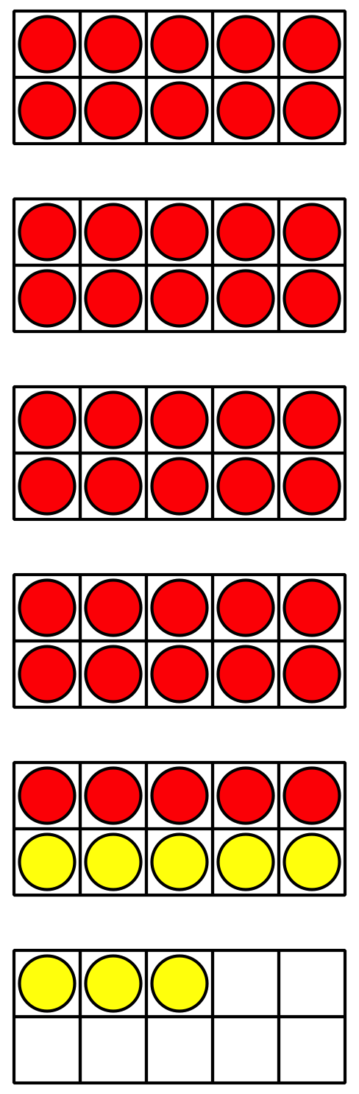

1 Choose a Way to Add

Student Task Statement
Find the value of $8+47$.
Show your thinking using drawings, numbers, or words.

2 Add ‘Em Up Partner

Student Task Statement
Practice Round:
Show your thinking using drawings, numbers, or words.
Equation: __________________________________
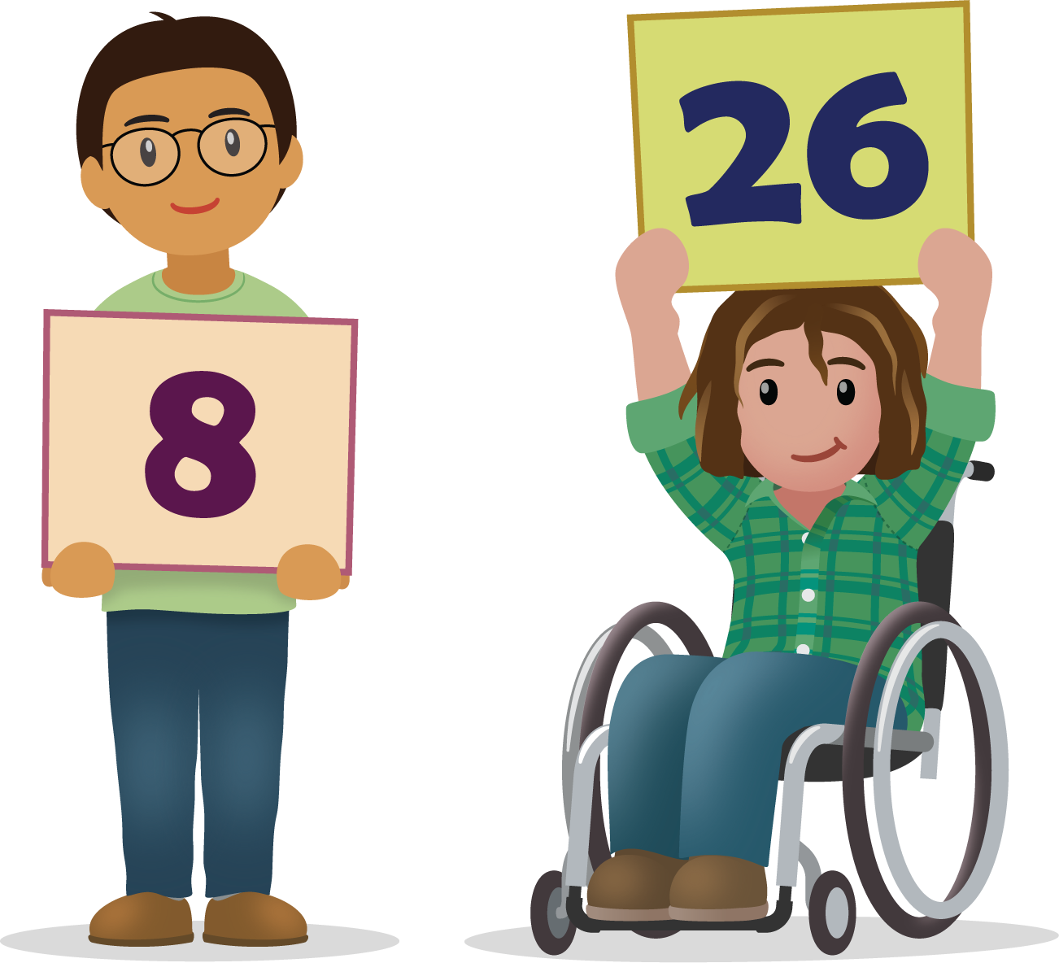
Round 1:
Show your thinking using drawings, numbers, or words.
Equation: __________________________________
Round 2:
Show your thinking using drawings, numbers, or words.
Equation: __________________________________
Round 3:
Show your thinking using drawings, numbers, or words.
Equation: __________________________________
Round 4:
Show your thinking using drawings, numbers, or words.
Equation: __________________________________
Round 5:
Show your thinking using drawings, numbers, or words.
Equation: __________________________________

3 Tyler’s Teacher (Optional)

Student Task Statement
- Tyler’s teacher collected 37 dollars for the class field trip.
Then someone brought in 7 more dollars.
How much money did Tyler’s teacher collect?
Show your thinking using drawings, numbers, or words.
- Tyler’s teacher needs to know if all of his students are in the classroom.
There are 8 students sitting at tables and 26 students on the rug.
How many students are in the classroom?
Show your thinking using drawings, numbers, or words.
© CC BY 2021 Illustrative Mathematics®

