Lesson 17: Use the Four Operations to Solve Problems
- Let’s use the four operations to solve problems.

Warm-up: True or False: Multiply by 10
Decide if each statement is true or false. Be prepared to explain your reasoning.
- $2×40=2×4×10$
- $2×40=8×10$
- $3×50=15×10$
- $3×40=7×10$

17.1: Questions about a Situation
What questions could you ask about this situation?
There are 142 guests at a party. All the guests are in 2 rooms. Room A has 94 guests. Room B has 6 tables that each have the same number of guests. There are 4 pieces of silverware and 1 plate for each guest.

17.2: Party Problems
For each problem:
a. Write an equation to represent the situation. Use a letter for the unknown quantity.
b. Solve the problem. Explain or show your reasoning.
- Kiran is making paper rings each day to decorate for a party. From Monday to Thursday he was able to complete 156 rings. Friday, Kiran and 2 friends worked on making more rings. Each of them made 9 more rings. How many rings did they make over the week?
- Mai has 168 muffins. She put 104 of the muffins in a basket. She packed the rest of the muffins into 8 boxes with the same number of muffins. How many muffins were in each box?
- There are 184 cups on a table. Three tables with 8 people at each table come up to get drinks and each use a cup. How many cups are on the table now?

Section Summary
Section Summary
In this section, we learned how to multiply single-digit numbers by multiples of ten. We used strategies to multiply teen numbers and numbers greater than 20.
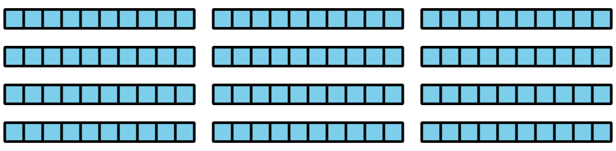
$4×30$
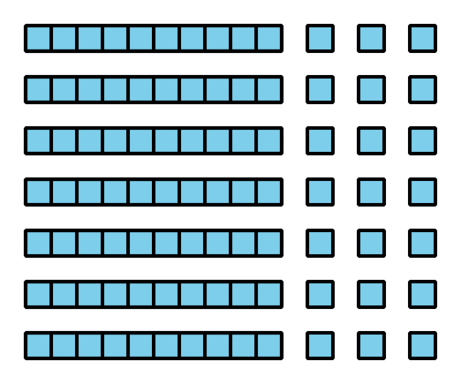
$7×13$
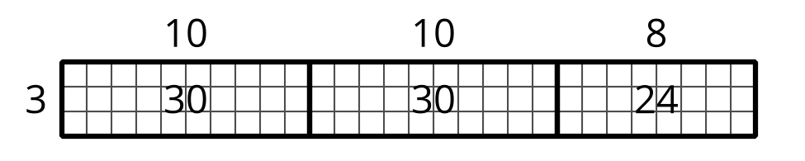
$3×28$
© CC BY 2021 Illustrative Mathematics®

