Lesson 1: Estimation Explorations with Fractions
- Let’s explore estimations with fractions.

Warm-up: Which One Doesn’t Belong: Fractions
Which one doesn’t belong?
A
B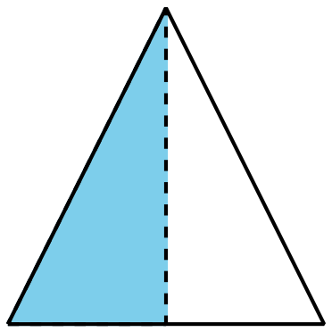
C
D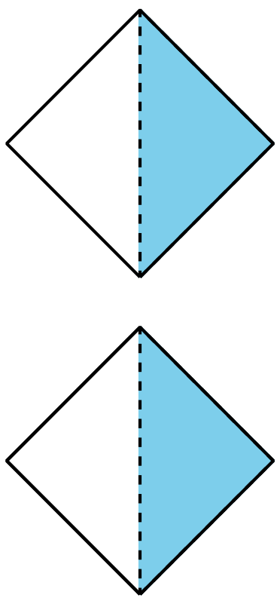

1.1: Estimation Exploration: Diagram
What fraction of the square is shaded?
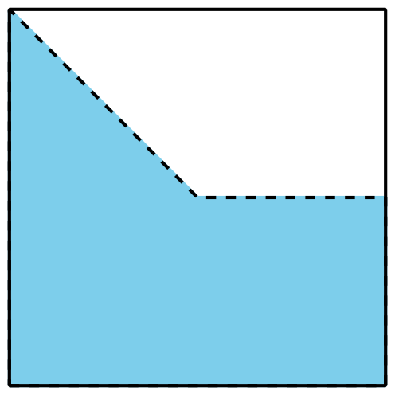
Record an estimate that is:
too low | about right | too high

1.2: Estimation Exploration: Fraction Strip
What fraction of the strip is shaded?
Record an estimate that is:
too low | about right | too high

1.3: Estimation Exploration: Number Line
What number does the point represent?
Record an estimate that is:
too low | about right | too high
© CC BY 2021 Illustrative Mathematics®

