Unit 6 Lesson 12: Filling containers

1 Which One Doesn’t Belong: Solids (Warm up)

Student Task Statement
These are drawings of three-dimensional objects. Which one doesn’t belong? Explain your reasoning.
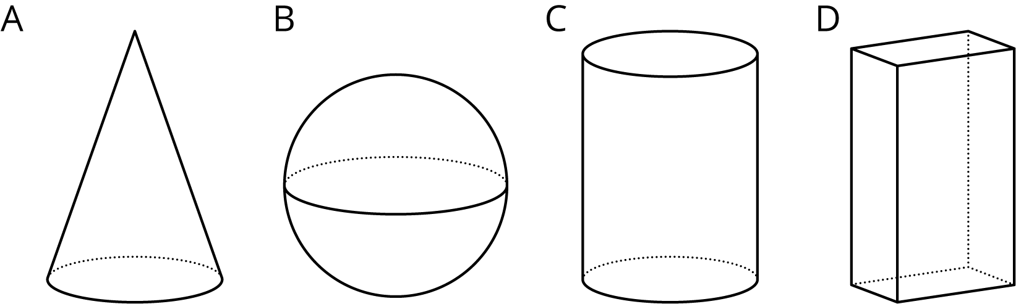

2 Height and Volume

Student Task Statement
Your teacher will give you a graduated cylinder, water, and some other supplies. Your group will use these supplies to investigate the height of water in the cylinder as a function of the water volume.
- Before you get started, make a prediction about the shape of the graph.
- Fill the cylinder with different amounts of water and record the data in the table.
- volume (ml)
- height (cm)
- Create a graph that shows the height of the water in the cylinder as a function of the water volume.
- Choose a point on the graph and explain its meaning in the context of the situation.

Activity Synthesis
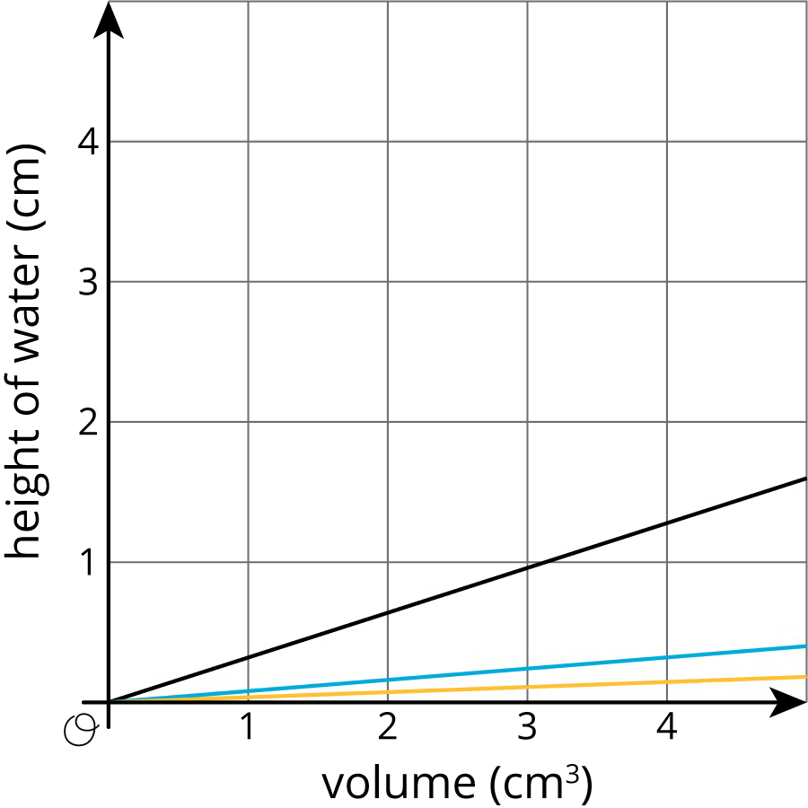

3 What Is the Shape?

Student Task Statement
- The graph shows the height vs. volume function of an unknown container. What shape could this container have? Explain how you know and draw a possible container.
- 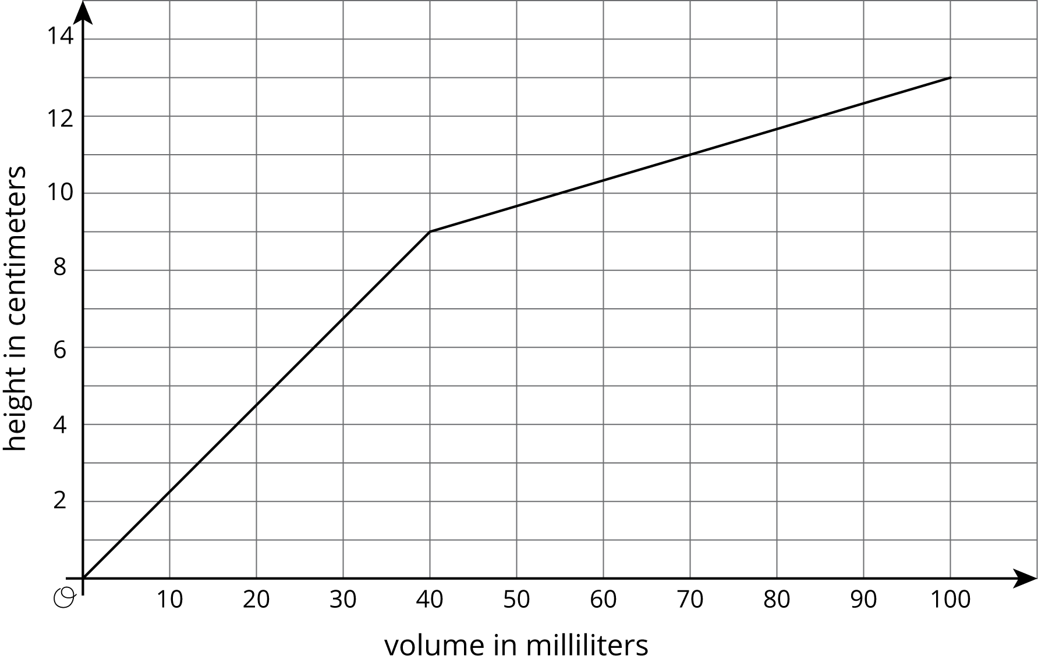
- The graph shows the height vs. volume function of a different unknown container. What shape could this container have? Explain how you know and draw a possible container.
- 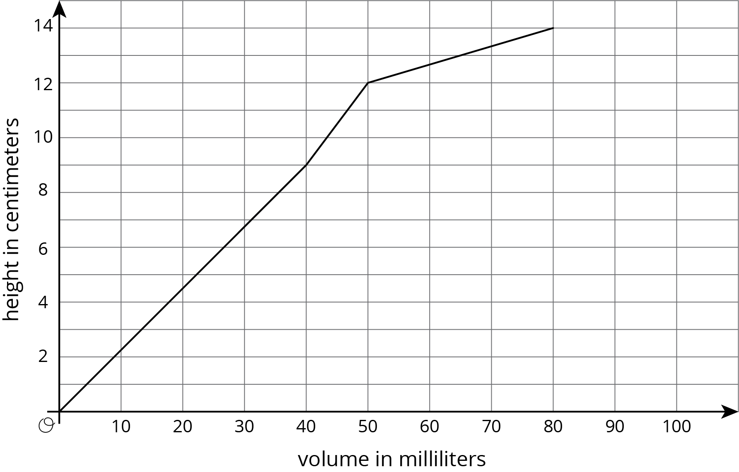
- How are the two containers similar? How are they different?
© CC BY Open Up Resources. Adaptations CC BY IM.

