Unit 8 Lesson 10: Applications of the Pythagorean Theorem

1 Closest Estimate: Square Roots (Warm up)

Student Task Statement
Which estimate is closest to the actual value of the expression? Explain your reasoning.
- $\sqrt{24}$
  - 4
  - 4.5
  - 5
- $\sqrt{7}$
  - 2
  - 2.5
  - 3
- $\sqrt{42}$
  - 6
  - 6.5
  - 7
- $\sqrt{10}$ + $\sqrt{97}$
  - 13
  - 13.25
  - 13.5

2 Cutting Corners

Student Task Statement
Mai and Tyler were standing at one corner of a large rectangular field and decided to race to the opposite corner. Since Mai had a bike and Tyler did not, they thought it would be a fairer race if Mai rode along the sidewalk that surrounds the field while Tyler ran the shorter distance directly across the field. The field is 100 meters long and 80 meters wide. Tyler can run at around 5 meters per second, and Mai can ride her bike at around 7.5 meters per second.
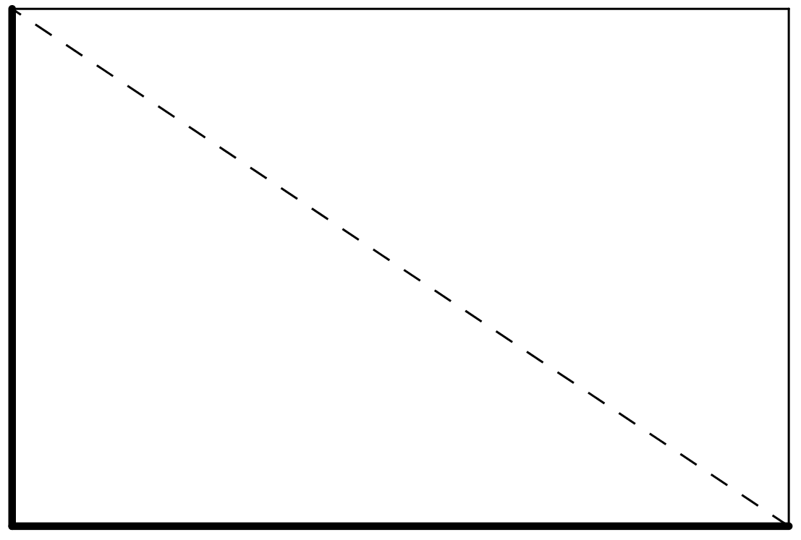
- Before making any calculations, who do you think will win? By how much? Explain your thinking.
- Who wins? Show your reasoning.

3 Internal Dimensions

Student Task Statement
Here are two rectangular prisms:
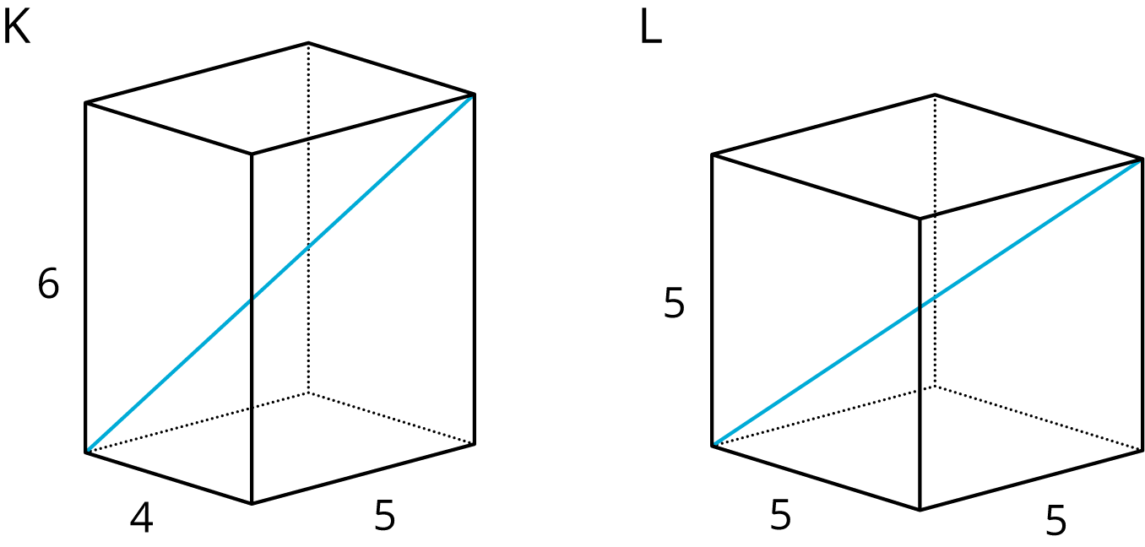
- Which figure do you think has the longer diagonal? Note that the figures are not drawn to scale.
- Calculate the lengths of both diagonals. Which one is actually longer?
© CC BY Open Up Resources. Adaptations CC BY IM.

