Unit 1 Lesson 6: The Locker Problem

Choral Count: Twos and Fours (Warm up)

Student Task Statement

1 Questionable Lockers

Student Task Statement
The picture shows lockers in a school hallway.
The 20 students in Tyler’s fourth-grade class are playing a game in a hallway that is lined with 20 lockers in a row.
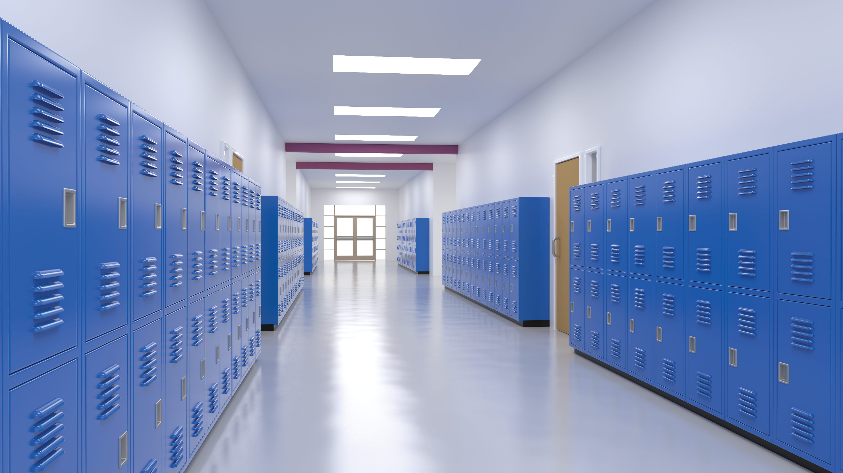
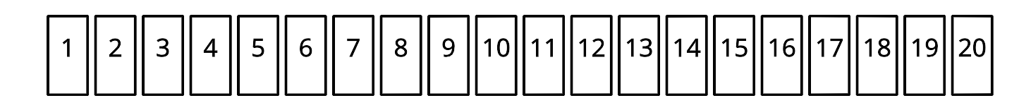
- The first student starts with the first locker and goes down the hallway and opens all the lockers.
- The second student starts with the second locker and goes down the hallway and shuts every other locker.
- The third student stops at every third locker and opens the locker if it is closed or closes the locker if it is open.
This process continues until all 20 students in the class have touched the lockers.
Create a representation to show what you understand about this problem. Consider:
- How does your representation show lockers?
- How does your representation keep track of students who touch lockers?
- How does your representation show which lockers are open or closed?

2 An Open and Shut Case

Student Task Statement
The 20 students in Tyler’s fourth-grade class are playing a game in a hallway with 20 lockers in a row.
Your goal is to find out which lockers will be touched after all 20 students take their turn touching lockers.
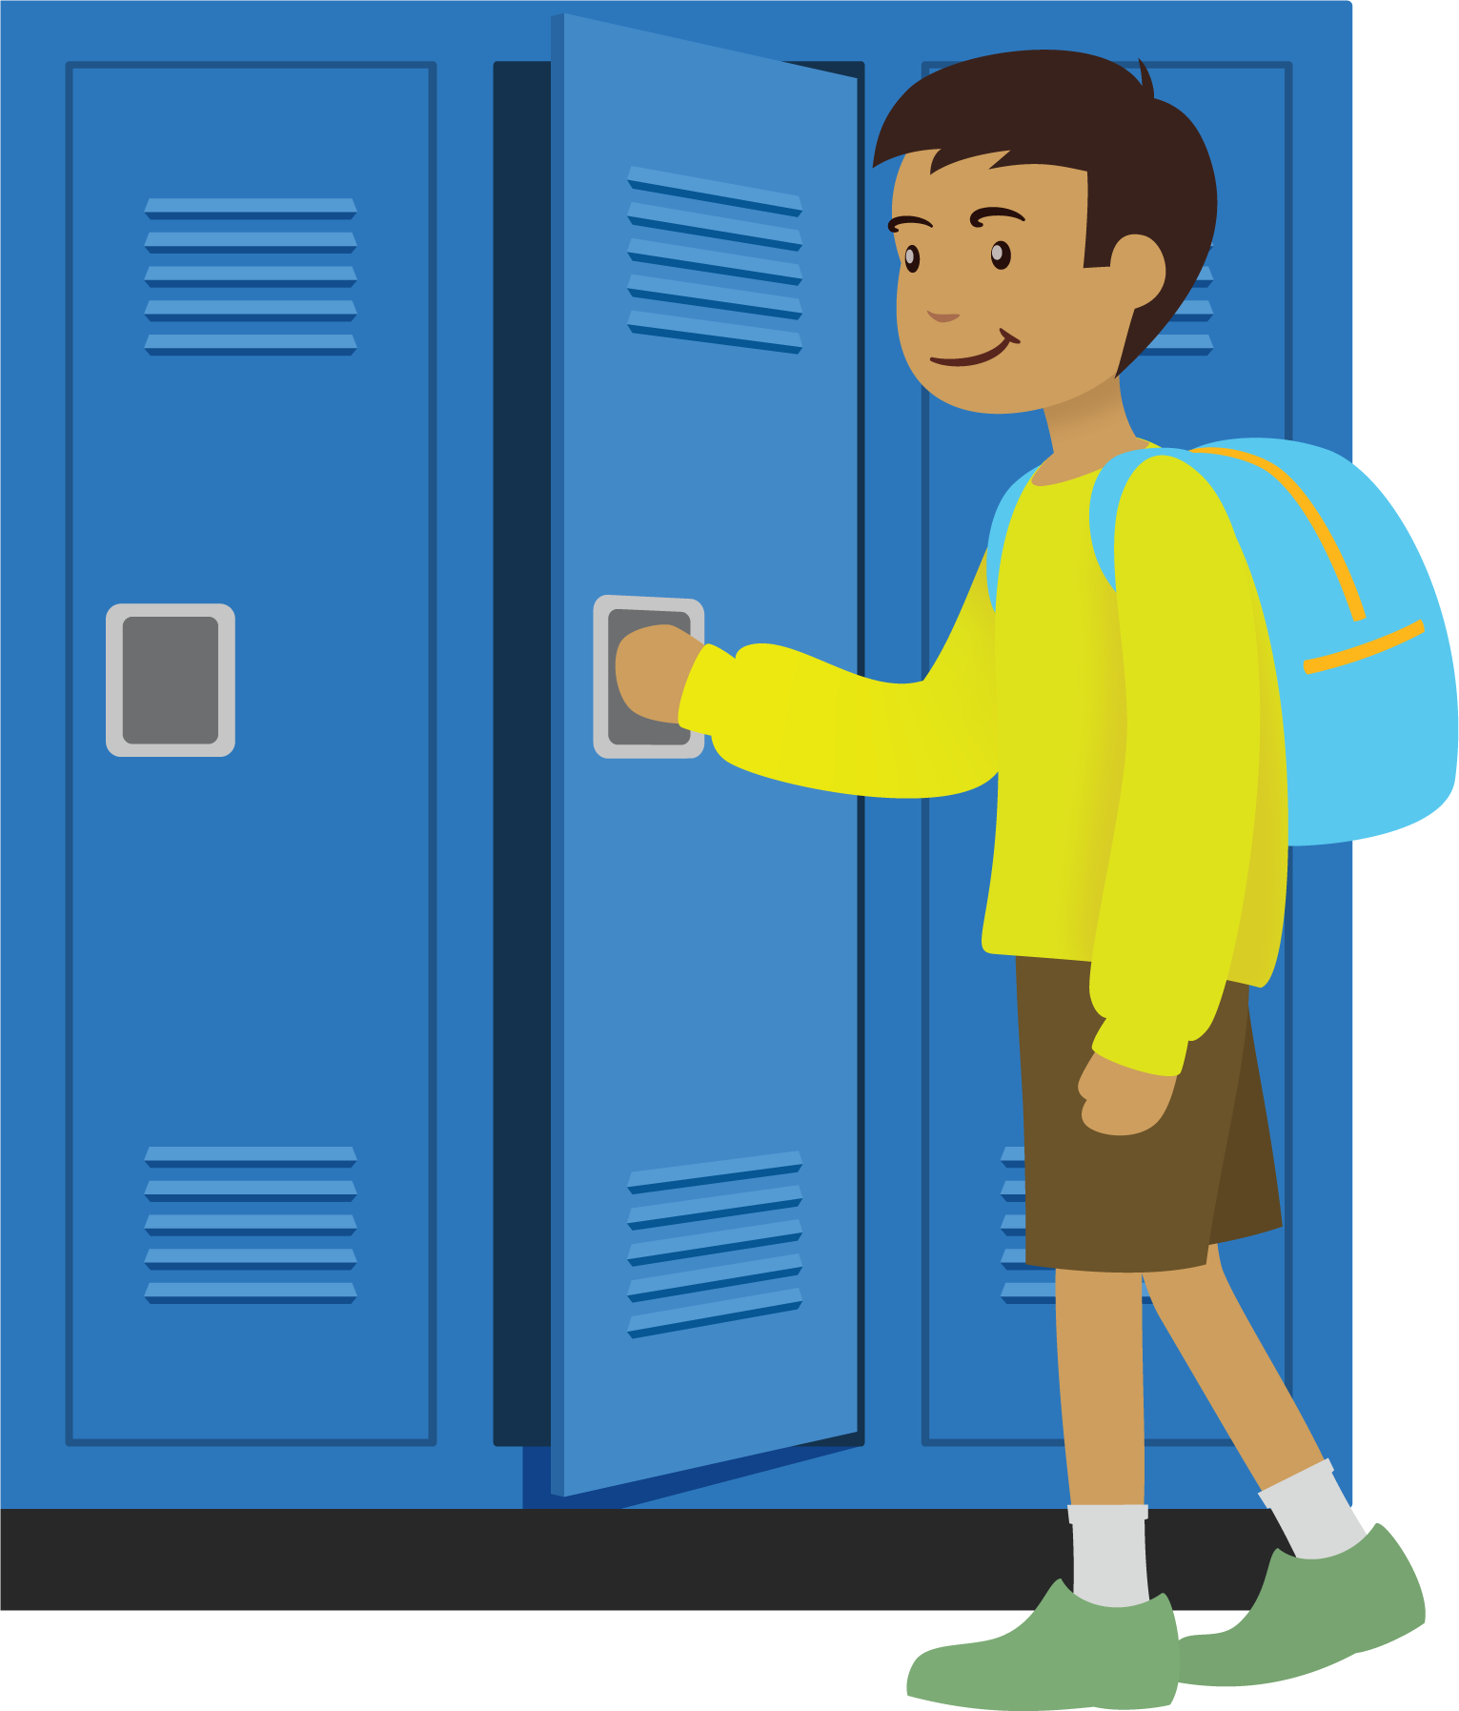
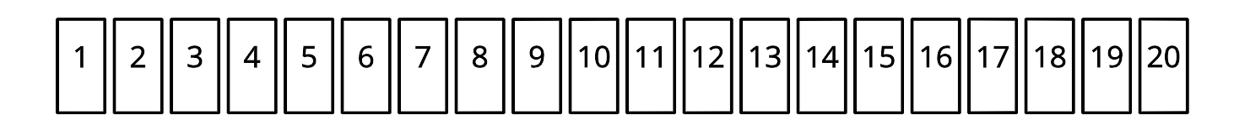
- Which locker numbers does the 3rd student touch?
- Which locker numbers does the 5th student touch?
- How many students touch locker 17? Explain or show how you know.
- Which lockers are only touched by 2 students? Explain or show how you know.
- Which lockers are touched by only 3 students? Explain or show how you know.
- Which lockers are touched the most? Explain or show how you know.
If you have time: Which lockers are still open at the end of the game? Explain or show how you know.
© CC BY 2021 Illustrative Mathematics®

