Lesson 4: Interpretemos datos de medidas que están en diagramas de puntos

Standards Alignments
Building On | 2.MD.D.9
Addressing | 3.MD.B.4
Building Towards | 3.MD.B.4

Teacher-facing Learning Goals
- Interpret line plots that display measurement data in fractions of an inch.

Student-facing Learning Goals
- Demos sentido a diagramas de puntos que tienen longitudes en mitades de pulgada y en cuartos de pulgada.

Lesson Purpose
The purpose of this lesson is for students to make sense of line plots that represent measurements to the nearest half or fourth of an inch.
In grade 2, students made line plots to show measurements to the nearest whole unit. In previous lessons, they measured objects with rulers marked with halves and fourths of an inch. In this lesson, students interpret line plots that show lengths in half inches and quarter inches and ask and answer questions about the data.

Access for:

Students with Disabilities
- Engagement (Activity 2)

English Learners
- MLR6 (Activity 2)

Instructional Routines
Notice and Wonder (Warm-up)

Lesson Timeline
Warm-up | 10 min
Activity 1 | 20 min
Activity 2 | 15 min
Lesson Synthesis | 10 min
Cool-down | 5 min

Teacher Reflection Question
What part of the lesson went really well today in terms of students’ learning? What did you do that made that part go well?

Cool-down
(to be completed at the end of the lesson) 5min
Interpreta y escoge

Standards Alignments
Addressing | 3.MD.B.4

Student-facing Task Statement
Selecciona todas las afirmaciones que son verdaderas sobre las medidas que muestra el diagrama de puntos.
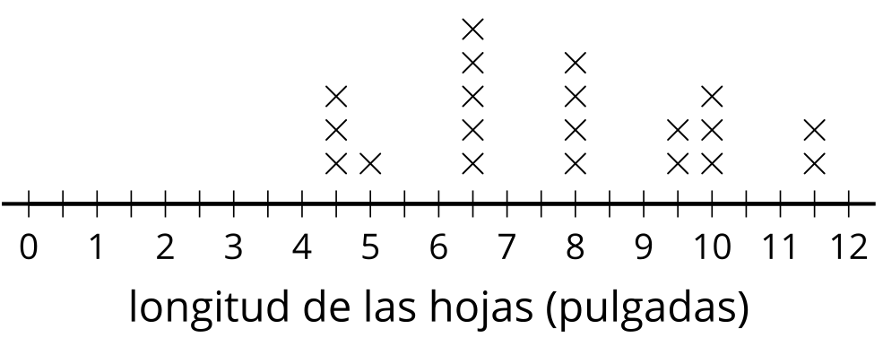
- Cinco hojas tenían una longitud de $6\frac{1}{2}$ pulgadas.
- Seis hojas tenían una longitud de $9\frac{1}{2}$ pulgadas.
- 12 hojas fueron medidas.
- 20 hojas fueron medidas.
- La hoja más corta medía 5 pulgadas.
- La hoja más corta medía $4\frac{1}{2}$ pulgadas.

Student Responses
A, D, F

