Unit 5 Lesson 10: Solutions to Linear Equations

1 Same Perimeter (Warm up)

Student Task Statement
There are many possible rectangles whose perimeter is 50 units. Complete the first 3 entries of the table with lengths, $ℓ$, and widths, $w$.
$ℓ$
$w$

Activity Synthesis
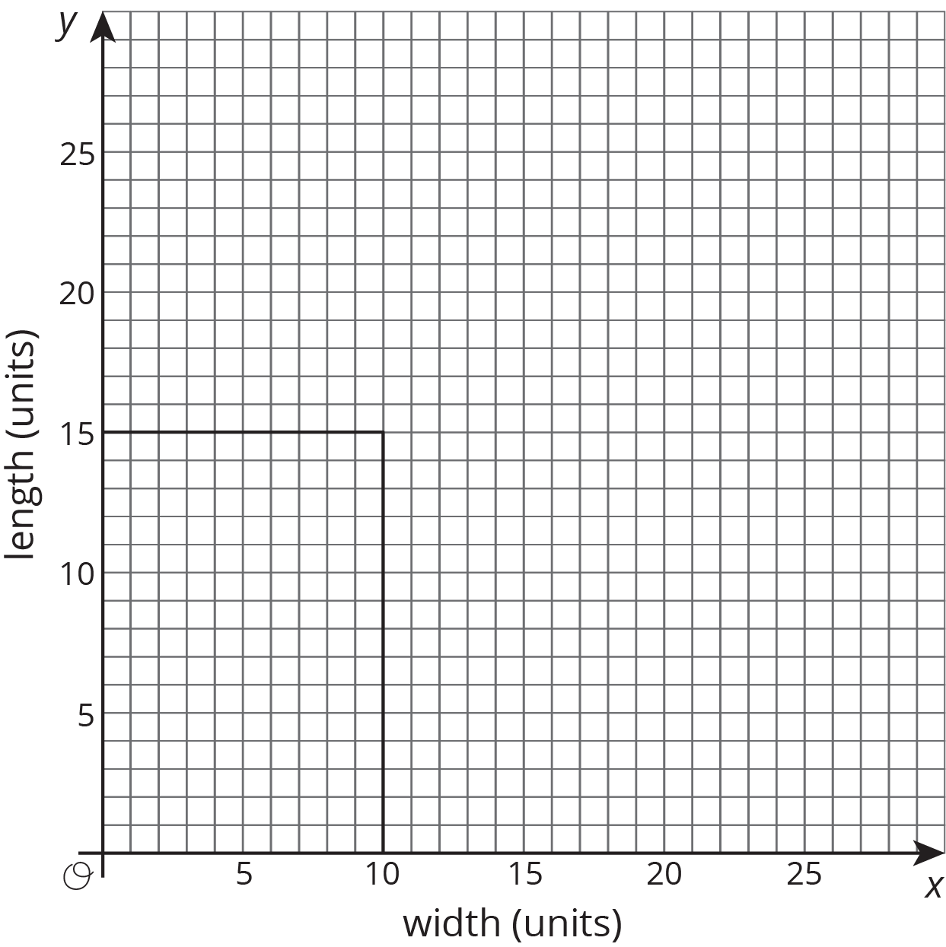

2 Apples and Oranges

Student Task Statement
At the corner produce market, apples cost $1 each and oranges cost $2 each.
- Find the cost of:
  - ​6 apples and 3 oranges
  - 4 apples and 4 oranges
  - 5 apples and 4 oranges
  - 8 apples and 2 oranges
- Noah has $10 to spend at the produce market. Can he buy 7 apples and 2 oranges? Explain or show your reasoning.
- What combinations of apples and oranges can Noah buy if he spends all of his $10?
- Use two variables to write an equation that represents $10-combinations of apples and oranges. Be sure to say what each variable means.
- What are 3 combinations of apples and oranges that make your equation true? What are three combinations of apples and oranges that make it false?

3 Solutions and Everything Else

Student Task Statement
You have two numbers. If you double the first number and add it to the second number, the sum is 10.
- Let $x$ represent the first number and let $y$ represent the second number. Write an equation showing the relationship between $x$, $y$, and 10.
- Draw and label a set of $x$- and $y$-axes. Plot at least five points on this coordinate plane that make the statement and your equation true. What do you notice about the points you have plotted?
- List ten points that do not make the statement true. Using a different color, plot each point in the same coordinate plane. What do you notice about these points compared to your first set of points?
© CC BY Open Up Resources. Adaptations CC BY IM.

