Lesson 11: Compare and Sort Solid Shapes
- Let’s figure out how solid shapes are alike and different.

11.1: Compare Solid Shapes
alike | different
____________________ | ____________________
____________________ | ____________________
____________________ | ____________________

11.2: Sort Solid Shapes
_____________________
_______________
_____________________
_______________

11.3: Introduce Geoblocks, Feel and Guess
Choose a center.
Geoblocks
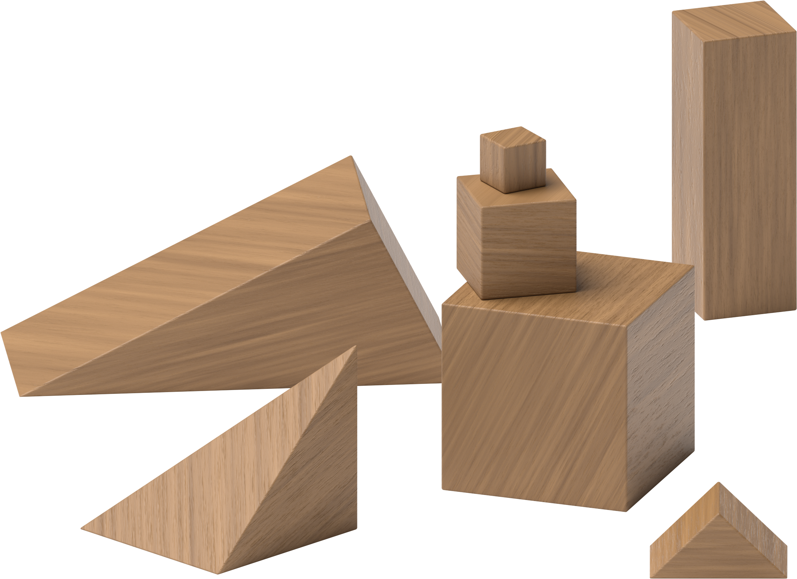
Counting Collections
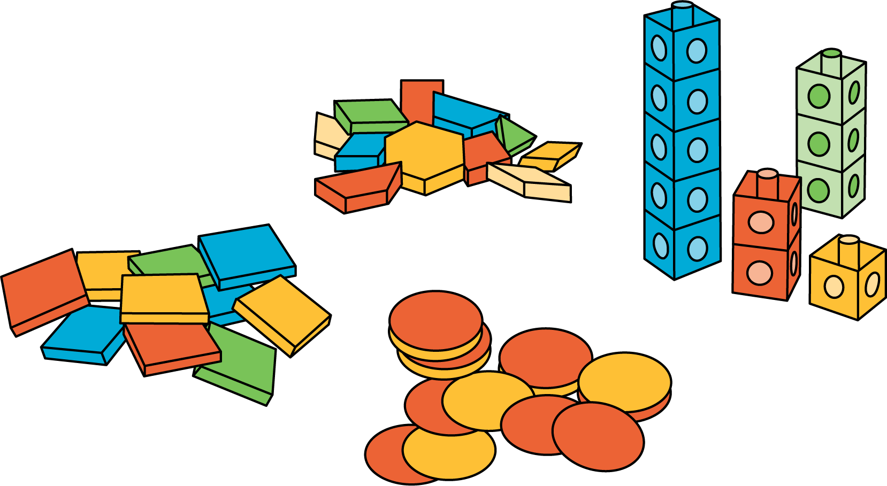
Match Mine
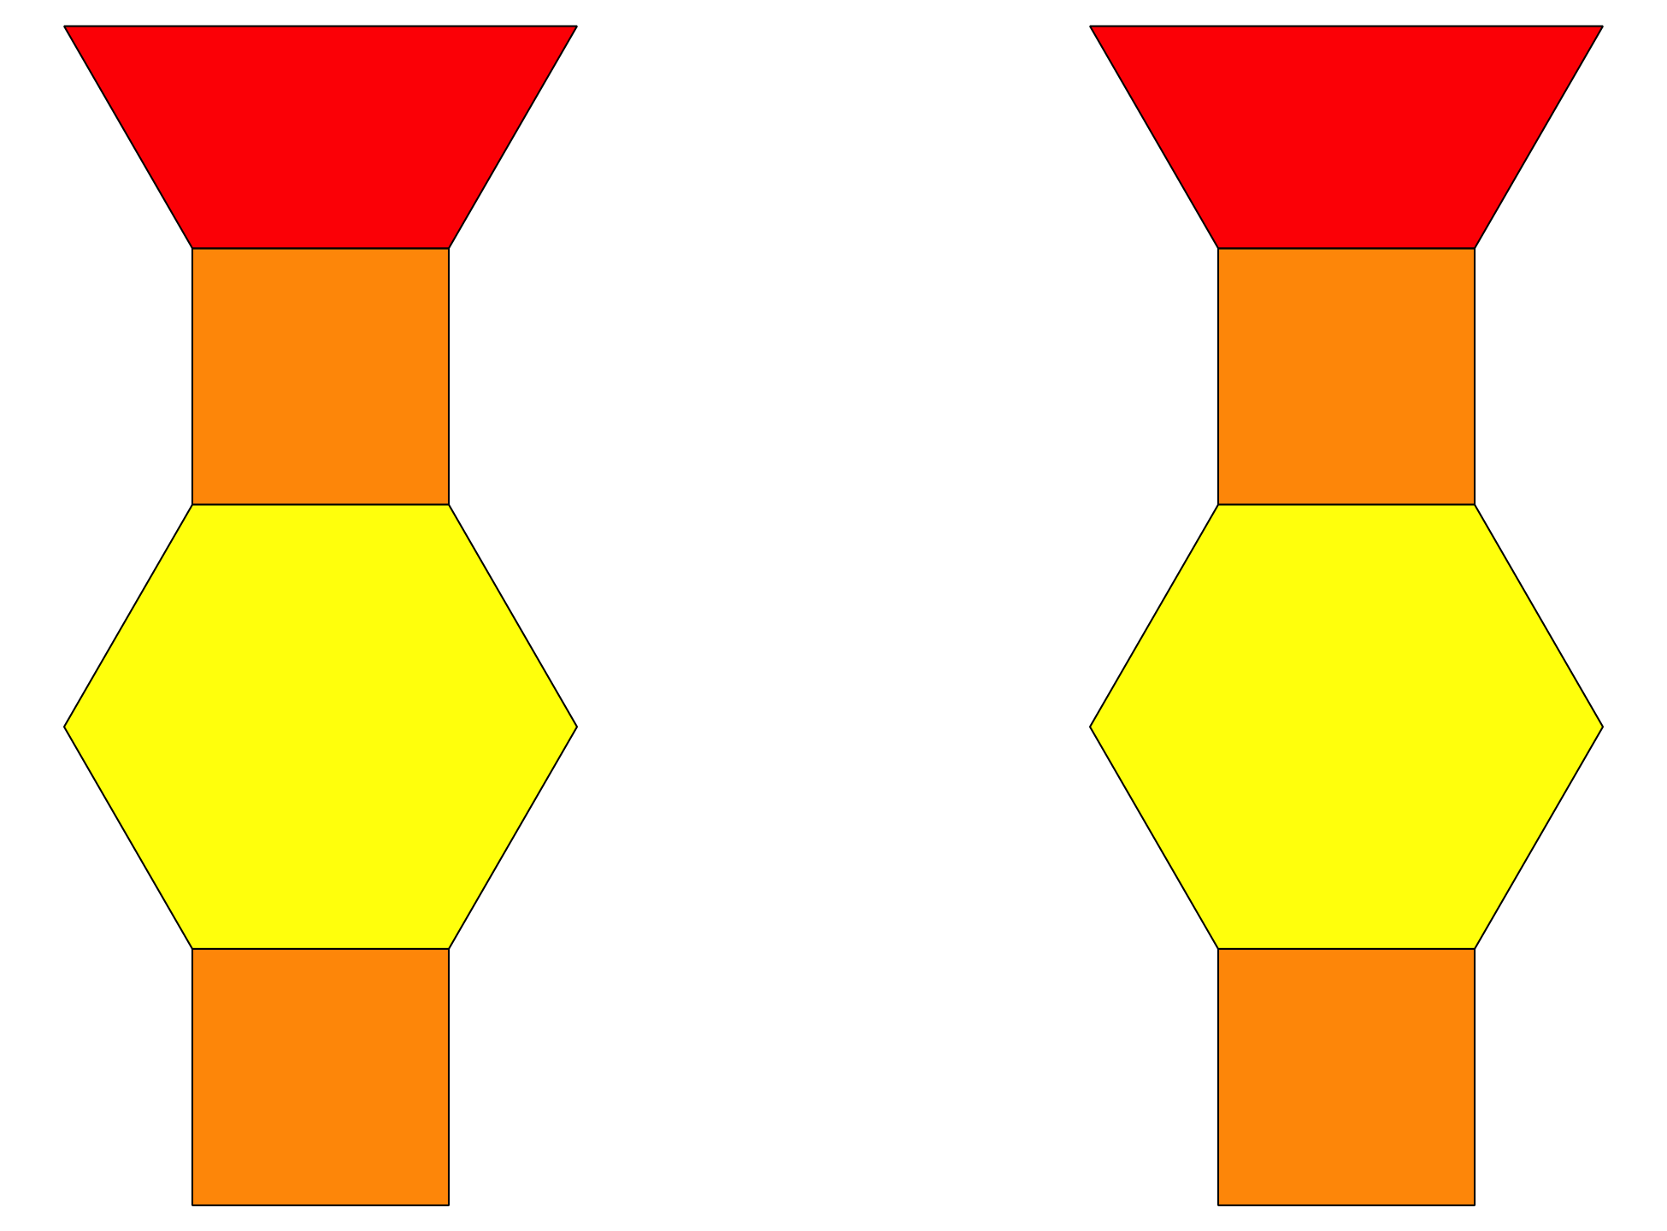
Shake and Spill
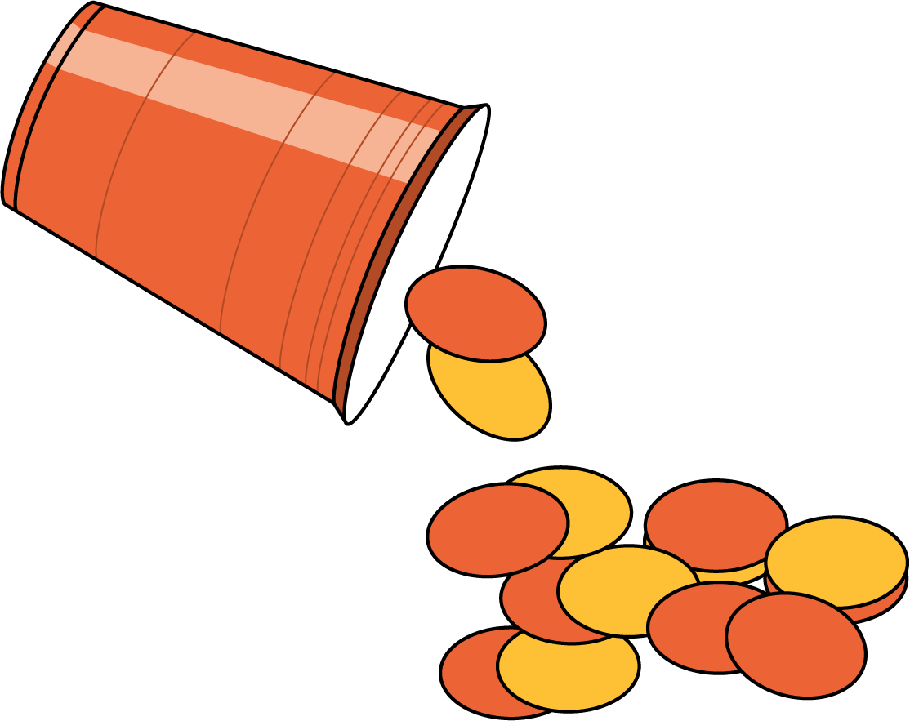
© CC BY 2021 Illustrative Mathematics®

