Lesson 14: What Do You Know About Polynomials?
- Let's put together what we've learned about polynomials so far.

14.1: What Else is True?
$G(x)$ is a polynomial. Here are some things we know about it:
- It has degree 3.
- Both $x$ and $(x+4)$ are factors of $G$.
- It has 2 horizontal intercepts, but only 1 is negative.
- Its leading coefficient is negative.
What else do we know is true about $G(x)$?

14.2: Info Gap: More Polynomials
Your teacher will give you either a problem card or a data card. Do not show or read your card to your partner.
If your teacher gives you the data card:
- Silently read the information on your card.
- Ask your partner, “What specific information do you need?” and wait for your partner to ask for information. Only give information that is on your card. (Do not figure out anything for your partner!)
- Before telling your partner the information, ask, “Why do you need to know (that piece of information)?”
- Read the problem card, and solve the problem independently.
- Share the data card, and discuss your reasoning.
If your teacher gives you the problem card:
- Silently read your card and think about what information you need to answer the question.
- Ask your partner for the specific information that you need.
- Explain to your partner how you are using the information to solve the problem.
- When you have enough information, share the problem card with your partner, and solve the problem independently.
- Read the data card, and discuss your reasoning.
Pause here so your teacher can review your work. Ask your teacher for a new set of cards and repeat the activity, trading roles with your partner.

14.3: Even More Polynomials
- Without letting your partner see, do the following:
  - write a polynomial of degree 3 or 4 in factored form
  - sketch the graph of your polynomial
  - rewrite its expression in standard form
- On a separate slip of paper, write the standard form of your polynomial along with 1 of the factors (or 2 factors, if the polynomial has degree 4). Trade slips with your partner.
- Use the information your partner gave you about their polynomial to:
  - rewrite their polynomial in factored form
  - sketch a graph of their polynomial showing all horizontal intercepts
- Once you and your partner have finished graphing, check your factored form and graph with your partner and discuss any differences.

Lesson 14 Summary
We can look at the same polynomial in many different ways. Let’s think about $P(x)=x^{3}−7x+6$. It’s written in standard form, but we could also write it in factored form as $(x−2)(x+3)(x−1)$. If we graph $P(x)$, we get this:
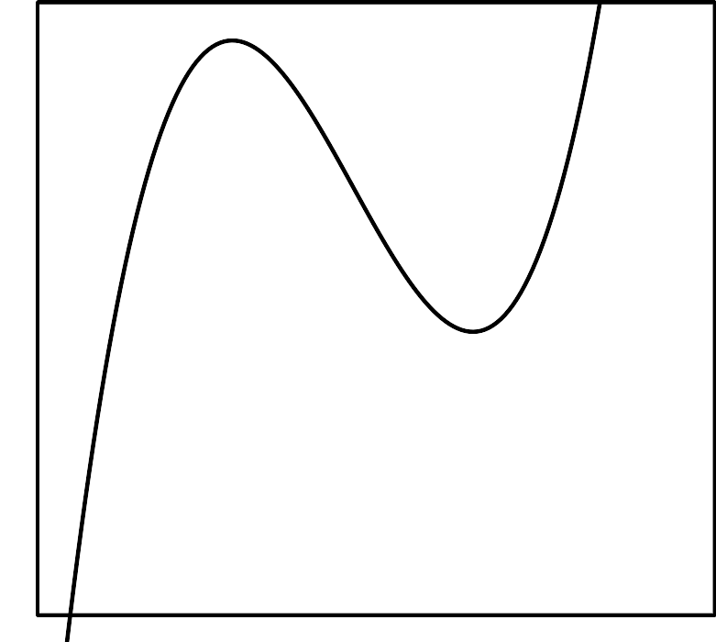
Depending on what we know about $P(x)$ and what we want to do, different forms of it will be more useful. If we want to quickly estimate the value of $P(x)$ for some value of $x$, the graph might be most helpful. If we don’t know what the graph of $P(x)$ looks like, the factored form can help us find the zeros and sketch it. If we want to know the general shape of the graph, we can use the standard form to find the end behavior. If we want to know the factors of $P(x)$ and we only know the standard form, we can guess some possible factors and divide $P(x)$ by them. If we have the factored form and we want to know the standard form, we can multiply all the factors together.
© CC BY 2019 by Illustrative Mathematics®

