Lesson 19: More Money Problems
- Let’s solve money problems with lots of dollars.

Warm-up: Number Talk: Use Ten to Add Within 100
Find the value of each expression mentally.
- $18+32$
- $28+32$
- $28+34$
- $38+35$

19.1: Shop with Friends
Write the letter next to the story problem it represents.
A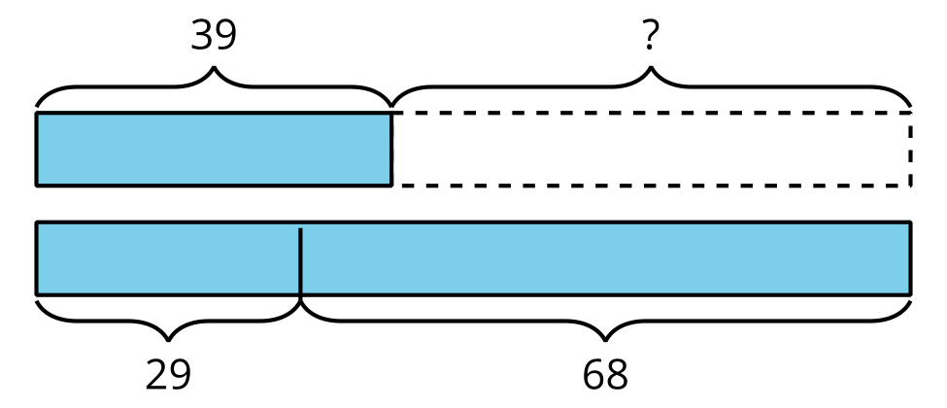
B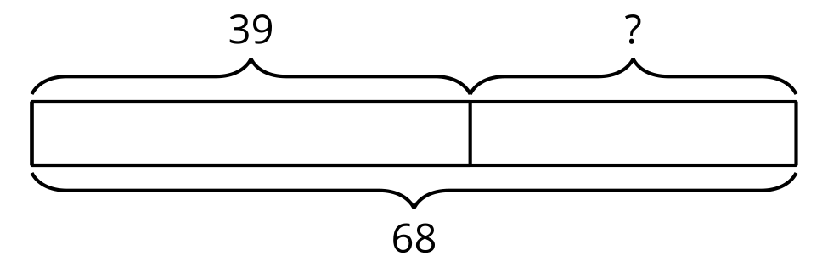
C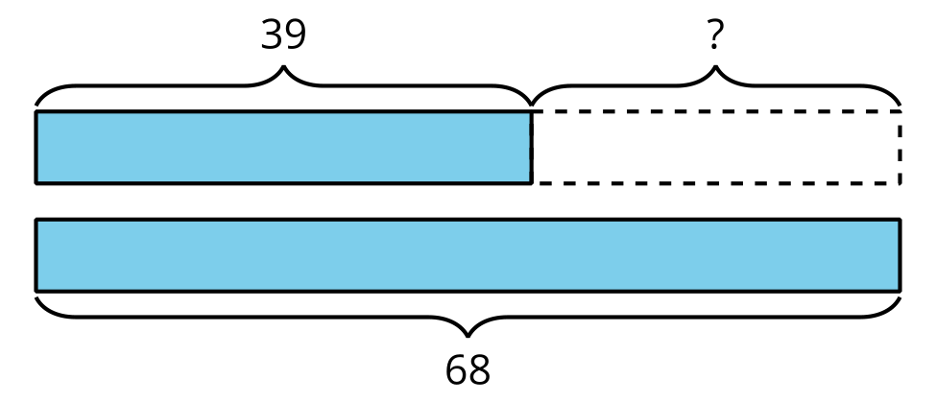
D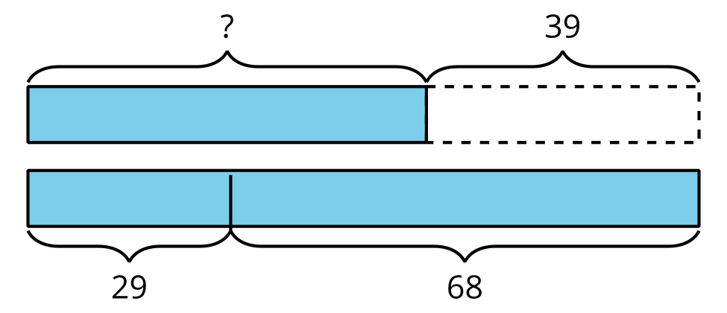
- A basketball costs $39 less than a soccer ball and football combined.
- The soccer ball costs $29 and the football costs $68.
- How many dollars does the basketball cost? _____
- Jada is saving to buy a gift for her dad. The gift costs $68. So far she has $39.
- How much more does she need? _____
- A pair of pants costs $39.
- A shirt costs $29 and a pair of shoes cost $68.
- How many more dollars do the shirt and shoes cost than the pants? _____
- Diego has $39. His mom gave him some money for his birthday. Now he has $68.
- How much money did he get for his birthday? _____

19.2: Money Among Friends
For each problem, show your thinking. Write your final answer using the $. Use a diagram if it helps.
- Mai has $27, Elena has $48, and Jada has $16. How much money do they have altogether?
- Tyler has $45, Andre has $36, and Noah has $28. How much less money does Tyler have than Andre and Noah combined?
- Lin has $19. Together, Lin and Han have $45. Then Han gets $17 more. How much money does Han have now?

Section Summary
Section Summary
In this section we learned the value of quarters, dimes, nickels, and pennies and how to recognize each coin. We used addition and counting strategies to find the values of mixed sets of coins. We learned that a dollar has the same value as 100 cents and combined coins to make $1. We also solved story problems about money.
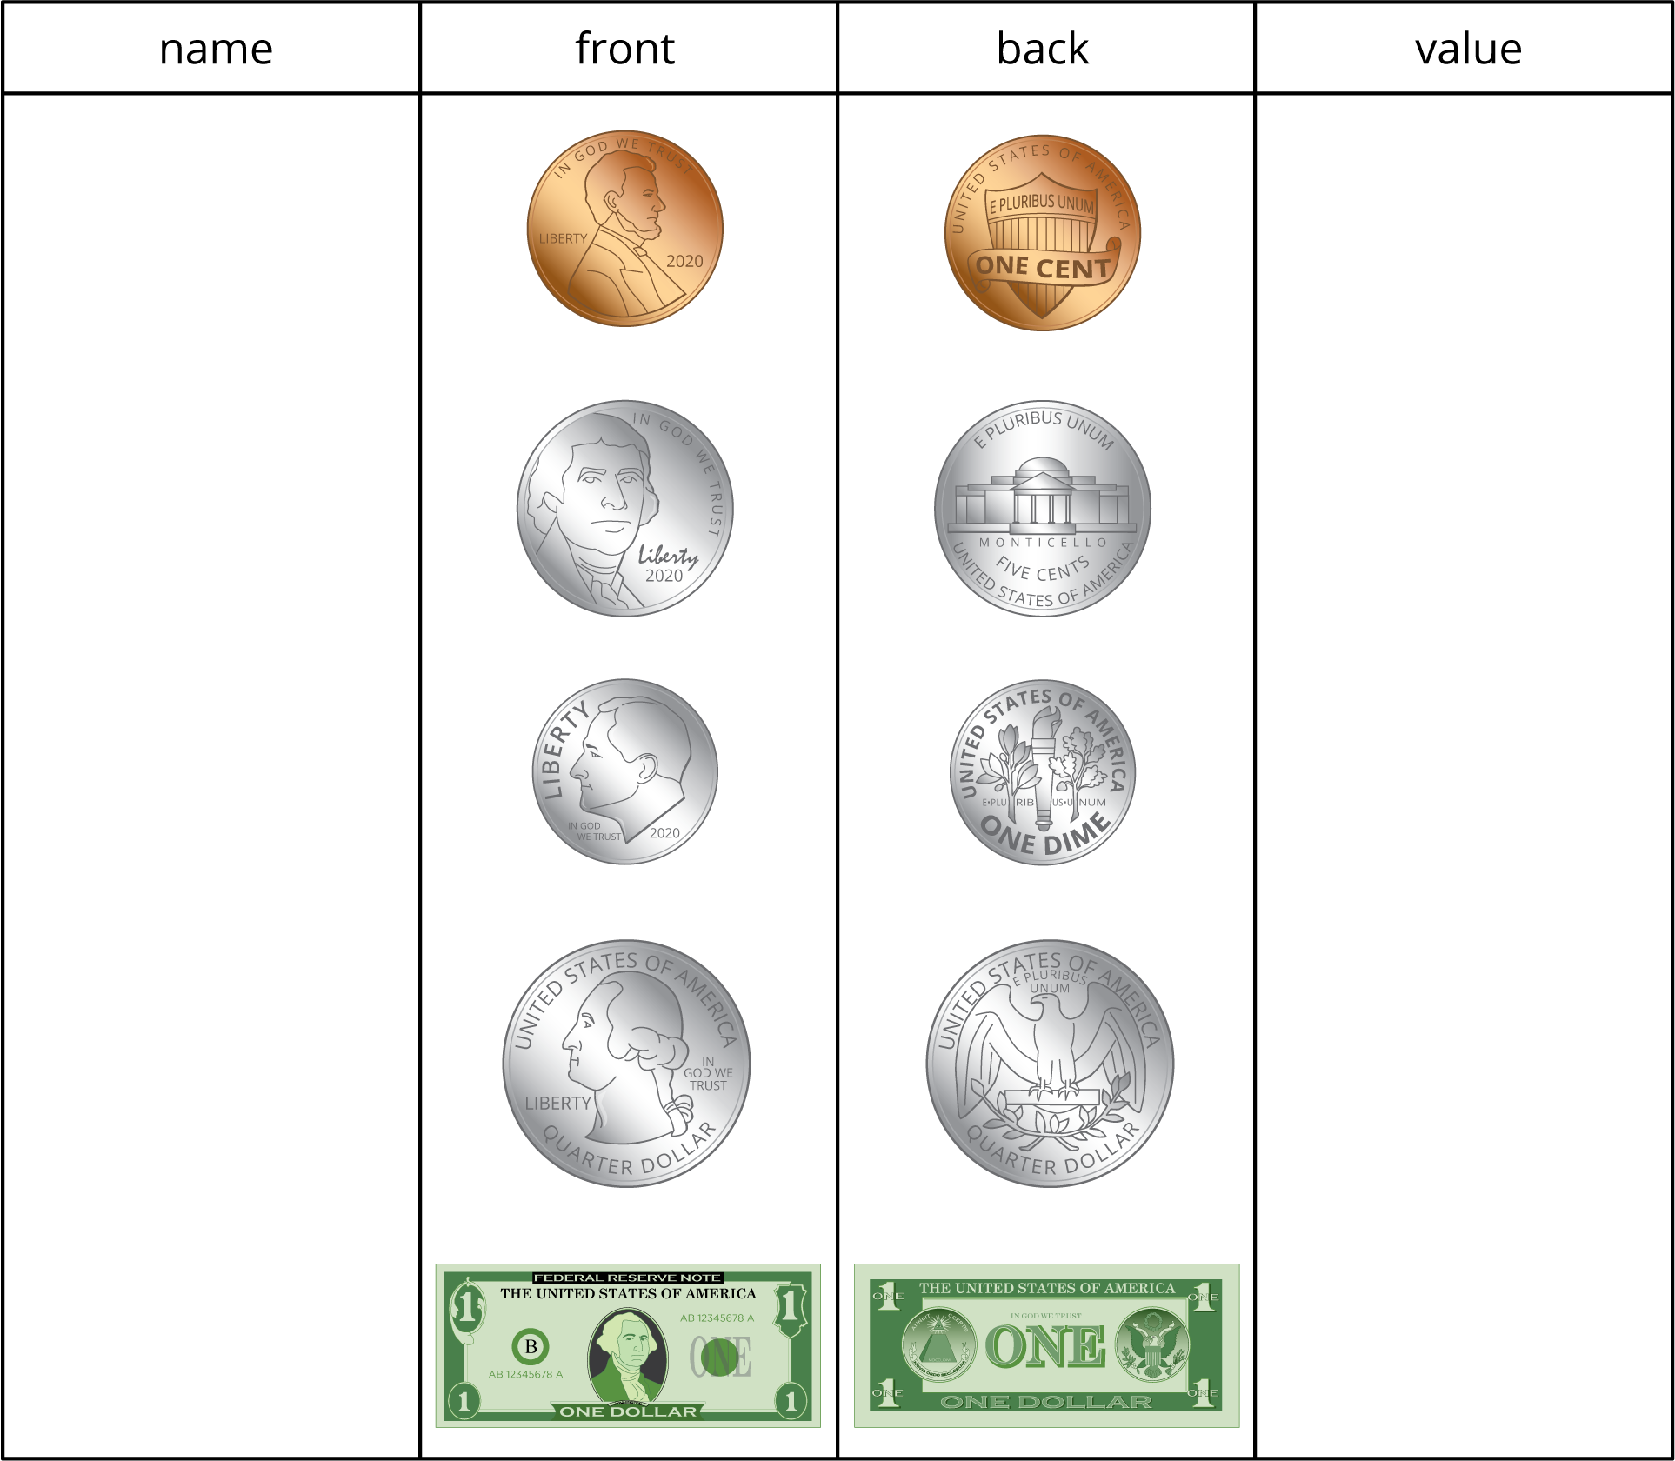
© CC BY 2021 Illustrative Mathematics®

