Lesson 18: Larger Numbers in Equal Groups
- Let’s divide with larger numbers.

Warm-up: What Do You Know About Division?
What do you know about division?

18.1: Groups on a Field Trip
There are 48 students going on a field trip to the aquarium. They visit the exhibits in groups of 4 students. How many groups will there be?
Show your thinking using diagrams, symbols, or other representations.
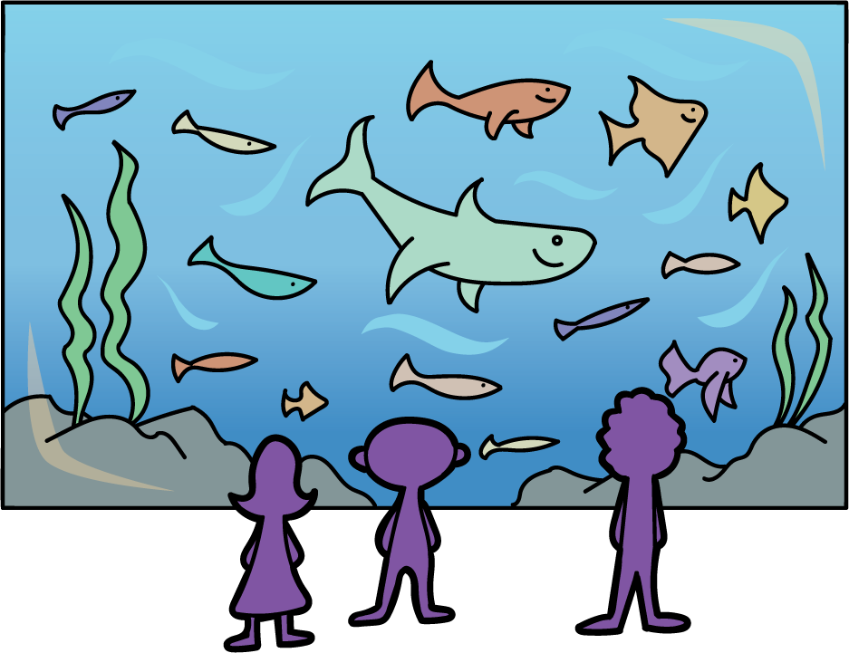

18.2: Bus Ride and Lunch Groups
For each question, show your thinking using diagrams, symbols, or other representations.
- On another field trip, 72 students and teachers rode in 3 buses to a science museum, with the same number of people in each bus. How many people rode in each bus?
- During lunch, the 72 people sat at long tables, with 12 people at each table. How many tables did they use?
© CC BY 2021 Illustrative Mathematics®

