Lesson 2: Create Your Own Number Line
- Let’s create number lines and compare fractions.

Warm-up: Which One Doesn’t Belong: Fractions on Number Lines
Which one doesn’t belong?
A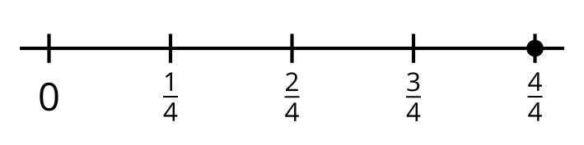
B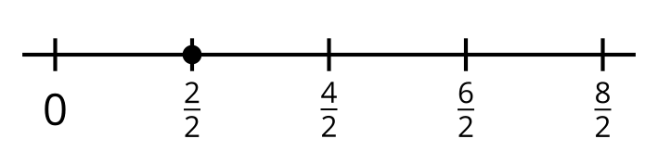
C
D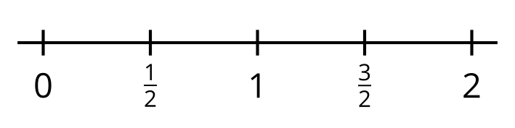

2.1: Create Your Own Number Line
Create a long number line on the floor.
Locate and label each fraction on the number line. Be prepared to explain your reasoning.
0 | 1 | 2 | $\frac{1}{2}$ | $\frac{1}{3}$ | $\frac{6}{2}$ | $\frac{12}{3}$ | $\frac{1}{4}$
$\frac{5}{4}$ | $\frac{6}{6}$ | $\frac{5}{6}$ | $\frac{9}{8}$ | $\frac{15}{8}$ | $\frac{5}{3}$ | $\frac{18}{6}$ | $\frac{2}{8}$

2.2: Make a Statement
Write 6 fraction comparison statements about the numbers on your number line. Include 2 statements for each symbol ($>$, $=$, and $<$).

Choose 2 statements you wrote. Use numbers, pictures, or words to show that they are true.
© CC BY 2021 Illustrative Mathematics®

