Lesson 12: Build Solid Shapes
- Let’s create solid shapes.

12.3: Centers: Choice Time
Choose a center.
Build Shapes
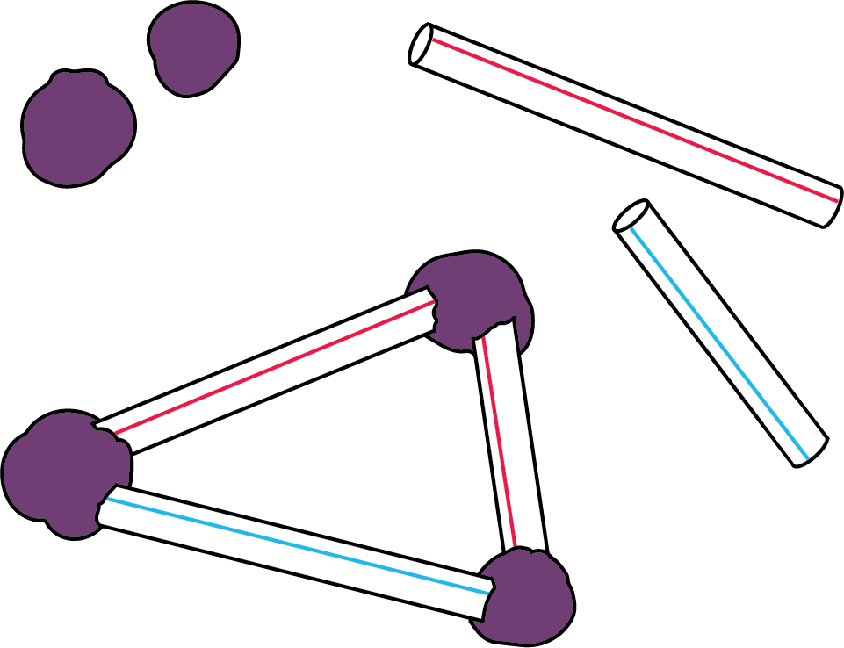
Geoblocks
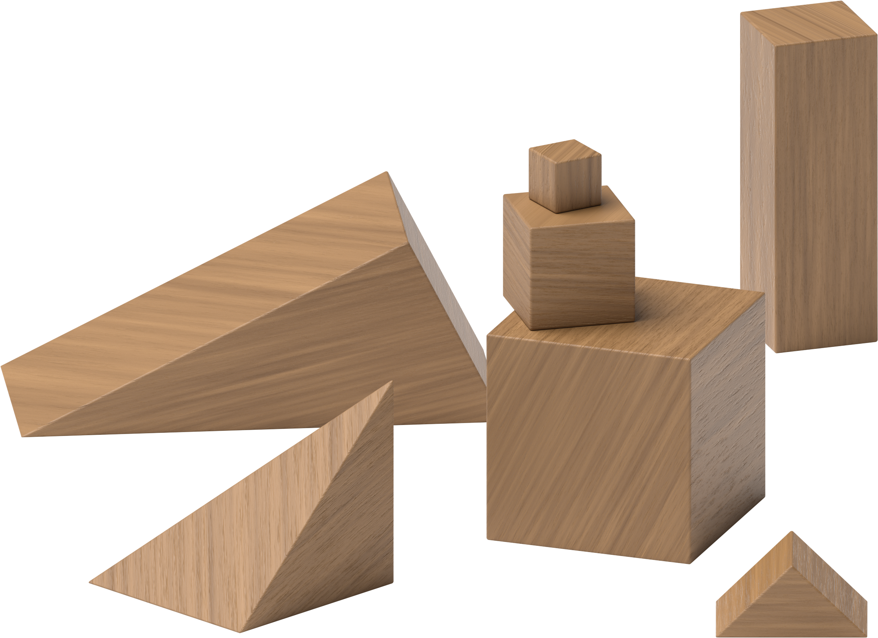
Counting Collections
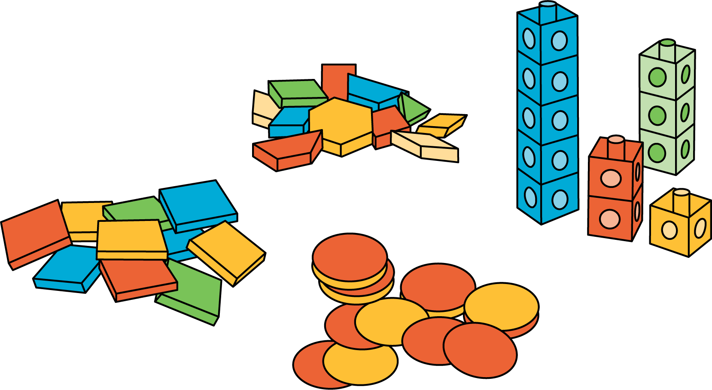
Match Mine
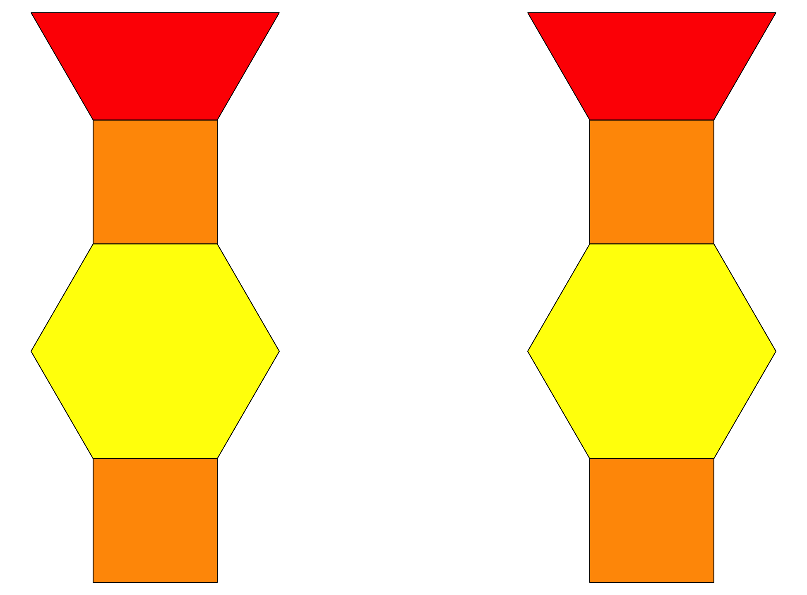
Shake and Spill
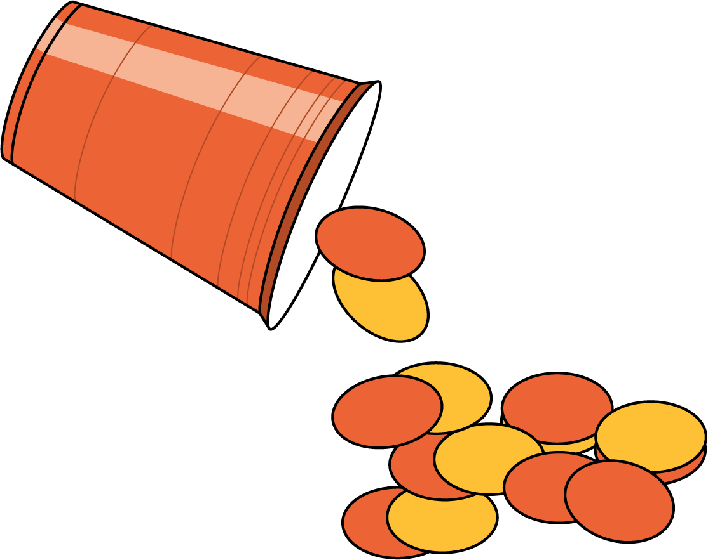
© CC BY 2021 Illustrative Mathematics®

